Task 1
Here are some keywords linked to photosynthesis but they have become scrambled. Can you unscramble them? Write them in the table below:

afel | gxoyne | soecugl | trewa
tohpoynseshsit | nhigltsu | lclhrohoylp | barcon exodidi

Write the keywords below:

Task 2
Using your knowledge, complete the text below about photosynthesis.

- All living things need e_ _ _ _ _. Animals e _ _ plants or other animals but
p_ _ _ _ _ feed in a different way.

- Green plants can make their own food so we call them p_ _ _ _ _ _ _ _. They make their own food by the process of p _ _ _ _ _ _ _ _ _ _ _ _ _.

- To make their own food plants need to absorb s_ _ _ _ _ _ _ to make g _ _ _ _ _ _ from w _ _ _ _ and c _ _ _ _ _ d _ _ _ _ _ _. During this process a waste gas is also produced that is very useful to plants and animals for respiration. This is called
o _ _ _ _ _.

- It is in the l _ _ _ _ _ that most photosynthesis takes place. This is because there are lots of chloroplasts here that contain c _ _ _ _ _ _ _ _ _ _. This is the chemical that makes the plant g _ _ _ _. This chemical traps energy from the s _ _ for photosynthesis.

- The word equation for photosynthesis is:

c _ _ _ _ _ d _ _ _ _ _ _ | + | w _ _ _ _ | → | g _ _ _ _ _ _ | + | o _ _ _ _ _

Task 3
Use your knowledge to add labels to the diagram below showing the reactants and products of photosynthesis.

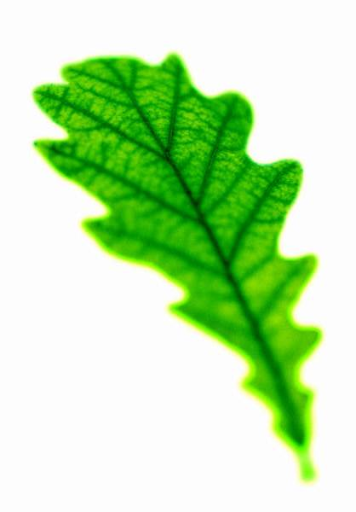

Task 4
Answer these questions about photosynthesis.
- What is the function of chlorophyll in photosynthesis?

- What are the two gases involved in photosynthesis? Which is a reactant and which is a product of photosynthesis?

- How does the plant absorb water?

- Do you think a mushroom can photosynthesise? (Circle your answer)
yes no
Explain your answer:

- Explain how the sun provides energy for both plants and animals.

Suggested answers

Task 1

leaf | oxygen | glucose | water
photosynthesis | sunlight | chlorophyll | carbon dioxide

Task 2
Using your knowledge, complete the text below about photosynthesis.

- All living things need energy. Animals eat plants or other animals but plants feed in a different way.

- Green plants can make their own food so we call them producers. They make their own food by the process of photosynthesis.

- To make their own food plants need to absorb light energy to make glucose from water and carbon dioxide. During this process a waste gas is also produced that is very useful to plants and animals for respiration. This is called oxygen.

- It is in the leaves that most photosynthesis takes place. This is because there are lots of chloroplasts here that contain chlorophyll. This is the chemical that makes the plant green. This chemical traps energy from the sun for photosynthesis.

- The word equation for photosynthesis is:

carbon dioxide | + | water | → | glucose | + | oxygen

Task 3

water
carbon dioxide
oxygen
glucose
light energy

Task 4
- It absorbs the energy from the sunlight to use for photosynthesis.
- carbon dioxide (reactant) and oxygen (product)
- The roots absorb water from the soil, through root hairs.
- No. Mushrooms are not green and therefore they have no chloroplasts and no chlorophyll. This means that they cannot absorb sunlight and they cannot photosynthesise.
- Plants are producers they use light energy to produce glucose.
Energy from the sun is transferred along food chains.
Animals need to consume other plants and animals to obtain the energy they need.

