Types of chemical reaction diagram
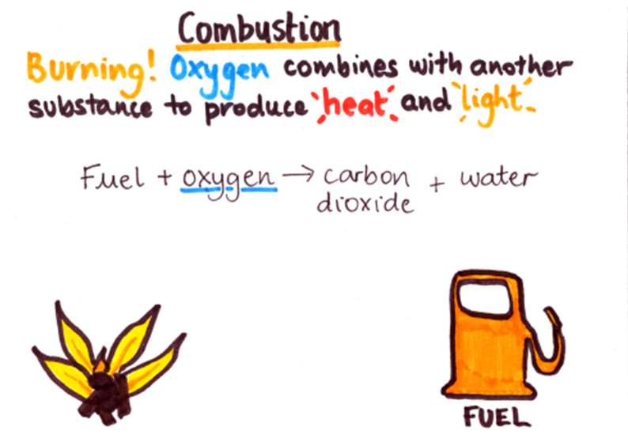 | 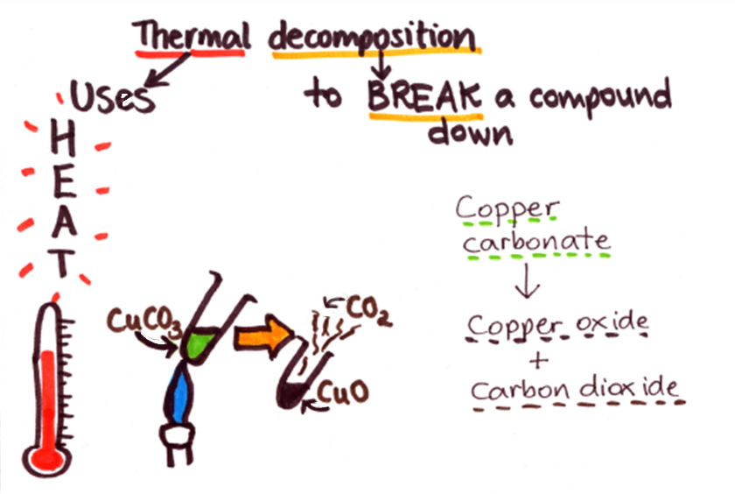
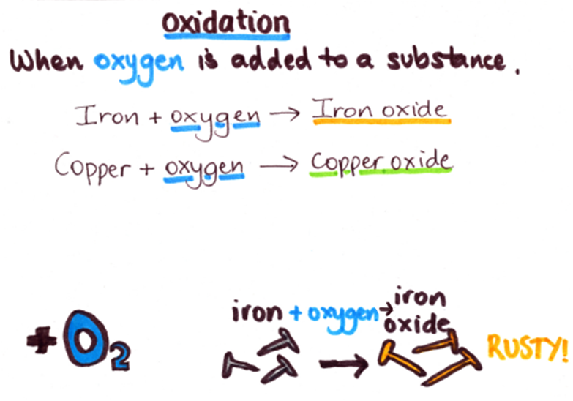 | 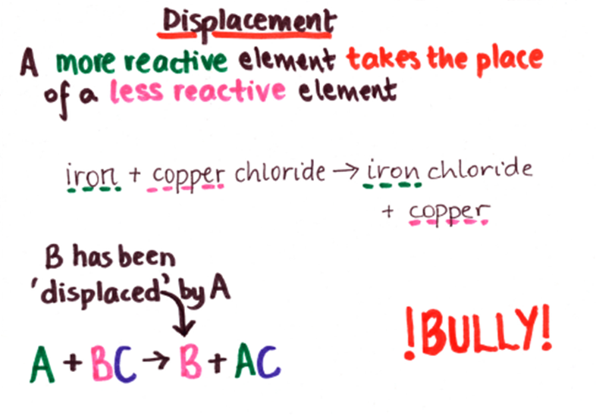

1) For each equation below, decide what type of reaction it is and then complete the table.

Equation | Type of chemical reaction | Reason for choice
petrol + oxygen → carbon dioxide + water
sodium + magnesium chloride → magnesium + sodium chloride
magnesium carbonate → magnesium oxide + carbon dioxide
ethane + oxygen → carbon dioxide + water
magnesium + oxygen → magnesium oxide
lead + silver sulphate → lead sulphate + silver
zinc nitrate → zinc oxide + nitrogen dioxide + oxygen
kerosene + oxygen → carbon dioxide + water
sodium + oxygen → sodium oxide

2) Did you find it difficult to decide the ‘type of chemical reaction’ for any of the equations in the table? Why?

3) For each equation below, decide what type of reaction it is and then try to complete the word equation.
- Type of reaction:
wood + oxygen → +
- Type of reaction:
+ → silver oxide
- Type of reaction:
sodium carbonate (+ heat) → +
- Type of reaction:
potassium + iron chloride → + iron

4) Write word equations for:
- The combustion of diesel

- The oxidation of sodium

- The thermal decomposition of potassium carbonate

- A displacement reaction between magnesium and copper sulphate

5) Explain why magnesium and potassium chloride will not react together.

Teaching notes

These questions were designed to be used with the ‘Types of chemical reaction’ diagram. However, they could be used with other information about the same types of reaction (combustion, oxidation, thermal decomposition, displacement). Some modification of the questions may be necessary in this case.

Suggested answers (the reasons will be varied):
1) For each equation below, decide what type of reaction it is and then complete the table.
Equation | Type of chemical reaction | Reason for choice
petrol + oxygen → carbon dioxide + water | combustion | burning a fuel
sodium + magnesium chloride → magnesium + sodium chloride | displacement | an element has taken the place of another
magnesium carbonate → magnesium oxide + carbon dioxide | thermal decomposition | a compound has been broken down
ethane + oxygen → carbon dioxide + water | combustion | burning a fuel
magnesium + oxygen → magnesium oxide | oxidation | oxygen has been added
lead + silver sulphate → lead sulphate + silver | displacement | an element has taken the place of another
zinc nitrate → zinc oxide + nitrogen dioxide + oxygen | thermal decomposition | a compound has been broken down
kerosene + oxygen → carbon dioxide + water | combustion | burning a fuel
sodium + oxygen → sodium oxide | oxidation | oxygen has been added

2) For each equation below, decide what type of reaction it is and then try to complete the word equation.
- Type of reaction: combustion
wood + oxygen → carbon dioxide + water
- Type of reaction: oxidation
silver + oxygen → silver oxide
- Type of reaction: thermal decomposition
sodium carbonate (+ heat) → sodium oxide + carbon dioxide
- Type of reaction: displacement
potassium + iron chloride → potassium chloride + iron
3) Write word equations for:
- The combustion of diesel
diesel + oxygen → carbon dioxide + water
- The oxidation of sodium
sodium + oxygen → sodium oxide
- The thermal decomposition of potassium carbonate
potassium carbonate → potassium oxide + carbon dioxide
- A displacement reaction between magnesium and copper sulphate
magnesium + copper sulphate → magnesium sulphate + copper
4) Explain why magnesium and potassium chloride will not react together.
Magnesium is less reactive than potassium and so it can’t displace the potassium (NB: no reactivity series is provided, but this could be deduced from the information given.

