Types of chemical reaction diagram
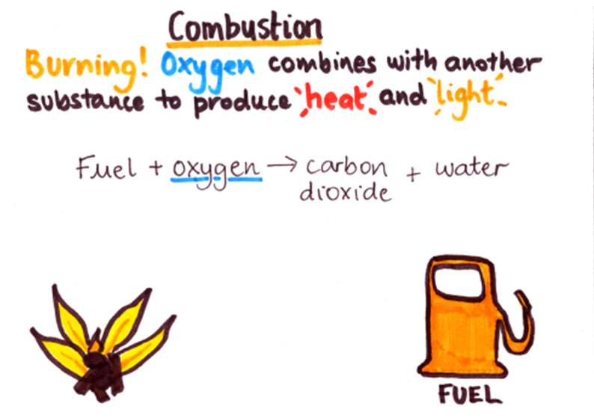 | 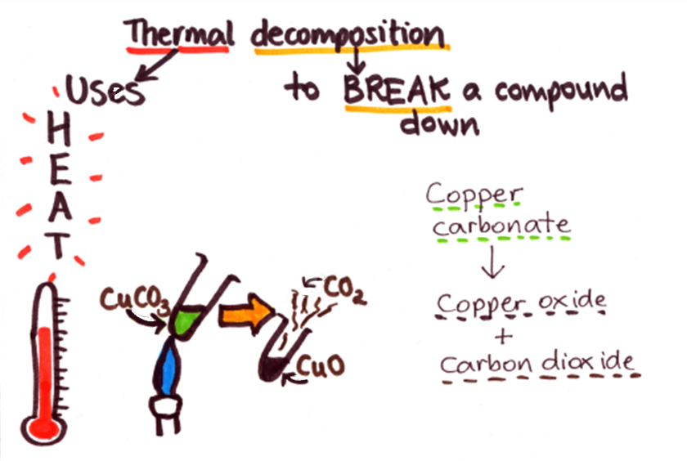
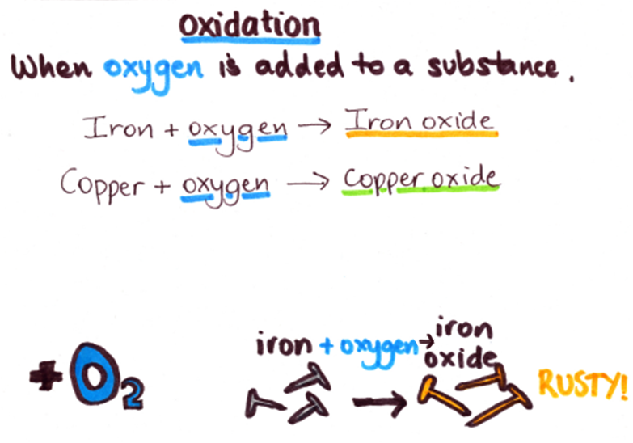 | 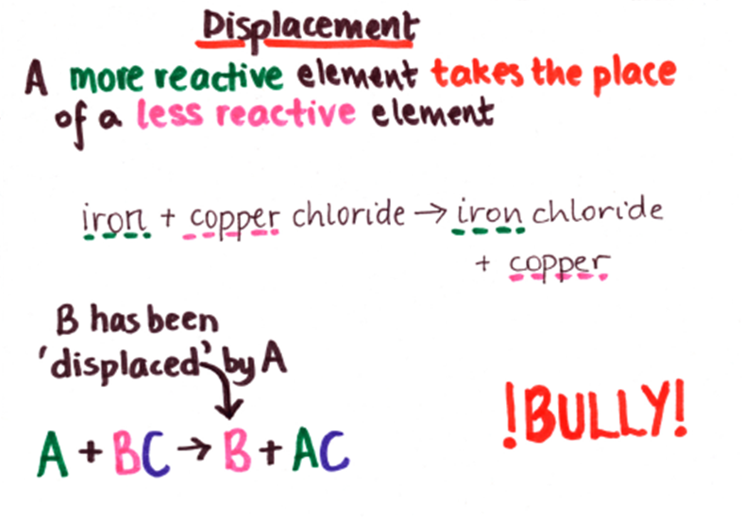

- For each equation below, decide what type of reaction it is and then complete the table.

Keywords

combustion | thermal decomposition | oxidation | displacement

Equation | Type of chemical reaction | Reason for choice
petrol + oxygen → carbon dioxide + water
sodium + magnesium chloride → magnesium + sodium chloride
magnesium carbonate → magnesium oxide + carbon dioxide
ethane + oxygen → carbon dioxide + water
magnesium + oxygen → magnesium oxide

- For each reaction below complete the word equation.
- Type of reaction: combustion
wood + oxygen → +
- Type of reaction: oxidation
+ → silver oxide
- Type of reaction: thermal decomposition
sodium carbonate (+ heat) → +
- Type of reaction: displacement
potassium + iron chloride → + iron

Keywords

silver | carbon dioxide | water | water
carbon dioxide | sodium oxide | oxygen | potassium chloride

- Cut out the boxes below and complete the word equations for:
- The combustion of diesel
→
- The oxidation of sodium
→
- The thermal decomposition of potassium carbonate
→
- A displacement reaction between magnesium and copper sulphate
→
Keywords

potassium carbonate | sodium oxide | sodium + oxygen
diesel + oxygen | magnesium sulphate + copper | carbon dioxide + water
magnesium + copper sulphate | potassium oxide + carbon dioxide

Teaching notes

These questions were designed to be used with the ‘Types of chemical reaction’ diagram. However, they could be used with other information about the same types of reaction (combustion, oxidation, thermal decomposition, displacement). Some modification of the questions may be necessary in this case.
Suggested answers (the reasons will be varied):

Equation | Type of chemical reaction | Reason for choice
petrol + oxygen → carbon dioxide + water | combustion | burning a fuel
sodium + magnesium chloride → magnesium + sodium chloride | displacement | an element has taken the place of another
magnesium carbonate → magnesium oxide + carbon dioxide | thermal decomposition | a compound has been broken down
ethane + oxygen → carbon dioxide + water | combustion | burning a fuel
magnesium + oxygen → magnesium oxide | oxidation | oxygen has been added

- Type of reaction: combustion
wood + oxygen → carbon dioxide + water
- Type of reaction: oxidation
silver + oxygen → silver oxide
- Type of reaction: thermal decomposition
sodium carbonate (+ heat) → sodium oxide + carbon dioxide
- Type of reaction: displacement
potassium + iron chloride → potassium chloride + iron

- The combustion of diesel
diesel + oxygen → carbon dioxide + water
- The oxidation of sodium
sodium + oxygen → sodium oxide
- The thermal decomposition of potassium carbonate
potassium carbonate → potassium oxide + carbon dioxide
- A displacement reaction between magnesium and copper sulphate
magnesium + copper sulphate → magnesium sulphate + copper

