Task 1

Complete the sentences using your knowledge and the keywords below.

chromosomes | 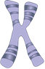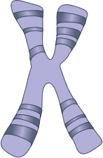 |  |  | Chromosomes are found inside the __________ of a cell.  There are ________ pairs of chromosomes in every human body cell.  One of each pair of chromosomes comes from each__________.  Chromosomes are made up of long lengths of _________.
genes | 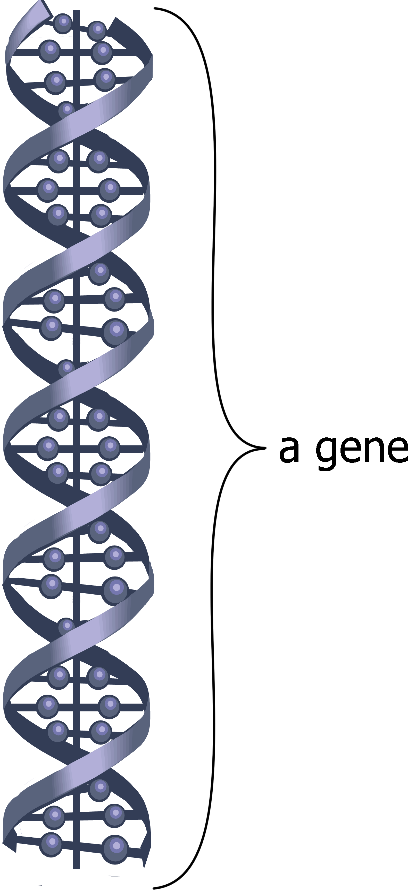 |  |  | A gene is a short section of a ______________________.  Each gene ____________ for a different _________________.  Genes work in ____________. There are different versions of each gene, one is often ________________ over the others.
DNA | 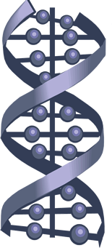 |  |  | DNA is short for ________________________ ___________.  It is a long chain ________________ that is made up of a combination of __________ DNA bases.  DNA has a special structure called a _________ _________.
Keywords
4 | DNA | pairs | double |  | nucleus | characteristic | chromosome
23 | codes | helix | molecule |  | parent | dominant | deoxyribonucleic acid

Task 2
Draw lines to match up the beginning and the end of the sentences relating to chromosomes, genes and DNA.
DNA is short for … |  | ... called a double helix.
Chromosomes contain many genes that … |  | … deoxyribonucleic acid.
Genetic material is found… |  | ... 4 DNA bases.
There are 23 pairs ... |  | ... controlled by genes.
DNA is a molecule made up of a combination of ... |  | … of a chromosome.
We inherit our genes ... |  | … code for our characteristics.
Each gene is a short section ... |  | … long coiled chains of DNA.
Chromosomes are made up of … |  | … of chromosomes in the nucleus of a body cell.
DNA has a special structure … |  | ... in the nucleus of each cell.
Our characteristics are ... |  | ... from our parents.

Task 3 – dominoes game
Cut up the cards and complete each sentence.
... controlled by genes. | START: DNA is short for …
... in the nucleus of each cell. | There are 23 pairs ...
… deoxyribonucleic acid. | Chromosomes contain many genes that …
… of chromosomes in the nucleus of a body cell. | DNA is a molecule made up of a combination of ...
... from our parents. | Each gene is a short section ...
… code for our characteristics. | Genetic material is found…
... 4 DNA bases. | We inherit our genes ...
… long coiled chains of DNA. | DNA has a special structure …
... called a double helix. | Our characteristics are ...
… of a chromosome. | Chromosomes are made up of …

Teaching notes and answers
This activity sheet can be used to introduce the topic of chromosomes, genes and DNA (with teacher explanation) or could be used as part of a recap lesson. It covers the basic structure of chromosomes, genes and DNA and some key facts.
Task 3 is a dominoes game which could be used as an alternative to Task 2. Cut up the cards before the lesson to save time.
Task 1
chromosomes |  | Chromosomes are found inside the nucleus of a cell.  There are 23 pairs of chromosomes in every human body cell.  One of each pair of chromosomes comes from each parent.  Chromosomes are made up of long lengths of DNA.
genes |  | A gene is a short section of a chromosome.  Each gene codes for a different characteristic.  Genes work in pairs. There are different versions of each gene, one is often dominant over the others.
DNA |  | DNA is short for deoxyribonucleic acid.  It is a long chain molecule that is made up of a combination of 4 DNA bases.  DNA has a special structure called a double helix.

Task 2 and 3 answers
DNA is short for … deoxyribonucleic acid.
Chromosomes contain many genes that … code for our characteristics.
Genetic material is found … in the nucleus of each cell.
There are 23 pairs … of chromosomes in the nucleus of a body cell.
DNA is a molecule made up of a combination of … 4 DNA bases.
We inherit our genes … from our parents.
Each gene is a short section … of a chromosome.
Chromosomes are made up of … long coiled chains of DNA.
DNA has a special structure … called a double helix.
Our characteristics are … controlled by genes.

