Data sheet

Table A Table B

Water re-absorption in tubules (ml/min) |  | Urine concentration (mOsm/L) |  |  | Urine flow rate (ml/min) |  | Urine concentration (mOsm/L)
89 |  | 100 |  |  | 1.0 |  | 390
90 |  | 190 |  |  | 1.3 |  | 525
91 |  | 150 |  |  | 1.4 |  | 760
91.5 |  | 210 |  |  | 1.5 |  | 675
92 |  | 160 |  |  | 2.0 |  | 483
93 |  | 110 |  |  | 2.8 |  | 343
94 |  | 300 |  |  | 3.5 |  | 111
95 |  | 320 |  |  | 3.6 |  | 226
95.5 |  | 500 |  |  | 4.5 |  | 550
96 |  | 420 |  |  | 5.0 |  | 400
97 |  | 580 |  |  | 5.2 |  | 209
97.5 |  | 530 |  |  | 5.8 |  | 304
98 |  | 630 |  |  | 6.3 |  | 90
98.5 |  | 750 |  |  | 7.3 |  | 101
99 |  | 740 |  |  | 7.7 |  | 190
 |  |  |  |  |  | 7.9 |  | 103
 |  |  |  |  |  | 8.4 |  | 57
 |  |  |  |  |  | 9.0 |  | 122
Table C
Filtration rate in glomerulus(ml/min) | 53 | 60 | 66 | 68 | 70 | 75 | 81 | 87 | 90 | 98 | 103 | 110 | 111 | 115 | 122 | 130 | 137 | 142 | 145 | 149
Urine flow rate (ml/min) | 7.5 | 2.4 | 5.5 | 6.7 | 1.0 | 3.5 | 1.2 | 7.1 | 2.5 | 4.7 | 3.6 | 2.0 | 6.9 | 3.0 | 2.7 | 5.9 | 4.7 | 3.3 | 1.1 | 6.7

Table D
Substance | Quantity %
 | Blood | Urine
Water | 92 | 95
Proteins | 7 | 0
Glucose | 0.1 | 0
Sodium ions | 0.37 | 0.6
Chloride ions | 0.37 | 0.6
urea | 0.03 | 2

Table E
Organ | % of body mass | Use of body's total energy (%)
Brain | 3.0 | 60
Liver | 1.8 | 16
Kidneys | 0.4 | 10
Heart | 0.5 | 7

Information sheet

We know that our kidneys are responsible for removing waste from our bodies but they also play a vital role in maintaining the precise composition of fluids in our bodies. This is known as osmoregulation and is an example of homeostasis. Through filtration, re-absorption and secretion they ensure the proportion of water, ions and other solutes in the body fluid remains balanced.

Every minute 1 200 ml of blood is processed by the kidneys. The capillaries of the glomerulus filter blood. Large cells and molecules such as red blood cells and proteins remain in the capillaries whilst blood plasma which contains dissolved substances, is filtered out. In all, about 180 litres of filtrate is formed each day. This is an enormous amount of fluid on its way to be stored in the bladder and it is important that most of the water from it is re-absorbed, returning to the bloodstream or the person would quickly become dehydrated.
The glomerulus is not where the re-absorption of water and solutes is controlled. Experiments show there is no link between the amount of filtrate produced by the glomerulus and the amount of urine produced.
The re-absorption of water and solutes is regulated further along the kidney tubule. The hormone ADH controls the permeability of the walls of the collecting ducts. When the walls are made more permeable in response to ADH, more water is reabsorbed from the urine by osmosis. A small volume of urine is produced and it is more concentrated.
If a person has had a drink or has not been sweating much there is relatively more water in their blood stream. Less ADH is released. The walls of the collecting ducts become less permeable and no water is removed from the urine. A greater volume of dilute urine is produced.
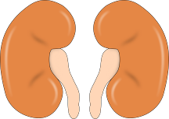
The kidneys also control the level of solutes (dissolved substances) in our blood. Although glucose is present in the filtrate from the glomerulus, it is not usually present in urine. Glucose is re-absorbed into the blood stream. It is moved into the capillaries by active transport.
Sodium chloride is also moved out of the kidney tubules by active transport. Unlike osmosis and diffusion, active transport requires energy to 'carry' the salt molecules across the cell membrane. So, although they are relatively small organs, the kidneys require a significant amount of energy to function.
Kidney questions

- Why do you think the word for 'bladder' originates from a word which means 'to blow'?

- Many small structures found inside the body have names which were first used in the 1600's. What invention might have contributed towards the discovery of these structures? Explain your answer by using an example.
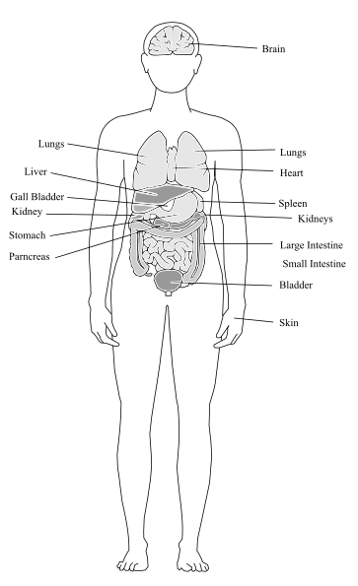
- Negative feedback is quite a tricky concept to describe. Imagine trying to explain it to your parents or carers. Can you make it simple by describing an 'every day' example of negative feedback?

- List two important functions of the kidneys.

- The job of the glomerulus is quite simple. Can you explain what it does?

- Where is most of the work of the kidney carried out?

- Kidneys make up only 0.4% of our body mass yet they use 10% of the energy produced by the body. Why is this?

- Why do we need kidneys?

Teaching notes

Activity instructions:

- Working in groups, students draw graphs from the data sheet in tables A, B and C.
- Ask them to describe in simple terms what the graphs are showing.
- Then read the text as a group or whole class.
- Students then match the graphs and tables to relevant parts of the text, providing evidence for the statements made.
- Students can then answer the questions.
Suggested answers - kidney questions

- Bladders were used as the first footballs and had to be inflated.
- The microscope was being used around this time. Many structures are too small to be seen with the naked eye, e.g. capillaries. They would have been visible for the first time under a microscope and their discoverers would have given them names e.g. the glomerulus would have looked like a ball of thread.
- You are talking too loudly in class; teacher tells you to talk more quietly; you drop the volume a bit; the teacher continues to tell you to talk more quietly until your voice is an appropriate volume; the teacher stops giving you the instruction to talk more quietly; the drop in your volume is being fed back to and monitored by the teacher who continues to issue instructions (hormones like ADH) until the appropriate level is restored.
- Removal of waste e.g. urea; regulating salt and water levels; balancing proportions of water and solutes; osmoregulation; homeostasis
- The glomerulus filters blood allowing a large proportion of blood plasma to pass out of the capillaries and into the kidney tubules. It prevents red blood cells and most proteins from leaving the blood stream.
- Further along the kidney tubule, in the loop of Henle and collecting duct.
- A large amount of blood plasma is filtered by the kidneys every hour. The filtered liquid contains dissolved substances such as ions and glucose. Most of these solutes are needed by the body and have to be re-absorbed. The solutes are moved by active transport which requires energy.
- Kidneys are essential for removing waste products from the blood stream and for maintaining the correct water/solute balance in the body

