Starter activity: Substrate – enzyme – product game

A starter activity for students to play in pairs

Instructions
Each player selects one group consisting of a substrate (nutrient), its appropriate enzyme and the product (see table 1).


- Each player has a different coloured pen.
- Using a 5 x 5 grid...
- Players take it in turns to write down one of the words from their group.
- Rather like noughts and crosses, you are trying to get a line of three whilst preventing your opponent from making a line from their three words. Simple.
- However, the words must run in a particular order: substrate-enzyme-product.
- The line of words can be read forwards or backwards; up and down; diagonally.

So, carbohydrates – carbohydrase – glucose
glucose – carbohydrase – carbohydrates
are both correct.

But, lipase – lipids – fatty acids + glycerol
amino acids – proteins – protease
are not correct.


- The winner is the person who gets the first correct row of three or the person who gets the most rows of three (see grid below).

Table 1

 | Substrate | Enzyme | Product
Group 1 | carbohydrate | carbohydrase  (or amylase) | glucose
Group 2 | sucrose | sucrase | glucose + fructose
Group 3 | lactose | lactase | glucose + galactose
Group 4 | protein | protease | amino acids
Group 5 | lipids (or fats) | lipase | fatty acids + glycerol

The winner is the person who gets the first correct row of three or the person who gets the most rows of three.

 |  | protease | glucose + fructose
 |  | sucrase
 | sucrose | protease | amino acids
proteins |  |  | protease
 |  |  | sucrose

Activity 2: Digestive enzymes – what can you deduce?

Teaching notes
Give each small group of students copies of the graphs and tables. Using just the graphs and tables, students draw conclusions about some of the enzymes involved in digestion.

Suggested responses
Some of the things students might say.
- Enzymes are specific e.g. sucrase works on sucrose but not other sugars such as lactose.
- The names of enzymes often end in '-ase' or '-sin'.
- Small intestine is main site of enzyme action.
- Pancreas produces several enzymes. (Also produces hormone insulin. What's the difference between an enzyme and a hormone? Enzyme - an organic catalyst which increases the rate of biochemical reactions. It isn't changed by the reaction. Hormone – molecules produced in one part of body which trigger a specific reaction in target tissues and organs. Hormones are changed by the reaction.)
- Enzymes reduce the amount of energy needed to start a reaction.
- The rate of an enzyme-catalysed reaction increases rapidly with increased substrate conc. Rate of increase in reaction rate soon diminishes until it levels off, remaining constant with increased substrate conc.
- Rate of chemical kinetic reaction increases in proportion to increasing substrate conc.
- Salivary amylase is most reactive at approximately 37 °C – optimum temperature.
- Pepsin works best in acid conditions. Breaks down proteins in stomach. Trypsin continues break down of proteins in small intestine. Trypsin works best in alkaline conditions – optimum pH. (Why don't proteases such as pepsin and trypsin digest the wall of the stomach/intestine? Both enzymes are secreted as slightly different substances which are altered by and become active in, the acid/alkaline conditions of the stomach/small intestine.)

Digestive enzyme | Substrate | Product | Location
Amylase | starch | sugars | mouth
Sucrase | sucrose | glucose + fructose | villi in small intestine
Lactase | lactose | glucose + galactose | small intestine
Pepsin | protein polypeptides | protein peptides | stomach
Trypsin | protein peptides | amino acids | small intestine
Lipase | fats | fatty acids + glycerol | small intestine


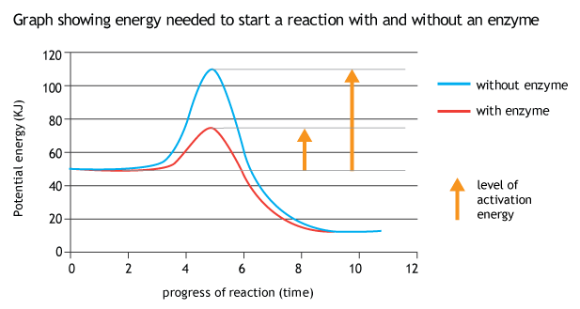


Digestive enzyme | Site of production | Site of reaction
Amylase | salivary glands | mouth
Sucrase | villi | small intestine
Lactase | pancreas | small intestine
Pepsin | mucosal lining of stomach | stomach
Trypsin | pancreas | small intestine
Lipase | pancreas | small intestine

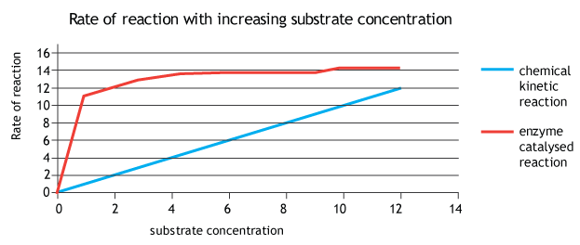

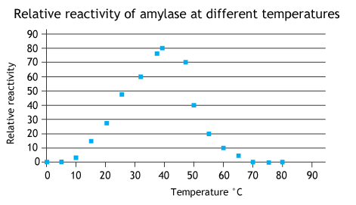

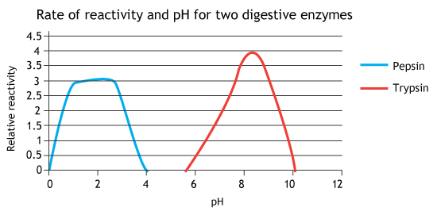

Activity 3 - comparing a chemical kinetic reaction with an enzyme catalysed reaction

Teaching notes
Students may be familiar with this graph from Activity 2.

Students describe what the graph is showing. This may begin simply with comments about the title, axes, what each coloured line represents, the (lack of) units or they can go straight into describing the relationship between substrate concentration and rate of reaction for each type of reaction and comparing the two.

They then read the description of a model (Activity 3 – student sheet) which helps to explain the shape of the enzyme-catalysed reaction and answer a few questions.

Some suggested answers:

- The enzyme molecules
- The substrate
- The products of the reaction
- The enzyme-substrate complex
- The children's hands
- The reaction
- I was looking for the idea that the children are actively seeking the sweets. It's not just a random collision.
- This was quite tricky – something that splits apart on contact e.g playing conkers; dodgem cars at fairground becoming entangled when they make contact??

Activity 3 – student sheet

Comparing a chemical kinetic reaction with an enzyme catalysed reaction

The graph shows to types of reaction. To explain the difference between these two types of reaction, we could use the idea of a room with wrapped sweets scattered across the floor to demonstrate an enzyme-catalysed reaction. Imagine a crowd of children are released into the room. Their job is not to eat the sweets but to unwrap them as quickly as possible, leaving the chocolates and wrappers on the floor.

Initially, the more sweets there are in the room the faster they will be unwrapped. However, there comes a point, quite soon, when the rate of unwrapping begins to level off despite there being more sweets in the room. This is because the children are occupied whilst they unwrap a sweet. During this time they cannot move on to another sweet.

In the more 'usual' chemical reaction the reaction relies on the substrate particles colliding with one another. The higher the concentration of particles the greater the chance is of a collision.

Answer the following questions about the enzyme reaction model.
  - What do the children represent is this model of an enzyme-catalysed reaction?
  - Which component of the reaction do the sweets represent?
  - How about the separated chocolates and wrappers?
  - What does the child plus sweet combination represent?
  - Where is the active site?
  - What is being modelled when a child is occupied in unwrapping a sweet?
  - In what ways does a child doing this activity behave differently to an enzyme?
  - Can you think of a model to demonstrate a chemical kinetic reaction?

Activity 4: Comparing catalysts and enzymes

Teaching notes

This is useful as a starter activity in a lesson about digestive enzymes.

Instructions
Students read the text (Activity 4 – student sheet) and list as many similarities and differences between chemical catalysts and biological enzymes as they can.
Alternatively, the paragraphs could be numbered and students in different areas of the room be given one paragraph to read and to identify one similarity/difference.

Suggested answers

Similarities | Differences
Have same properties | Enzymes more effective at increasing reaction rate
Lower the activation energy | Enzymes are more specific
Increase reaction rate | Enzymes are proteins
Unchanged at end of reaction | Some catalysts just provide a platform for reactants to stick to.
Both have active site | Enzymes are produced by living organisms
Both can combine with a chemical to make a new compound | Enzymes work best relatively low temperatures e.g. 37°C in humans

Activity 4 - student sheet

Enzymes have all the same properties as chemical catalysts. They lower the amount of energy needed to get the reaction started (activation energy), as well as increasing the speed of the reaction once it has started.

However, enzymes are more effective at this than chemical catalysts e.g. the decomposition of hydrogen peroxide (H2O2), is accelerated 3 x 10⁴ times in the presence of ferric ions which act as a catalyst; but it is accelerated 1 x 10⁸ times in the presence of the enzyme catalase.

Chemical catalysts tend to work on a wide range of reactions, whereas enzymes are usually very selective and only bind to one specific substrate.

Like catalysts, enzymes are not permanently altered by the reaction and can be re-used. Almost all consist of proteins which are large molecules with a complex structure. Many catalysts are ions, elements or quite simple inorganic compounds. Because they are produced by living organisms, enzymes work best at relatively low temperatures. Catalysts generally require high temperatures or pressure to be effective.

Catalysts work in two main ways. In one, the reactants stick to the surface of the catalyst (active site) and move around increasing the chance that they will collide and so react e.g. platinum catalyst in the catalytic converter of a car. In the second way, the catalyst combines with a chemical to make a new compound. This is unstable and quickly breaks down releasing a different new compound and the catalyst. This is also how many enzymes work. Such a catalytic reaction is responsible for the depletion of ozone in the atmosphere.

