Task 1
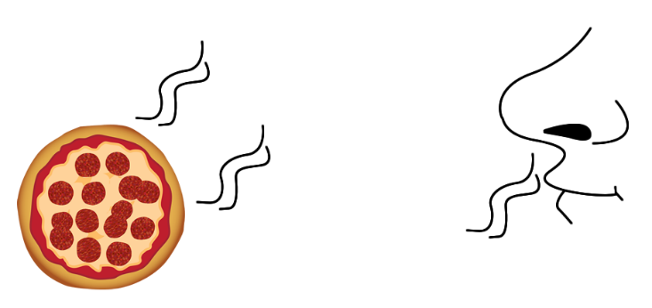
There is nothing better than the smell of a delicious meal when you walk through the door, but how does the smell reach your nose?
- Write down your ideas.

- Match up the word diffusion to the correct definition.
 |  | … is when a gas hits a cold surface and turns into a liquid.
Diffusion … |  | … is when a heated liquid turns into a gas.
 |  | … is the movement of particles from a place where there are a lot of them to a place there are fewer of them.

- The first diagram shows the particles as soon as the pizza is put out. The black dots represent the ‘smelly’ particles and the white dots represent air particles.

Complete how the particles would look in the second diagram after 10 minutes.
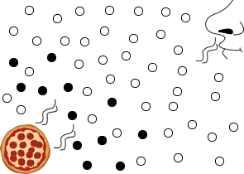 |  | 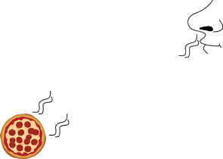
After 0 minutes |  | After 10 minutes

Task 2

The pictures below show a diffusion experiment where a tea bag was placed in a glass of hot water and a glass of cold water. A photograph of the experiment was taken every 20 seconds.

- Cut out the pictures and place them in the correct order and match the correct time to each picture

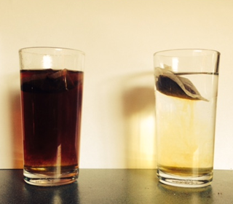 | 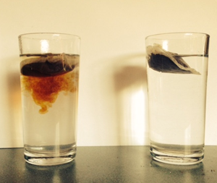 | 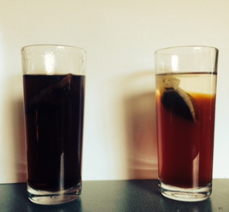
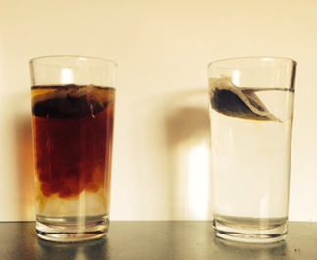 | 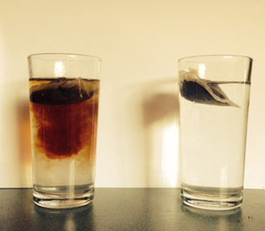 | 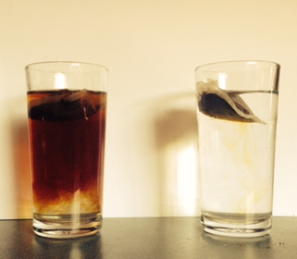
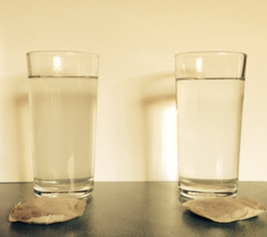 | at 0 seconds | at 20 seconds
 | at 40 seconds | at 60 seconds
 | at 80 seconds | at 100 seconds
 | at 120 seconds

- Complete this write-up of the experiment by crossing out the incorrect words.

- This experiment was set up to investigate how temperature affects diffusion / evaporation in liquids / gases.
- The glass on the left / right is the one with the hot water in it. I know this because this is the glass where diffusion happened faster / slower.
- Diffusion happens faster / slower in hot liquids and gases because when the particles are hot they have more / less energy and move round more so the particles spread out faster.
- Diffusion still happens in cold liquids but it happens slower / faster.

- Look at the statements below. Use the column on the right to indicate whether you think the statement is true or false.
Statements about diffusion | True or false?
Diffusion can happen in solids.
Diffusion happens faster in warm fluids than in cold.
Diffusion is where the particles spread out randomly.
Making a cup of tea is not an example of diffusion.
Smells travel by diffusion.

Teaching notes and answers
Task 1
- Diffusion is the movement of particles from a place where there are a lot of them to a place there are fewer of them.
- Black and white dots should be evenly dispersed.

Task 2

- This experiment was set up to investigate how temperature affects diffusion in liquids.
- The glass on the left is the one with the hot water in it. I know this because this is the glass where diffusion happened faster.
- Diffusion happens faster in hot liquids and gases because when the particles are hot they have more energy and move round more so the particles spread out faster.
- Diffusion still happens in cold liquids but it happens slower.

Statements about diffusion | True or false?
Diffusion can happen in solids. | false
Diffusion happens faster in warm fluids than in cold. | true
Diffusion is where the particles spread out randomly. | true
Making a cup of tea is not an example of diffusion. | false
Smells travel by diffusion. | true

