You are going to test some chemicals to find out how the different colours in fireworks are made.

Fireworks contain three ‘ingredients’:

- A chemical which will burn, called a fuel.
- Another chemical that will give oxygen to help the burning, called potassium nitrate.
- A chemical that gives a bright colour when it burns.
Task 1 - choosing the colour
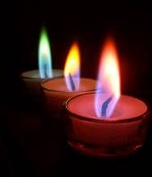
You will try putting some different metal compounds into a flame. Read the instructions on how to do a flame test.

Watch the coloured flames that you get with the different chemicals.

© Darcie Tanner 2006 flic.kr/p/cMrks

Instructions - how to do a flame test with a wooden splint
(The wooden splints have been soaked overnight in distilled water.)
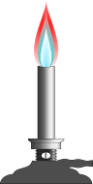
- First, put on safety specs and take a damp splint.
- Dip it into the powder you are testing, move the splint through the flame. (Do not hold the sample in the flame as this would cause the splint to catch fire).
- Notice what colour you see (if any). Compare it to the chart below. Throw the splint away.
Metal | 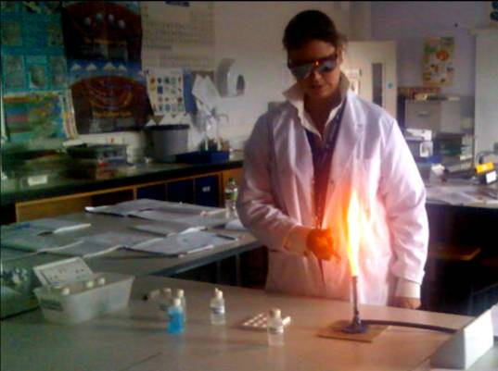  Flame colour
calcium | orange-red
copper | blue-green
Sodium | orange
potassium | violet
zinc | greenish-white
© Tess Watson 2007 flic.kr/p/xx8Uo

Teaching notes

NB: Carry out a risk assessment before doing this activity.

The Royal Society of Chemistry has some excellent video demonstrations of fireworks and other resources:
www.rsc.org/learn-chemistry/resource/res00001145/chemistry-of-fireworks?cmpid=CMP00002195#!cmpid=CMP00002193

Technician notes

Equipment per group:
- heatproof mat
- Bunsen burner
- x10 wooden splints soaked in distilled water overnight
- a range of metal salt powders for flame tests.

