Enzymes are:  - Protein molecules  - Biological catalysts and increase the rate of chemical reactions  - Affected by temperature and pH.  - Found in animals, plants and microorganisms.  - They break large molecules into smaller molecules.  - They have a specific shape to fit a particular substrate. |  |  |  | Factors affecting enzyme action  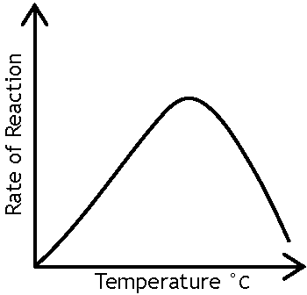  1. Temperature  Enzymes work faster as the temperature increases.  They have an optimum temperature at which the rate of reaction is at its fastest.  At higher temperatures the rate of reaction decreases as the enzymes become denatured.  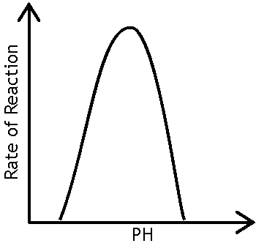  This is because the shape of the active site is lost and they are not  able to form an enzyme-substrate complex.
2. pH
Changes in pH affect the shape of the active site.
Enzymes have an optimum pH.
Enzymes in digestion  Enzymes break down large insoluble food molecules into smaller soluble ones which can be absorbed through the small intestine wall to enter the bloodstream. |  |  |  |  |  |  |  |  |  | Enzymes revision
 |  |  |  |  |  |  |  | Product | Enzymes |  | Explanation
Substrate | Enzyme | Product |  |  | Where enzyme is produced | Optimum pH |  | Biological washing powder | lipases and proteases |  | Digest biological stains off clothes
Starch | amylase  (a carbohydrase) | glucose |  |  | salivary glands & pancreas | 7 |  | Baby food | protease |  | Pre-digest protein to make digestion easier for babies
Protein | trypsin  (a protease) | amino acids |  |  | stomach, pancreas, & small intestine | 3 |  | Slimming foods | isomerase (carbohydrase) |  | Converts glucose into fructose (less of which is needed to sweeten food)
Lipids | lipases  (fats) | fatty acids & glycerol |  |  | pancreas | 8

Enzymes are: |  |  |  | Factors affecting enzyme action
Enzymes in digestion |  |  |  |  |  |  |  | Commercial use of enzymes
 |  |  |  |  |  |  |  | Product | Enzymes | Explanation
Substrate | Enzyme | Product |  |  | Where enzyme is produced | Optimum pH

Teaching notes
Use as an information mat or poster when students are practising exam questions.
Have one copy in the middle of the room, put the students in groups and ask them to fill in a blank copy of the sheet by taking it in turns to visit the mat and bring back one piece of information.
It could be used as a revision exercise for students to fill in themselves.

Differentiation
Make differentiated versions of the sheet by filling in some of the information. For extra challenge give students a version with errors in it and ask them to proofread it and then fill in a blank sheet with the corrections.

