Definition of a species:
What is monoculture?
What is sustainability?

What does biodegradable mean?

Draw a diagram of the carbon cycle

Include these words:

- photosynthesis
- respiration (twice)
- decay
- combustion
- decomposing

Extinction rates are increasing due to:

New species evolve due to:

Describe the process of natural selection:
Evolution and ecology
Look at the diagram below and name a:

producer: predator:

What might the shrews be competing for?

Who would be at risk if the caterpillars died out?

This diagram is called a:
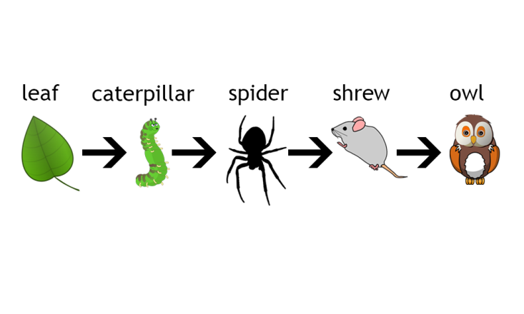
We can change the features of a species by:
The two scientists with different theories about the changes in species were:

Using similarities and differences between living things to put them into groups is called:

What is a habitat?

New species form when their environment changes. This happens because of:

Scientists measure environmental changes by looking at indicator organisms.
Increase in fertiliser run off leads to an increase in -
These animals are only present in clean water -

Plant sensitive to air pollution -

What is the definition of extinction?

What’s the difference between local and mass extinction?

Evidence for evolution comes from:

F
D

Nitrogen cycle involves the processes of:

Why do we need biodiversity?

Evolution and ecology
Not all of the energy at each stage of the food chain is passed on. What happens to the rest of it?

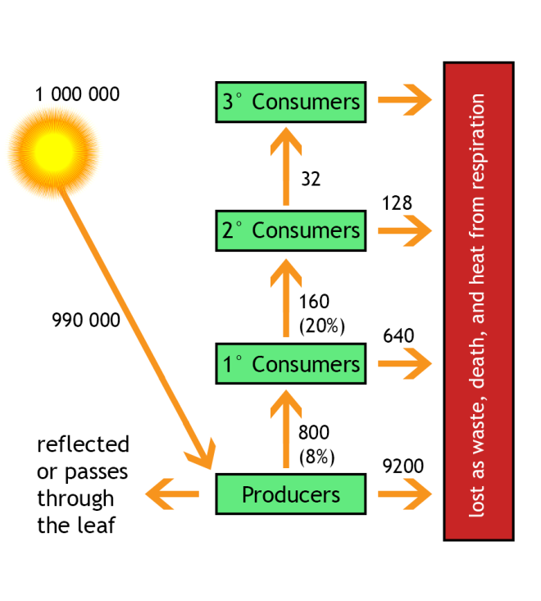
What is an adaptation?

Give examples of an adaptation to:
a. hot place

b. cold place

Name for the process by which species change over time:

Carbon cycle involves the processes of:

What is the ultimate source of energy?

Suggested answers
New species evolve due to:
Mutation, genetic variation, isolation, natural selection, speciation
We can change the features of a species by:
Natural selection
The two scientists with different theories about the changes in species were:
Lamarck, Darwin/Wallace
Carbon cycle involves the processes of:
Photosynthesis
Respiration
Combustion
Decay

Extinction rates are increasing due to:
Human activity causing increasing rates of habitat loss and climate change

Describe the process of natural selection:
Variation within a species, individuals with favourable characteristics survive to reproduce and pass genes onto next generation.
Look at the diagram below and name a:

Producer: plant Predator: spider/shrew/owl

What might the shrews be competing for? Food - spiders, space, water

Who would be at risk if the caterpillars died out? The rest of the food chain – spiders/shrews/owls

This diagram is called a: food chain

Evolution and ecology
Nitrogen cycle involves the processes of:

Nitrogen
Fixation
Decay
Denitrification
What is monoculture?

Cultivation of a single crop
What is sustainability?
Maintaining a balance by avoiding depletion of natural resources
What is a habitat?
The natural environment in which an organism usually lives
Definition of a species:
A group of organisms that can produce fertile offspring
What does biodegradable mean?
Can be decomposed by microorganisms

Using similarities and differences between living things to put them into groups is called:
Classification
New species form when their environment changes. This happens because of:
Natural selection
Scientists measure environmental changes by looking at indicator organisms.
Increase in fertiliser run off leads to an increase in algae.
These animals are only present in clean water – mayfly larva/freshwater shrimp
Plants sensitive to air pollution:
lichens
Name for the process by which species change over time:
Evolution
What is the definition of extinction?

The dying out of a species

What’s the difference between local and mass extinction?
Mass extinction is a period when unusually large numbers of species die out whereas local extinction is when a species ceases to live in an area but still exists elswhere
What is adaptation?
A characteristic that has developed over time that allows an orgaism to live successfully in its habitat.
Give examples of an adaptation to:
a. hot place: cactus – leaves reduced to spines to reduce water loss

b. cold place: polar bear – fat layers as insulation

Not all of the energy at each stage of the food chain is passed on. What happens to the rest of it?
Lost in waste materials / heat energy
Energy released by respiration is used for movement

Not all of the energy at each stage of the food chain is passed on. What happens to the rest of it?
Lost in waste materials / heat energy
Energy released by respiration is used for movement

Why do we need biodiversity?
For global food security, increased gene diversity reduces risk of disease, development of medicines etc

What is the ultimate source of energy?
The Sun

