
All school grounds are habitats for some living things. As far as a plant is concerned a school wall is just a rock face and any plants that are adapted to such a habitat will happily colonise it. Look around the school grounds for possible plant populations for students to investigate.

Suggested plant investigations
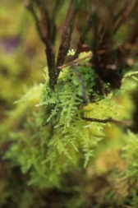
- Are there more mosses growing on one wall but less on another?
1.
- Does the wall with more moss on face in a particular direction? Why might that be?
- Mosses are plants so they need light to photosynthesise but they also have tiny leaves and dry out and die really quickly if there is not a ready supply of water. Does that affect the walls that the mosses colonise?
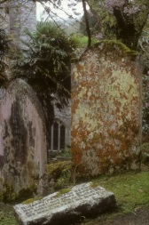
- What direction does the wall face? Why would that be important? Do they face a prevailing wind direction and why would that be important? Is the best wall a compromise or is one factor more important than the other?
2.
- Are there lichens within the school grounds? For example, the crusty yellow lichen called Xanthoria is commonly found in towns and cities. Where are they found (e.g. surface type, conditions, direction, height etc.)? Students could compare with surfaces where they are not so prevalent.
- Are there different types how does their distribution compare to each other?

- Moss, Devil’s Jump, Cornwall. Copyright Tim Knight
- Lichen, St Just in Roseland Church, Cornwall. Copyright Tim Knight

Before carrying out an investigation discuss with students:
- what they are trying to find out
- the data they could collect
- which methods they could use e.g. transect, random sampling
- how the data could be presented, e.g. line graph, bar charts etc.
- the research they could do to inform their conclusions and evaluation e.g. identifying and finding out about the species they are studying.

Evaluation discussion
- Was the experiment a fair test?
- Why are ecosystem investigations hard to control?
- How many results would be needed to be reasonably sure about the conclusions made?
- Have they taken enough results?
- Would the results be different at different times of the year? Why would that be?

