Task
Read the following article and answer the questions.

Imagine a vivid red light.
Now think of a time when you were younger and hurt yourself; perhaps you fell over and grazed your knee, or scalded yourself whilst helping in the kitchen.
Imagine simply shining a red light on the injury and the wound healing more quickly than usual! This really does work. Not in seconds or hours, that still only occurs in science fiction, but shining a certain type of red light onto a wound does speed up healing time.
The light in question is deep red (close to the infra-red part of the electromagnetic spectrum). It has a wavelength of 670 nanometres and it causes the mitochondria in cells to release more energy (ATP).
How does it do this?
At first, scientists speculated that the red light affected the enzymes found in mitochondria by speeding up their activity.
However, the most recent research reveals that it is water which is affected by the red light. Water seems to become less viscous (sticky) under this wavelength of light.
The light causes each water molecule to move slightly further away from its neighbour, making water 'runnier'. Cells are full of water and it seems enzymes in mitochondria work more easily when they are surrounded by water which is more fluid.
Scientists are investigating how this effect could be used to help heal skin wounds and burns. It may also be used to help treat some cases of infertility in males.

Questions
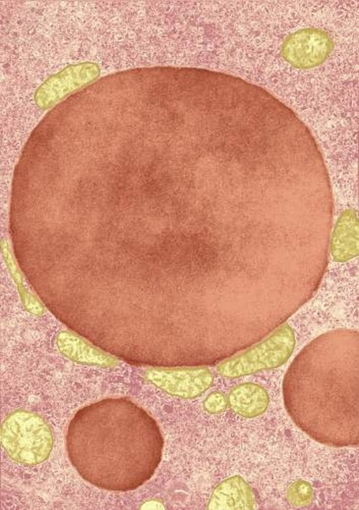
- What are mitochondria?
Mitochondria / Credit: Don W. Fawcett / Photo Researchers / Universal Images Group / Copyright © © Photo Researchers / For Education Use Only. This and millions of other educational images are available through Britannica Image Quest. For a free trial, please visit www.britannica.co.uk/trial
- What is the role of mitochondria in cells?
- Describe what you know about infra-red light.
- Would the deep red light described in the text be visible to our eyes? Can you explain your answer?
- Is this light safe to use in this way?
- What does 'viscous' mean?
- Think of six liquids you might find at home.
List them in order of viscosity.
- Draw a diagram to show the effect of shining deep red light on water molecules.
- Why would the release of more energy by mitochondria speed up healing?
- Can you suggest how this effect might be used in the treatment of infertility in males?

Teaching notes
This activity can be used as a starter or discussion point within a lesson.

The text links to Physics: electromagnetic spectrum; Chemistry: properties of water and behaviour of molecules and Biology: role of mitochondria and enzymes in cells.

Students read a short article. The questions can be used as discussion prompts or for written answers.

Suggested answers
Structures found in the cytoplasm of cells.
- Mitochondria are structures found in all cells.
- They are responsible for releasing energy for the cell.
- Answers will vary
- Yes, as it is part of the visible spectrum.
- Yes, it is ordinary red light which can be seen by our eyes without causing damage.
- Viscous is used to describe liquids and refers to how easily a liquid flows. A viscous liquid is sticky and flows slowly.
- Answers will vary
- Particle diagram showing water molecules still touching one another as in a liquid but with more room between them.
- The increased amount of energy released would enable cells/enzymes to work faster.
- Some sperm swim very slowly. This treatment would enable the mitochondria to release more energy which would enable sperm to swim more vigorously.

Information sources
- www.elixa.com/about-led/
- www.ncbi.nlm.nih.gov/pubmed/18177400

