Task
Read the text below and then answer the questions in full sentences.
 | lines
Atoms may form molecules. A molecule consists of two or more atoms joined together. | 1 - 2
If atoms are of the same element, they form molecules of the element. If atoms of two or more elements are joined together by chemical bonds, they form molecules of a compound. | 3 - 5
During a chemical reaction a different substance is made. These substances are products of the reaction. The starting chemicals are called reactants. The products can have very different properties from the reactants. | 6 - 10
A compound has a fixed composition e.g. iron sulphide (FeS) contains one atom of iron and one atom of sulphur joined together. | 11 - 12
Chemical reactions can take place between elements and compounds. There are three things to look out for that show a chemical reaction is occurring. | 13 – 15
- There may be a temperature change. Most chemical reactions transfer thermal energy to the surroundings, so we can measure an increase in temperature. | 16 - 18
- A gas is produced – bubbles show that gas is being produced. If a reaction is carried out in a beaker placed on a mass balance, then the mass of the beaker will go down as the gas produced escapes into the air. | 19 - 21
- There may be colour change. | 22

Questions
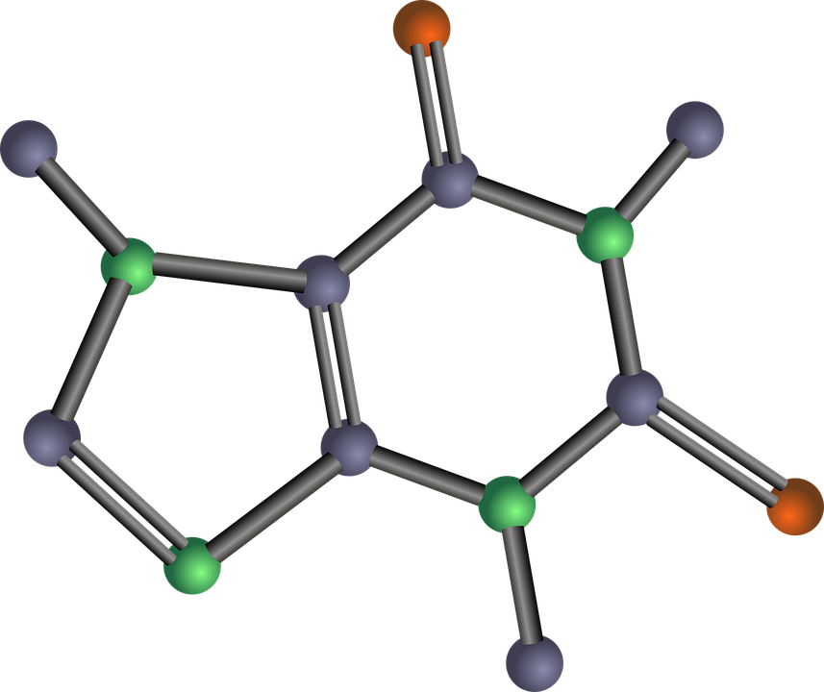
- What is a molecule?
- What does molecule of a compound mean?
- What does molecule of an element mean?
- What are the chemicals called at the start and end of a reaction?
- What does having a fixed composition mean?
- Name three signs of a chemical reaction.
- Why might the mass go down during some reactions?
- Are the properties of reactants and products the same?
- Some reactions cause a decrease in the temperature of the surroundings. Carefully read lines 16 –18 to help you suggest what might cause this.
- Explain why there might be a colour change in a reaction.

