Arctic hare
How is the artic hare adapted to live in the Arctic?
It has small ears so that | 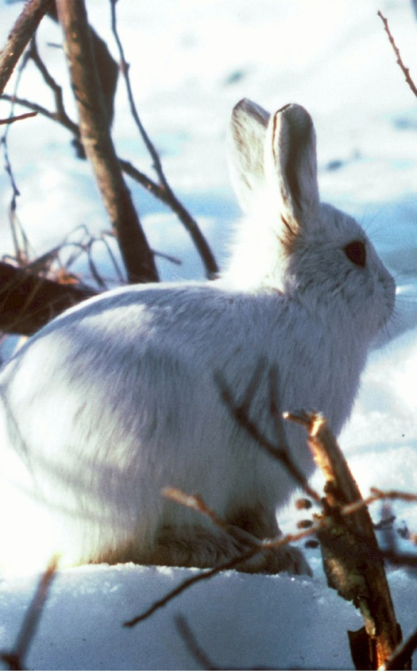 | It has white fur so that
It has large feet so that |  | It has thick fur so that

Camel
How is the camel adapted to life in hot deserts? (It does not store water in its hump – it’s actually a store of fat). |  | 

