Teaching notes
The objectives are to know how to use a quadrat, how to estimate numbers of organisms and to suggest why distribution of organisms may be uneven. It is suitable for Key Stage 3 and GCSE students. The Word document and the PowerPoint should be used together.
Slide 2 introduces the concepts of quadrats using paving slabs. There is a patio worksheet (page 2) students can complete or the exercise can be completed as a group using the PowerPoint.

Slide 3 and 4 introduce the idea of sampling a field. It would help if you have a real quadrat to show to students. Students throw the cardboard quadrat onto the field and count the number of daisies and dandelions. Before the lesson, print pages 4 and 5 and stick together to make the field. Alternatively print page 6 onto an A3 sheet. Quadrats can be made of card with a 4cm square window. A quadrat template is provided (page 3).
Slide 5 asks students to calculate the number of each plant in the whole of the field.
Ask each group to write their result on the board.

If you are not using the PowerPoint then the activity can still be carried out. Ask students to randomly throw their quadrat 10 times onto the field. They should count the number of dandelions and daisies inside it (if only part of the plant is inside the quadrat, it still counts). They should record their results in a table. Ask students to calculate the average number of each plant in a quadrat. If each quadrat is 1 m², estimate the number of each type of plant in the whole field (70 m²). Gather the class results together on the board and ask questions such as; why are everyone’s results different?, why are there areas where no plants are growing?, why should quadrats be thrown randomly? Etc.

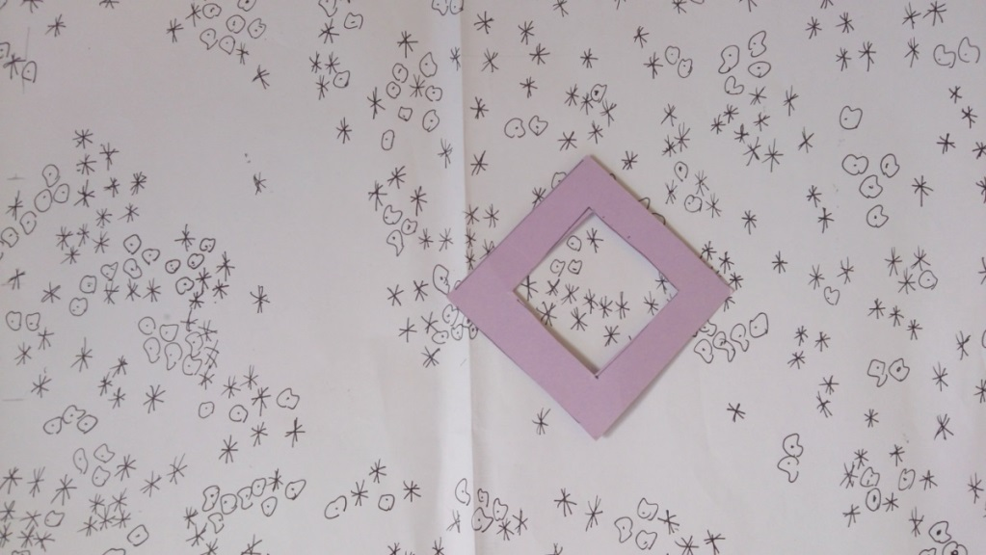

Answers – estimating the number of organisms on a patio
- ladybird – 15, spider – 10, worm - 6
- 10 square meters
- ladybird 30 spider 20 worm 12
- ladybird 1.5 spider 1 worm 0.6
- ladybird 75 spider 50 worm 30

Task - estimating the number of organisms on a patio
Jay’s patio is made up of 10 paving slabs. Each paving slab measures 1 square metre




Key
Ladybird |  | Spider |  | Worm | 

- How many of each type of organism live on the patio ?
ladybird spider worm

- How big is Jay’s patio ?

- Jay’s next door neighbour has a patio that is twice a big as Jay’s. Estimate how many of each type of organism might live on Jay’s next door neighbours patio
ladybird spider worm

- What is the average number of each organism per paving slab on Jay’s patio?
ladybird spider worm

- Estimate how many of each organism would be found on a patio that was made of 50 paving slabs.
ladybird spider worm

Quadrats template






