Task 1

Use the information sheets and demonstration equipment to identify key information about white light and the splitting of white light.

You should include the following in your key information:

- the name of a piece of equipment that can be used to split white light
- a description of how a prism affects white light
- notes to explain why a prism splits light into the colours of the spectrum.

Write an article for a newsletter aimed at Year 6 students. You should describe white light and explain how it can be split into the colours of the spectrum.

Emerging | Developing - secure | Mastery
Give the name of a piece of equipment that can be used to split white light. | Describe how a prism affects white light. | Explain why a prism splits light into the colours of the spectrum.
Equipment that can be used to split white light includes … | A prism is…  It affects white light by…  The colours white light is split into include… | Challenge…  Why do you think we can see a rainbow (think about droplets of water)?
Keywords

prism spectrum dispersion refracted speed medium angles

Task 2 - exam style question

The diagram below shows white light passing through a prism and forming a spectrum.

Ray of white light
prism
spectrum
White screen
- The spectrum contains light of all colours. Red is at one end of the spectrum, violet the other. Write the other colours in order in the spectrum.

- Explain how prisms split light.

- Use this idea about how prisms split light to explain how we see rainbows.
Review – peer assessment

Mark the work of the person sitting next to you. Identify something that went well and something that could be improved, write your comments in the last row of the table.

Well done you have … | To improve you need to …
- used keywords | - use keywords
- named a piece of equipment that can be used to split white light | - name a piece of equipment that can be used to split white light
- described what a prism does to white light | - describe what a prism does to white light
- explained how a prism is able to split white light into the colours of the spectrum | - explain how a prism is able to split white light into the colours of the spectrum
- explained why you can see a rainbow. | - explain why you can see a rainbow.
Identify something that went well:
Identify something that could be improved:

Information sheet 1

White light

White light is a mixture of many different colours.

White light can be split into a spectrum using a prism, a triangular block of glass or perspex. Light is refracted (changes direction) when it enters the prism, and each colour is refracted by a different amount. Light leaving the prism is spread out into its different colours, a process called dispersion.

Information sheet 2

White light

White light can be generated by a variety of sources both in space and by artificial sources on Earth. For example, the Sun is a source of white light. Artificial sources include fluorescent light bulbs and white LEDs which produce white light. White light is a mixture of many different colours, each with a different frequency (number of waves that pass a point in space in a time interval, usually one second).

White light can be split up into a spectrum of these colours using a prism, a triangular block of glass or Perspex plastic. Light is refracted when it enters the prism, and each colour is refracted by a different amount. This means that the light leaving the prism is spread out into its different colours, a process called dispersion.

When white light passes through a prism, it is dispersed and the different colours of the spectrum separate. Dispersion causes rainbows and the colours of the spectrum include: red, orange, yellow, green, blue, indigo and violet (lowest to highest frequency).
Dispersion happens because the different colours of light travel at different speeds in a medium such as glass. The amount of bending increases as the change in speed increases, therefore blue light bends more than red light.

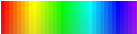
White light
Prism

Information sheet 3

Splitting white light

White light can be split into a spectrum of many different colours using a prism. This is a block of glass with a triangular cross-section. The light waves are refracted as they enter and leave the prism. The shorter the wavelength of the light the more it is refracted. As a result, red light is refracted the least and violet light is refracted the most, causing the coloured light to spread out to form a spectrum.

When a ray of light goes from one material to another, it bends. The amount of bending depends on the angle at which it strikes the surface, as well as on the difference in the speed of light in the two materials. The bigger the speed difference, the more it bends.

Prisms work because the speed of light changes as it moves from one medium to another (air to glass). The speed at which it travels causes the light to be refracted and bend. All light strikes the front of a prism at the same angle, but when it hits the back of the prism, the different colours are travelling in different directions due to the change in speed. The colours strike the back of the prism at different angles. They come out of the prism at different angles which separates then into the colours of the spectrum. This creates an effect similar to a rainbow.

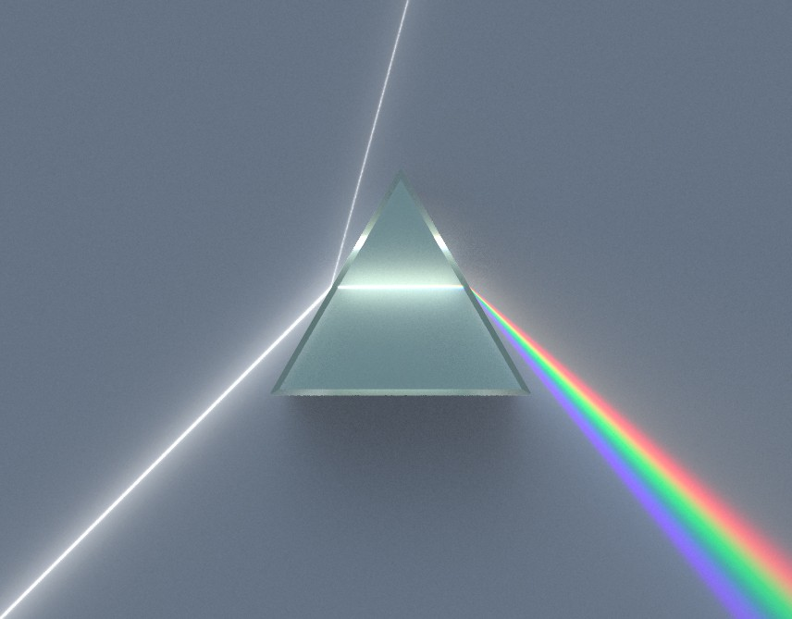

Teaching notes

Provide students the most appropriate information sheet/s according to ability for them to complete the first task. It would also be useful to set up a demonstration or practical activity of white light entering a prism (and/or show a video clip of the activity e.g. www.youtube.com/watch?v=CfVYmObSe6o (2.17 mins)).

There is also a peer assessment sheet to use at the end of the task.

Answers

Task 2

- Red, Orange, Yellow, Green, Blue, Indigo, Violet

- Light is refracted when it enters the prism, and each colour is refracted by a different amount. This means that the light leaving the prism is spread out into its different colours, a process called dispersion.

- Rainbows form when the rain drop acts like a prism. When refraction takes place in a prism the source of light is on one side and the refracted light leaves the raindrop, just like they would a prism having been spilt into the colours of the spectrum.

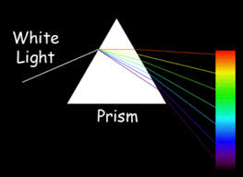
©Von Dispersive_Prism_Illustration_by_Spigget.jpg: Spiggetderivative work: Cepheiden (talk) - Dispersive_Prism_Illustration_by_Spigget.jpg, CC BY-SA 3.0, commons.wikimedia.org/w/index.php?curid=12098156 , de.wikipedia.org/wiki/Prisma_(Optik)#/media/File:Dispersive_Prism_Illustration.jpg
White light
Prism

