Task 1
Use the websites and other information provided by your teacher to complete the following.
How many species do scientists think have ever existed on Earth?

Only a few million species exist on Earth at present. The rest have become extinct. What is extinction?

What has been the main cause of extinction throughout the history of Earth? Why?

How does extinction occur by natural selection? Make a flowchart of the process.

What destroyed the dinosaurs?
When did dinosaurs become extinct?

What catastrophic event do scientists believe caused this?

Why would this event have caused extinction of dinosaurs?

Task 2
Discuss with your partner possible causes of extinction. The pictures are there to give you a clue.
Picture clue | Causes of extinction
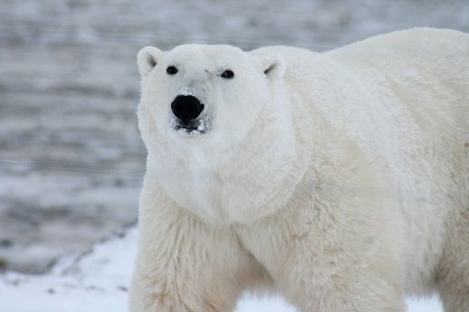
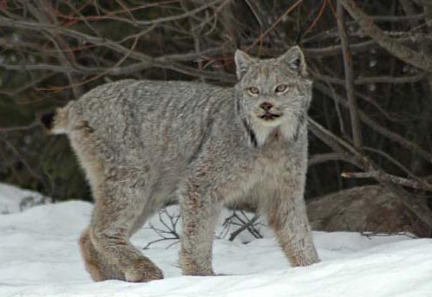

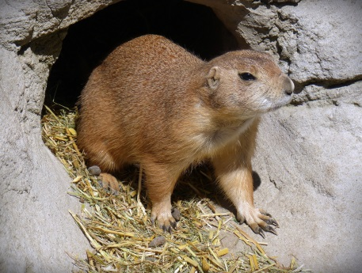
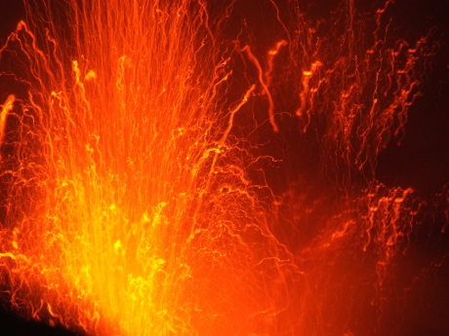

How could we prevent extinction of endangered organisms?

Extension Task

Read the document from Scientific American ‘Will cloning ever save endangered animals?’

(scientificamerican.com/article/cloning-endangered-animals/).

Use the information in the article to:
Either

- create a timeline of scientific progress in cloning.

or

- evaluate the statement ‘Extinction of endangered organisms could be prevented using cloning’.

How could we prevent extinction of endangered organisms?

Extension Task

Read the document from Scientific American ‘Will cloning ever save endangered animals?’

(scientificamerican.com/article/cloning-endangered-animals/).

Use the information in the article to:

Either

- create a timeline of scientific progress in cloning.

or

- evaluate the statement ‘Extinction of endangered organisms could be prevented using cloning’.

Teaching notes
Use the PowerPoint presentation to show images for starter activity and to help structure the lesson.
Task 1
Suggested links for research
- Dinosaur extinction http://tinyurl.com/TISE1 (science.nationalgeographic.com/science/prehistoric-world/dinosaur-extinction/)

- 5 major mass extinction events http://tinyurl.com/TISE2 (https://www.youtube.com/watch?v=FlUes_NPa6M)

- BBC Nature - Cretaceous-Tertiary mass extinction http://tinyurl.com/TISE3 (bbc.co.uk/nature/extinction_events/Cretaceous%E2%80%93Tertiary_extinction_event#intro)

- BBC - Mass extinction theories http://tinyurl.com/TISE4 (bbc.co.uk/nature/extinction_causes)

- BBC Bitesize – Extinction http://tinyurl.com/TISE5 (bbc.co.uk/schools/gcsebitesize/science/add_aqa/speciation/old_new_speciesrev4.shtml)

Suggested answers

How many species do scientists think have ever existed on Earth?
Over 5 billion

Only a few million species exist on Earth at present. The rest have become extinct. What is extinction? The process by which species die out – when there are no remaining individuals of a species left.

What has been the main cause of extinction throughout the history of Earth? Why? Mass extinctions - due to large scale environmental changes.

What destroyed the dinosaurs?
When did dinosaurs become extinct? Sixty-five million years ago

What catastrophic event do scientists believe caused this? The impact of a comet or asteroid (this came after a decline in species over millions of years due to flood basalt eruptions).

Why would this event have caused extinction of dinosaurs? Causing climate change by blocking out sunlight
Task 2

Use the PowerPoint to show students the answers.
Extension task
This links to section 4.1.2.3 Stem cells of the new GCSE Biology specification.
‘Rare species can be cloned to protect from extinction.’
Provide students with the link or print the article for them.
www.scientificamerican.com/article/cloning-endangered-animals/

Assessment for learning

This specimen paper has a 6 mark question about the causes of extinction.
Question paper - filestore.aqa.org.uk/subjects/AQA-BIOL-W-SQP-2F.PDF
Mark scheme - filestore.aqa.org.uk/subjects/AQA-BIOL-W-SMS-2F.PDF

© Oregon State University, 2011, flic.kr/p/ahJgYB
© Niaid-hiv-virion-mod.jpg: US National Institute of Health derivative work: Blleininger (Niaid-hiv-virion-mod.jpg) [Public domain], via Wikimedia Commons, upload.wikimedia.org/wikipedia/commons/f/f9/Niaid-hi-virion-mod.svg

