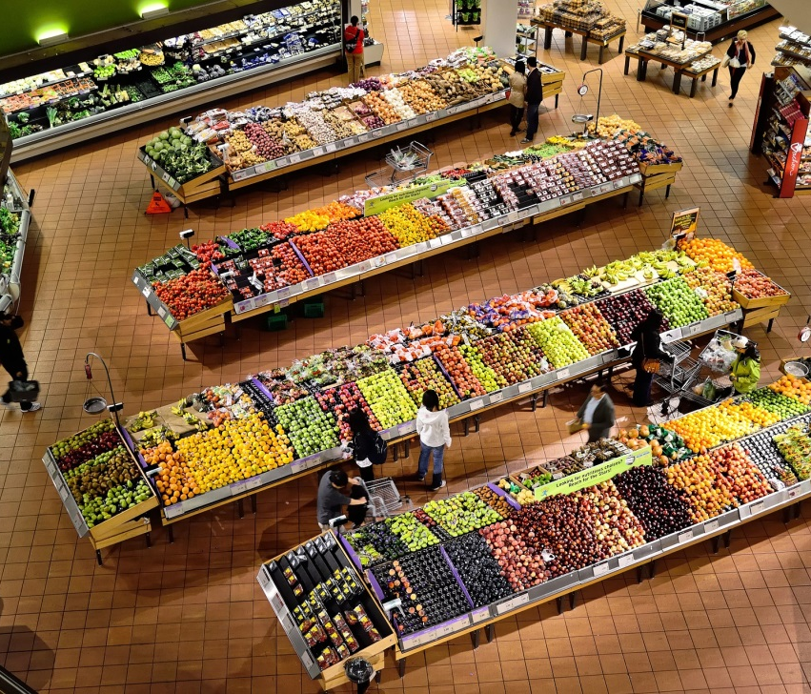
Supermarkets can stock around 90 000 different products. How do you as the customer, find what you want?
Imagine if shops grouped their products into only two categories such as 'fresh' and 'preserved' or 'vegetable' and 'meat'. It could take a long time to find a tin of baked beans!
Of course, supermarkets are much more sophisticated than that, after-all they want happy shoppers at the end of the day.
Just like supermarket bosses, scientists like to order things into groups. This is called classification. The natural world contains maybe 8.7 million species of plants, animals and micro-organisms. That's a lot of organisms to sift through if you want to find out what the creature you saw at the sea-side is.
Use the information provided to reveal how developments in science and technology have enabled scientists over the years to produce a more refined method of classifying living organisms.

Task
- Use Table 1 and some graph paper to help you construct an accurate timeline for the history of classification.

- What do you notice about your timeline?
- Why do you think this is?

- Add the developments outlined in Table 2 to your timeline.
Choose a development and describe the influence it had on classification.

- Cut out the images provided or find your own and add them to your timeline to illustrate the methods of classification.
Table 1: Important dates in the development of a method of classification for living things

Scientist | Date | Method of classification
Aristotle | 384-322 BC | All living things divided into plants and animals. Animals were further divided into swimming, flying and walking.
Andrea Cesalpino | 1519-1603 | Classified plants according to their fruits and seeds.
Carl Linnaeus | 1707-1778 | Grouped organisms into two kingdoms: plants and animals.
Ernst Haeckel | 1870's | Produced the first example of an evolutionary tree (called ‘The tree of mammals’).
Edouard Chatton | 1937 | In 1937 Edouard Chatton divided organisms into prokaryotes and eukaryotes. His work was forgotten until the 1960s.
Many scientists | 1950s | Scientists agreed to have five kingdoms: plants, animals, fungi, protists and bacteria.
Carl Woese | 1977 | In 1977 Carl Woese proposed a '3-domain system' of Archaea (primitive bacteria living in extreme environments), Bacteria (referred to as true bacteria) and Eukaryotes (all other organisms including protists, fungi, plants and animals).

Table 2: Important developments which have contributed towards changes in the method of classification

Date | Development
1400s | Plants were studied for their medicinal properties which were described in books known as Herbals. There was little interest in classifying animals.
1650s | The first light microscopes to magnify objects 266 times, were produced.
1859 | Darwin's 'The Origin of Species' was first published. This explained his scientific theory that organisms change and evolve over time by a process of natural selection.
1930s | The first electron microscopes were developed. These enabled scientists to study the structures inside the cells of plants, animals and bacteria. It revealed differences between the cells of bacteria and other organisms.
1970s | The process of electrophoresis enabled scientists to sequence the DNA of an organism. The evolution of the genetic code could now be investigated.

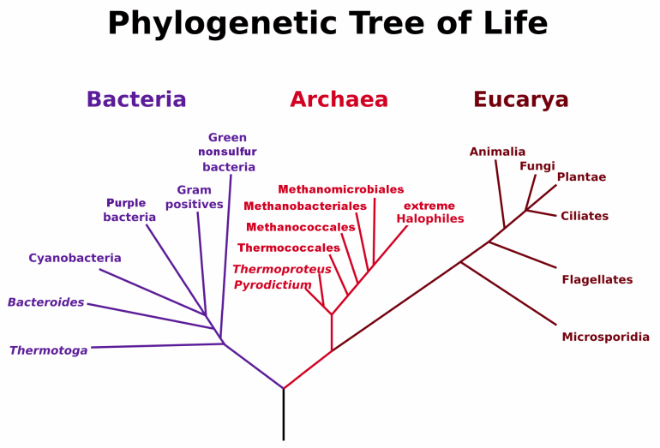 | 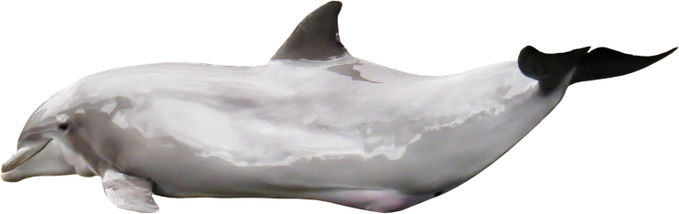 | 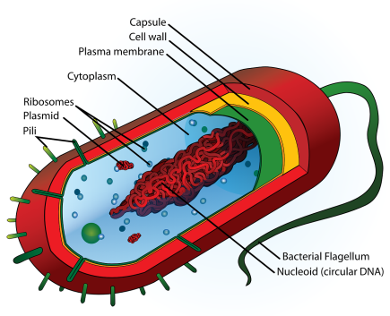
Tree of life: three-domain system. | Dolphin | Bacterial cell
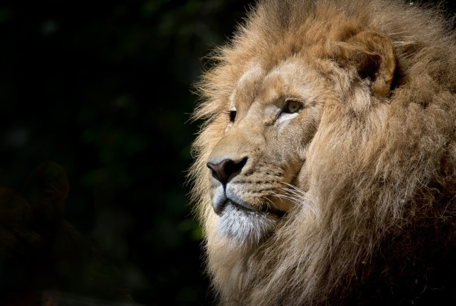 | 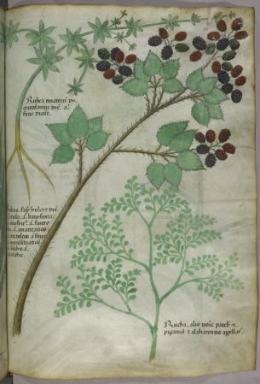 | 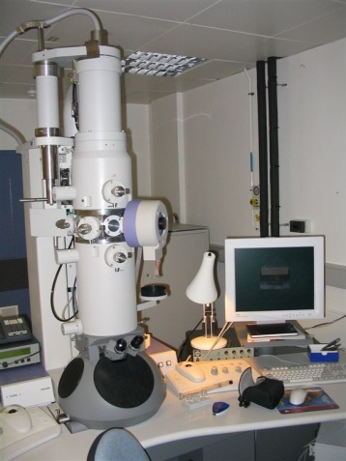
Animals | Herbal | Electron microscope

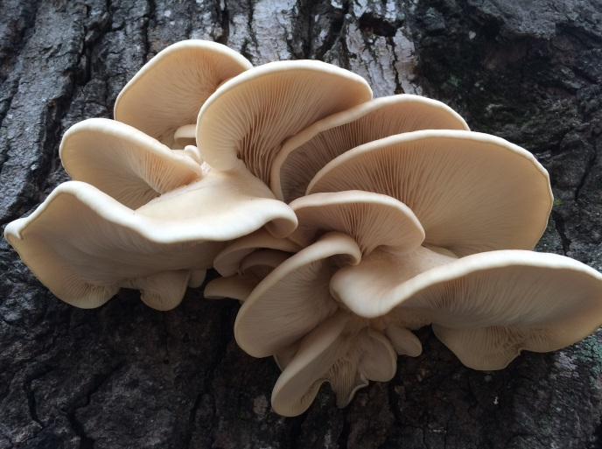 | 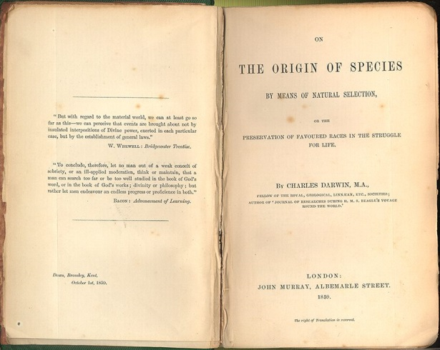 | 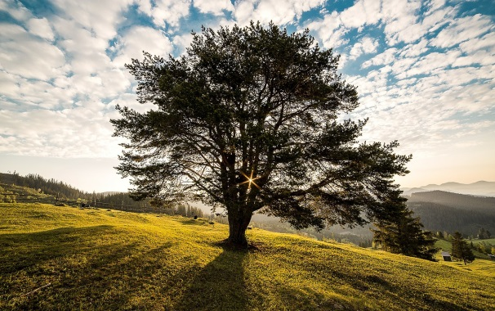
Fungi | Origin of species | Trees
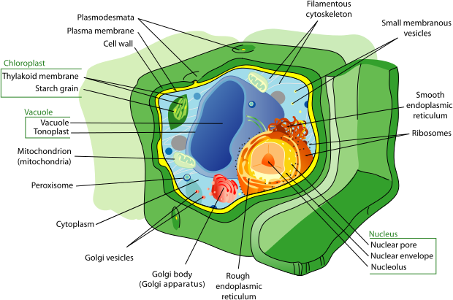 | 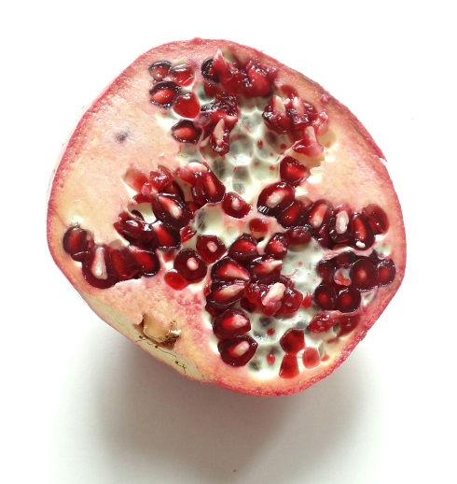 | 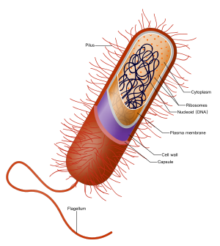
Plant cell (eukaryotic) | Fruits and seeds | Prokaryote

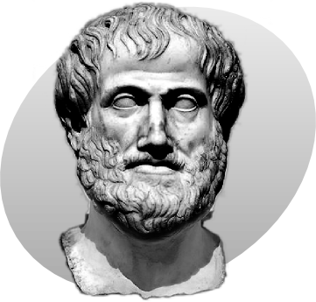 | 
Aristotle | Electrophoresis | Trees
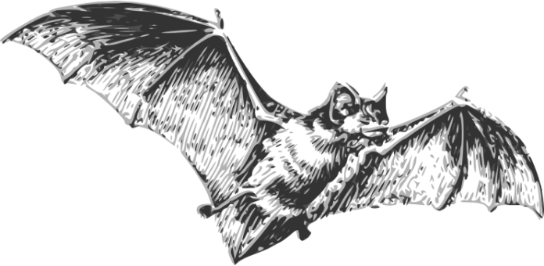 | 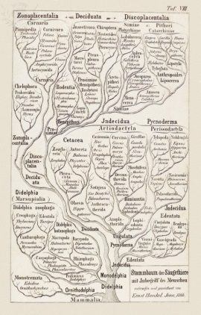 | 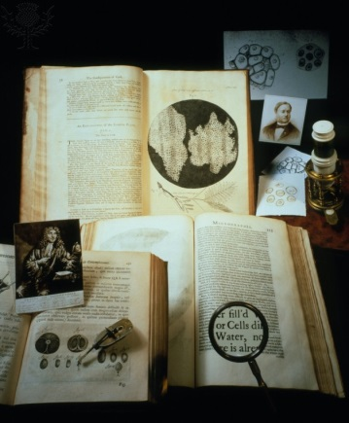
Bat | Tree of mammals | Three major figures in light microscopy

Image credits
- © Con-struct (Own work) [CC BY-SA 3.0 (http://creativecommons.org/licenses/by-sa/3.0)], via Wikimedia Commons, commons.wikimedia.org/wiki/File%3AP_Aristotle_grey.png
- © Maulucioni (Own work) [CC BY-SA 3.0 (http://creativecommons.org/licenses/by-sa/3.0)], via Wikimedia Commons, commons.wikimedia.org/wiki/File%3APhylogeneticTree%2C_Woese_1990.PNG
- © Lilly_M [GFDL (http://www.gnu.org/copyleft/fdl.html) or CC BY-SA 3.0 (http://creativecommons.org/licenses/by-sa/3.0)], via Wikimedia Commons, commons.wikimedia.org/wiki/File%3APolyacrylamid_gel_electrophoresis_apparatus-02.jpg
- Herbal. Herbal. Italy, N. (Lombardy). c. 1440. Italy, N. (Lombardy). From The National and Domestic History of England / Credit: British Library / Universal Images Group / Copyright © The British Library / For Education Use Only. This and millions of other educational images are available through Britannica Image Quest. For a free trial, please visit www.britannica.co.uk/trial
- Tree of mammals, historical artwork, 1866 From The National and Domestic History of England / Credit: MEHAU KULYK / SCIENCE PHOTO LIBRARY / Universal Images Group / Copyright © Science Photo Library / For Education Use Only. This and millions of other educational images are available through Britannica Image Quest. For a free trial, please visit www.britannica.co.uk/trial
- Three major figures in light microscopy From The National and Domestic History of England / Credit: JOHN READER / SCIENCE PHOTO LIBRARY / Universal Images Group / Copyright © Science Photo Library / For Education Use Only. This and millions of other educational images are available through Britannica Image Quest. For a free trial, please visit www.britannica.co.uk/trial

