Information sheet 1 - stents and statins
The heart has its own blood vessels which supply the heart muscle with glucose and oxygen. Blood vessels are like hose pipes with blood flowing through them. As people grow older, certain forms of cholesterol (a type of fat) carried in the blood may stick to the inside of the coronary artery. This forms a plaque which narrows the tube, slowing or even blocking the flow of blood to the heart. When this happens, the heart does not receive enough oxygen to work properly. The person may feel pain in their chest and this is one symptom of a heart attack.
A device called a stent can be inserted into the coronary artery to open up the narrow part and make it wider. Although this involves an operation, it is not as serious as other operations on the heart. There is less risk of complications after the surgery and patients recover more quickly. Sometimes, a patient may have an allergic reaction to the stent but this is unusual and blood flow to the heart is fully restored alleviating the symptoms of a heart attack. Over time, scar tissue could grow inside the stent and a blood clot may form, putting the person at risk of a stroke. A drug called aspirin is taken to reduce the risk of a clot forming.
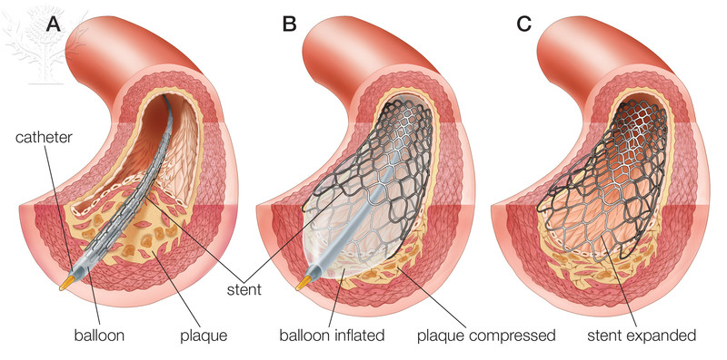
Balloon angioplasty and stent insertion / Credit: Encyclopaedia Britannica, Inc. / Copyright © Encyclopaedia Britannica / For Education Use Only. This and millions of other educational images are available through Britannica Image Quest. For a free trial, please visit www.britannica.co.uk/trial
Reducing the amount of cholesterol carried in the blood, reduces the likelihood of a build up of fats in the coronary artery. This can be done by eating a healthy, low fat diet, stopping smoking and reducing the amount of alcohol consumed. Exercise is also very beneficial. A group of drugs known as statins can be taken to decrease the amount of harmful cholesterol in the blood. They do not cure cardiovascular disease but can prevent it getting worse. Some side effects have been reported including, muscle pain, dizziness, insomnia, tingling hands and feet and inflammation of the liver or pancreas.

Information sheet 2 - heart valves
The heart itself, which pumps blood continually around the body, may also suffer from disease as it is a very complicated structure. Valves inside the heart open to let blood flow into a chamber or artery and then close to prevent the blood from returning. Heart valves can become stiff and perforated over time. They do not close as well and do not prevent the back-flow of blood. This reduces the amount of blood reaching the brain and body.
Heart valves can be replaced with artificial valves. The perfect artificial heart valve has yet to be designed. The ideal replacement valve should allow blood to flow in one direction only. It must be durable, opening and closing 40 million times a year. It must not cause blood clots and should allow blood to flow smoothly with no turbulence. The valve needs to be designed to close without damaging any red blood cells. Finally, artificial valves need to work quietly!
Inserting artificial valves into a heart involves major surgery. These valves keep working for 20 – 30 years but the patient must take drugs which reduce the risk of blood clots forming, for the rest of their lives.
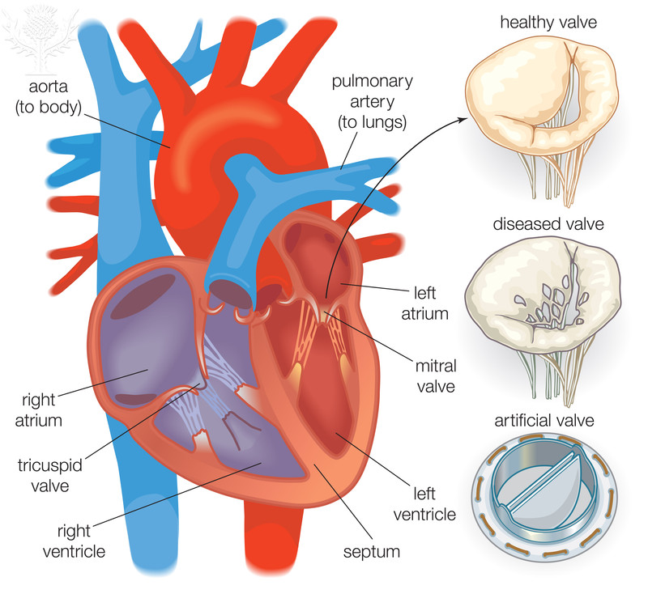
Diagram showing a normal, diseased, and artificial heart valve / Credit: Encyclopaedia Britannica, Inc. / Copyright © Encyclopaedia Britannica / For Education Use Only. This and millions of other educational images are available through Britannica Image Quest. For a free trial, please visit www.britannica.co.uk/trial
Replacement heart valves can also be biological in origin. They may use pig, cow or horse tissue or come from a human donor. This type of valve is usually given to older patients as the valve may only work well for 10 – 15 years. If the valve fails another operation will be needed. The patient does not have to take anticoagulant drugs but they will need medication to prevent the body rejecting the replacement valve.

Task
Read the information sheet that you have been given.
Use the table below to summarise the benefits and risks associated with the treatments mentioned in the article.
Treatment | Benefits | Risks

Teaching notes
There are two information sheets; one about stents and statins and the other covering heart valves.
After reading one of the sheets, students summarise the information into a table which outlines the benefits and risks of using a drug or mechanical device to treat coronary heart disease.
The information sheets about heart valves requires some deduction and further research to draw out detailed benefits and risks e.g. artificial valves may be audible to the recipient. To work out the benefits of using replacement valves, students would need to find out the problems caused by faulty and failing valves in the heart.

Useful websites:
- news.bbc.co.uk/1/hi/health/7488119.stm

- www.bbc.co.uk/news/health-32753907

- www.ncbi.nlm.nih.gov/pmc/articles/PMC3063655/

- www.heart-valve-surgery.com/heart-surgery-blog/2008/08/29/mechanical-or-bioprosthetic-heart-valve-replacements/

