Task
Look at the information sheets about different methods for treating heart disease. Use the information to fill in the table.
Method | Description | Advantages | Disadvantages

Information sheets
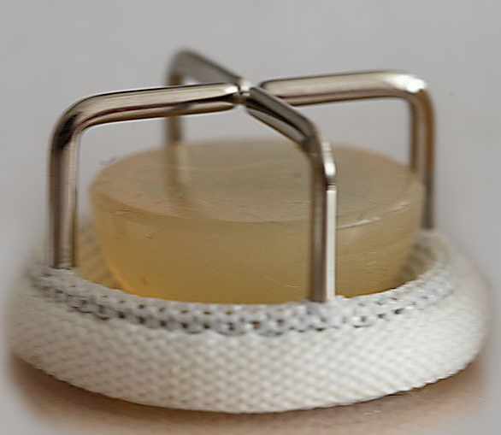
Artificial valves - what are they?
It’s a device implanted in the heart of a patient to replace their faulty valve.
By Stif Komar (Own work) [CC BY-SA 3.0 (http://creativecommons.org/licenses/by-sa/3.0)], via Wikimedia Commons
Artificial valves - advantages
- No rejection
Artificial valves: disadvantages
- Can damage red blood cells, so patients need to take anti-clotting drugs.
Biological valves – what are they?
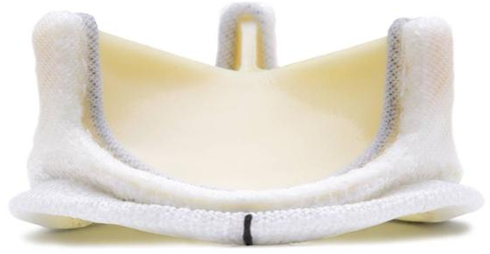
They are based on valves taken from animals, such as pigs or cattle. They are treated with chemicals to stop your body rejecting them.
By Stif Komar (Own work) [CC BY-SA 3.0 (http://creativecommons.org/licenses/by-sa/3.0)], via Wikimedia Commons
Biological valves – advantages
- No need for blood thinning drugs as they don’t damage red blood cells.
Biological valves – disadvantages
- Valves can harden and need replacing.
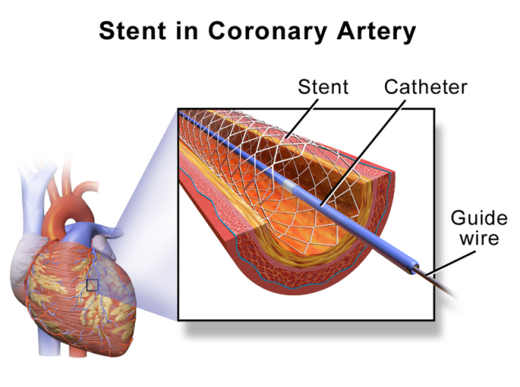
Stents – what are they?
Stents are used to treat narrow coronary arteries. The stent is pushed into position using an x-ray, the balloon is inflated, expanding the stent, and then removed, leaving the stent to open up the artery.
Stents – advantages
- Lowers risk of infection as major surgery
not required.
Stents – disadvantages
- Fatty deposits can build up again.

Bypass surgery – what is it?
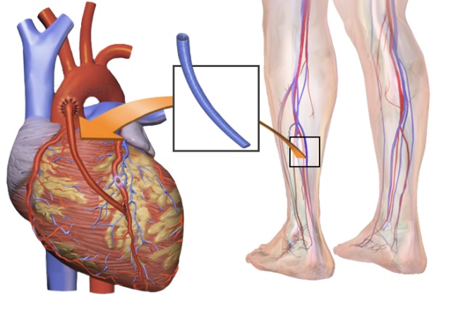
A surgical procedure used to treat coronary heart disease.
It transplants a vein from the leg to divert blood around narrowed or clogged parts of the major arteries to improve blood flow and oxygen supply to the heart.
Around 20,000 coronary artery bypass grafts are carried out in England every year.
Bypass surgery – advantages
- No rejection risks.
- Very effective treatment.
Bypass surgery – disadvantages
- Major surgery, so involves risks.
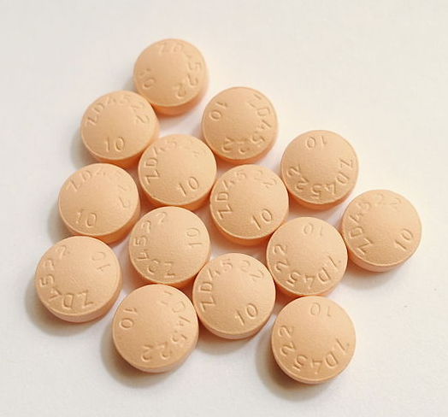
Statins – what are they?
These are drugs which lower cholesterol levels by stopping the liver producing as much.
Patients can also change their diet to help reduce cholesterol.
Statins – advantages
- They reduce cholesterol which helps slow down the build-up of fatty layers in the arteries.
Statins – disadvantages
- They have possible side effects, e.g. liver damage.
- Patient has to remember to take them regularly.


Artificial pacemakers - what are they?
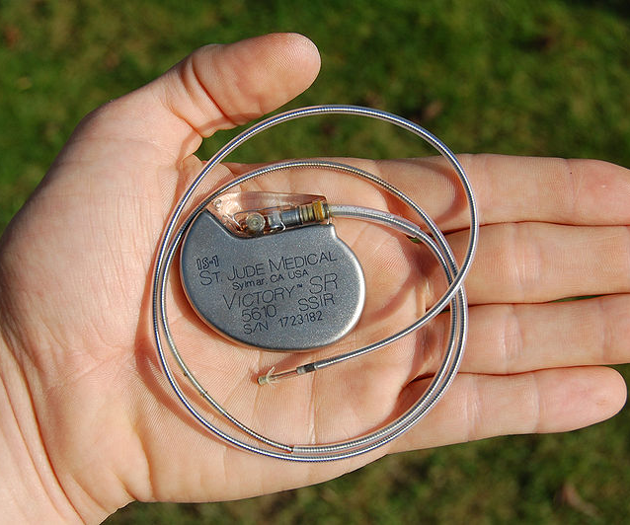
Some people can’t control their heart rate. Artificial pacemakers can be fitted under the skin. A wire is passed from a vein to the right atrium. This sends electrical impulses to the heart to control the heartbeat.
Artificial pacemakers – advantages
- Major surgery not required, so not very risky.
Artificial pacemakers – disadvantages
- The immune system can reject the pacemaker and it will need replacing.
- The pacemaker may sometimes malfunction.
Heart transplants – what are they?
A heart transplant is an operation to replace a damaged or failing heart with a healthy human heart from a donor who has recently died.
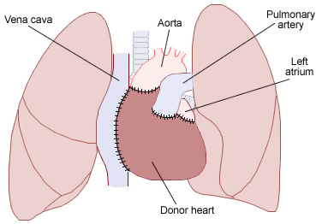
Heart transplants are rarely performed in the UK, mainly due to a lack of suitable donors.
There were 197 heart transplants performed in the UK between 2012 and 2013.
Heart transplants – advantages
- A better quality of life (improved strength, energy & stamina).
- More normal lifestyle day to day
- An improved chance of a longer life.
Heart transplants – disadvantages
- Major surgery (anaesthetic risks, bleeding, clotting, infection)
- Anti-rejection drugs needed for life
- A shortage of donors.

Teaching notes
Copy the information sheets, cut them up and spread round the room. Ask students to find the information to fill in the table with.

Ideas for differentiation
For students who need more support:
- the table could be partially filled in
- don’t cut the information sheets up
- students could work in groups and find information for just two methods each.
For more challenge ask students to:
- create their own table
- research the advantages and disadvantages themselves
- remove the headings from the information sheets.

Going further
Students could try this specimen exam question (question 5) from AQA for new (9-1) GCSE.
filestore.aqa.org.uk/resources/science/AQA-84641B1H-SQP.PDF

Image credits
- Bypass surgery - By Blausen Medical Communications, Inc. (Donated via OTRS, see ticket for details) [CC BY 3.0 (http://creativecommons.org/licenses/by/3.0)], via Wikimedia Commons
- Statins - By Mk2010 (Own work) [CC BY-SA 4.0 (http://creativecommons.org/licenses/by-sa/4.0)], via Wikimedia Commons
- Stents - By BruceBlaus. When using this image in external sources it can be cited as: Blausen.com staff. "Blausen gallery 2014". Wikiversity Journal of Medicine. DOI:10.15347/wjm/2014.010. ISSN 20018762. (Own work) [CC BY 3.0 (http://creativecommons.org/licenses/by/3.0)], via Wikimedia Commons
- Artificial pacemakes - By Steven Fruitsmaak [GFDL (http://www.gnu.org/copyleft/fdl.html) or CC BY 3.0 (http://creativecommons.org/licenses/by/3.0)], via Wikimedia Commons
- Heart transplant - By No machine-readable author provided. D Dinneen~commonswiki assumed (based on copyright claims). [GFDL (http://www.gnu.org/copyleft/fdl.html) or CC-BY-SA-3.0 (http://creativecommons.org/licenses/by-sa/3.0/)], via Wikimedia Commons

