




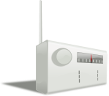

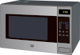
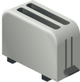
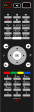



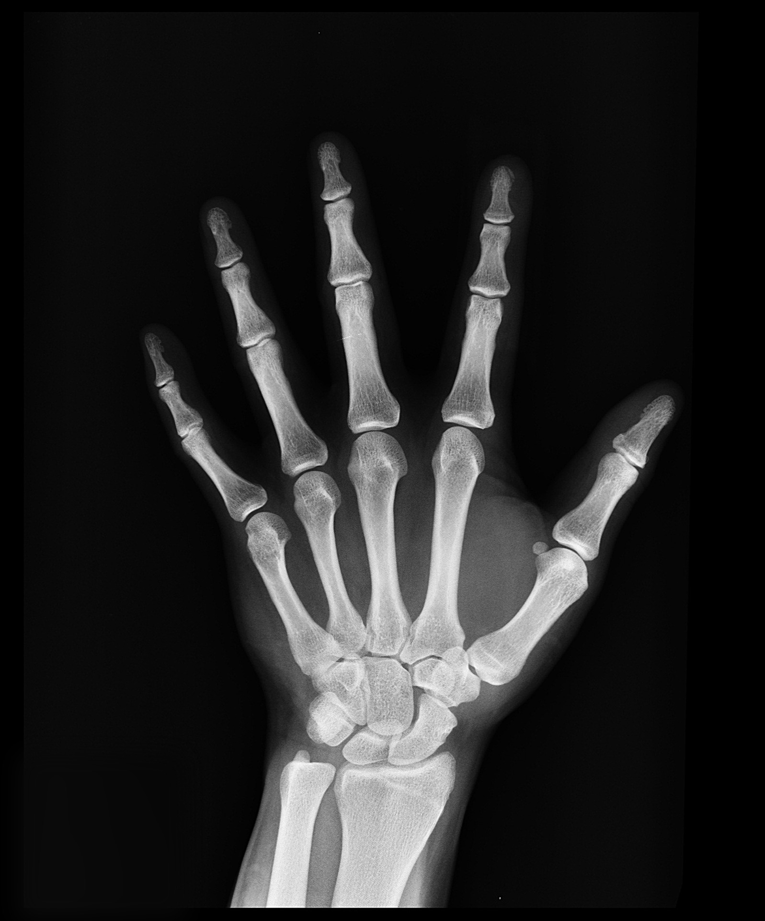

Name
Grade
1-3
Grade
1-3
Grade
4-6
Danger
Size
Grade
7-9
Use
Frequency
(Hz)
(m)
λ
Grade
4-6
Grade
7-9
Visible light
Ultra-violet
Infra-red
Microwaves
Radiowaves
X-Ray
Gamma
Mutate DNA
Cancer
Mutate DNA
Cancer
Skin
Cancer
Eye Damage
Burns
Heating water molecules
No danger
10⁸
10¹²
10¹⁵
10⁴
10¹⁶
10¹⁸
10²⁰
Algae
Molecule
Atom
Atomic nuclei
10³
10⁻⁵
10⁻¹⁰
House
Pin
10⁻²
10⁻⁶
10⁻⁸
10⁻¹²
Bee
Teaching notes

This is suitable to use with Yr9 – 11 students. It is a handy visual reference that can be kept in their book or laminated for use in class.

The design is in 2 parts which need to be cut out. On the first disc, cut away the relevant sections (depending on ability or target grade), then place it over the top of the second disc and secure with a split pin.

