Task 1
Colour in the diagram using the following key:
liver | red |  | gall bladder | green
pancreas | yellow |  | duodenum | blue
Label the diagram using the table below.
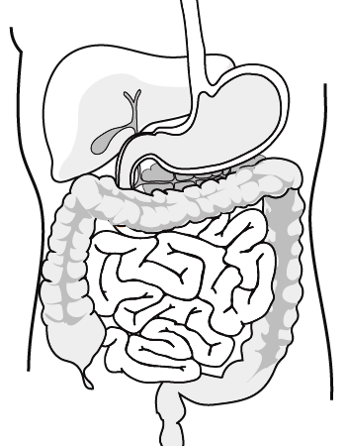

liver produces bile | bile duct | pancreatic duct
duodenum | bile stored in gall bladder | digestive enzymes produced in pancreas

Task 2
- What role does bile have in digestion?
- It neutralises food, coming from the , which is .
- It provides an environment – which is the pH for the enzymes which work in the small intestine.
- It emulsifies – increasing the surface area of the fat exposed to
enzymes.
- Draw a diagram to illustrate the role of bile in digestion. Don’t add labels, but swap your diagram with your partner and label their diagram.

Task 3 – digesting milk fat
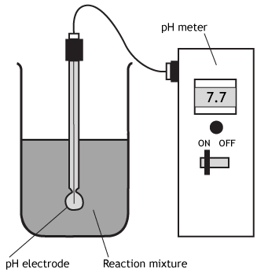
The diagram shows the apparatus used to investigate the digestion of milk fat by an enzyme. The reaction mixture contained milk and the enzyme.
- In experiment 1, bile was added as well.
- In experiment 2, water was added instead of bile.
The pH was recorded every 2 minutes.
- Suggest the name of the enzyme used in this experiment.
- What are the products of the reaction?
- What do you think will happen to the pH in each experiment?
- Look at the table below. Compare and explain the results of the two experiments.
Time in minutes | pH
Time in minutes | Experiment 1: with bile | Experiment 2: without bile
0 | 9.0 | 9.0
2 | 8.9 | 9.0
4 | 8.6 | 9.0
6 | 8.0 | 8.9
8 | 7.8 | 8.7
10 | 7.6 | 8.3

Teaching notes
Before doing Task 3 cut the sheet before question 4 so that this can be given to the students after they have answered the first 3 questions.
Suggested answers

digestive enzymes
produced in pancreas
pancreatic duct
bile stored in gall bladder
bile duct
duodenum
liver produces bile

Task 2
What role does bile have in digestion?
- It neutralises food, coming from the stomach, which is acidic.
- It provides an alkaline environment – which is the optimum pH for the enzymes which work in the small intestine
- It emulsifies fat – increasing the surface area of the fat exposed to lipase enzymes.

Task 3
- Lipase
- Fatty acids and glycerol
- pH will go down as acids are produced by breakdown of fats. The pH will decrease at a faster rate in the first experiment.

