Task

Throughout the day and night, you are constantly using energy. This energy is released by the process of respiration inside your cells. Respiration is the oxidation of foodstuffs to release energy.

Different activities require varying amounts of energy. Intense physical activity requires most energy but even when sleeping you need energy to maintain body temperature, heart rate, breathing etc.

The table shows various activities and the amount of energy needed by an average 15 year old for such activities.

Activity | Energy needed each hour (kJ)
Sleeping | 250
Sitting, resting, listening to music | 300
Reading, gaming, texting, watching TV | 350
Writing | 400
Studying, eating | 450
Washing, dressing | 600
Walking | 1000
Cycling, jogging | 1400
Playing active games e.g. football, swimming, rugby | 1500

Make up a list of all your activities for a particular day and then draw your own Energy Clock like the one shown below.

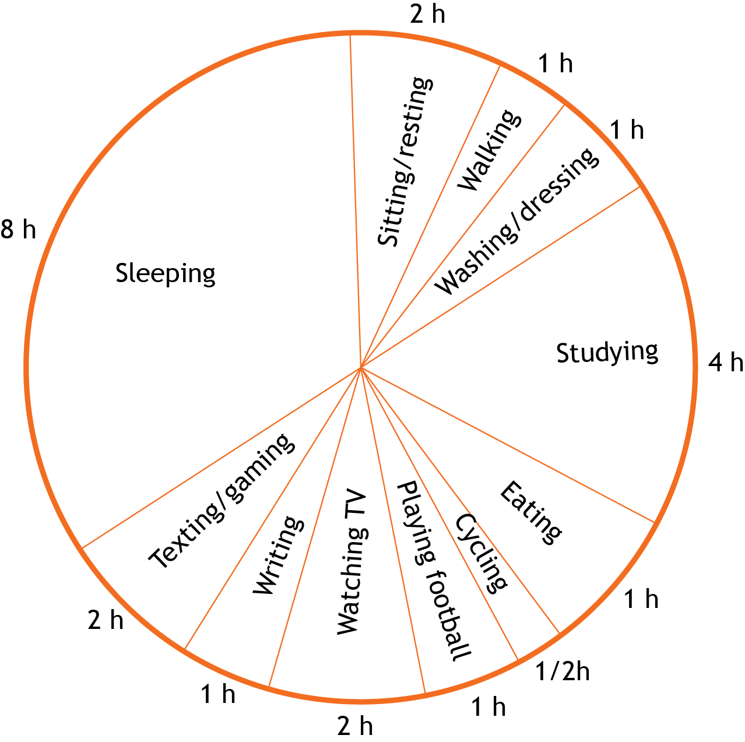

Using your energy clock and the table for energy values for different activities, calculate how much energy you use up in an average day.

Most teenagers use between 8 000 to 12 000 kJ each day.

How active is your day?

