RP Microscopy revision activities

Aim: Revision of the Microscopy required practical (RP), relating it to the content of the specification, including maths skills and working scientifically.

Keywords: resolution, magnification, mitochondria, ribosomes, eukaryotic, prokaryotic.

RP Microscopy | Specific content | Skills
Use a light microscope to observe, draw and label a selection of plant and animal cells. A magnification scale must be included. | 4.1.1.1 Eukaryotes and prokaryotes  4.1.1.2 Animal and plant cells  4.1.1.3 Cell specialisation  4.1.1.4 Cell differentiation  4.1.1.5 Microscopy | AT 7 – use of appropriate apparatus, techniques and magnification, including microscopes, to make observations of biological specimens and producing labelled scientific drawings.  WS 2.6, 3.3, 4.3,4.4,4.6  MS 1d

Starter activities

- Setting the scene – how to use a microscope

This activity is a recap of KS3 skills and puts into context the content and skills needed at GCSE. In pairs, ask students to describe how they would use a microscope to observe a biological specimen.

They could use the following key words: specimen, slide, eye piece, coarse adjustment knob, fine adjustment knob, objective lens, magnification, light/mirror, stage, cover slip.

- Magnification and microscopes PowerPoint (30133)

Use slides 2-7 to recap magnification and to practise using the magnification equation.

Main activities

- Marking cells

Give students a range of actual images of cells viewed under a microscope, from the selection provided on pages 5–10. If laminated, the images could be written on with wipeable markers and used again. The activity could be used as a class activity on the IWB with students annotating the images on the board.

NB The magnifications given are correct when the images are 10 cm wide when printed out.

Suggested further activities could include:

- The examples given are all eukaryotic cells. Ask students to describe the differences that they would expect to see in an image of a prokaryotic cell.

- Ask students to make labelled drawings of 2-3 cells from the images, they should include the magnification of the image.

Differentiation

There is a range of different images (pages 5-10) from simple cheek cells to more complex tissues. Give students the most appropriate images for the level that they are working at.

Answers
- Image 1 – Spirogyra algae

Cell length = 1.9 mm, cell width = 0.6 mm

- Image 2 – Canadian pondweed

Cell length = 0.1 mm, cell width = 0.07 mm

- Image 4 – Human cheek cells

Nucleus size – 0.014 mm (14 μm)

- Image 5 – Human blood cells

Red blood cell = 0.005 mm (5 μm), white blood cell = 0.01 mm (10 μm)

- Maths skills activities

Depending on the needs of the class, choose activities from the following maths skills resources.

Free sample resources:

- Standard form and order of magnitude calculations (27169)
- Maths skills in science – significant figures (25137)
- Large and small prefixes - interactive (24898)
- W1L2 Nanotechnology – Starter – Powers of 10 (24898)
- Minute in minutes (19386)

Available to subscribers:

- Incorrect standard form Snap (26496)
- Maths skills in Science – standard form (26497)

- Function and specialisation of cells

Use these activities to revise keywords and content across the specification – 4.1.1.1 Eukaryotes and prokaryotes, 4.1.1.2 Animal and plant cells and 4.1.1.3 Cell specialisation.

- Cell organelle card sort (26947)
- Cell structure dominoes (28216)
- Cells and their specialisms (19669)

- Comparing microscopes (page 11)

This activity compares light microscopes with electron microscopes. The activity can be differentiated:

- Easiest task – give students the statements and the table.
- Intermediate task – discuss the statements and then ask students to complete the table from memory.
- Challenge task – ask students to create their own table to show the differences between light and electron microscopes. If needed give them the statements to help them create the table.

The statements, blank table and completed table can also be found on the PowerPoint,
‘Magnification and microscopes’ (30133).

Plenary activities

- Microscopy – taboo (pages 12-13)

Taboo is a word guessing game. The objective is to have your team guess the keyword at the top of your card. This must be accomplished without using the word itself or any of the additional ‘taboo’ (forbidden) words listed on the card. Before the lesson, copy and cut up the taboo cards; each group of students will need a set.
- Students work in groups of at least four. Give each group a set of cards. Each group then splits into two teams.
- The cards need to be shuffled and placed face down.
- An individual from the first team takes the card from the top of the pile and describes the word at the top of the card without using the ‘taboo’ words. A member of the opposing team could sit by the clue-giver so that they can challenge if a taboo word is used. The rest of the clue–givers team must guess the word being described. Participants are not allowed to say ‘sounds like’ or ‘rhymes with’ and no gestures, sounds or drawings are permitted.
- Should the clue-giver be correctly challenged or if their team correctly guesses the word then they must move on to the next card.
- Each clue-giver is allowed one or two minutes to describe as many words as possible to the players in their team before play passes to the next team. There are no penalties for a wrong guess.
- For each word which is correctly guessed, the playing team receives one point.
This activity is designed to extend the students’ vocabulary range by finding other ways to describe the keyword. It allows a review of scientific vocabulary in addition to reinforcing the students’ memory of each scientific term.
Suggested further activities could include:

- In the lesson or homework prior to playing this game, ask students to revise the meanings of the keywords.

- Give each student a blank card to put a keyword onto. They then write a further five associated ‘taboo’ words underneath. Collect the cards and use as a class or group activity.

Main activity 1

Image 1

Look at the photograph of an algal cell below.

- Label as many parts of the cell as you can.

- Swap your photograph with another group and see if you can add any labels to theirs.

- What other organelles would be present that you cannot see here?

- Work out the actual length and width of one cell.

Spirogyra algae, light micrograph (x13)

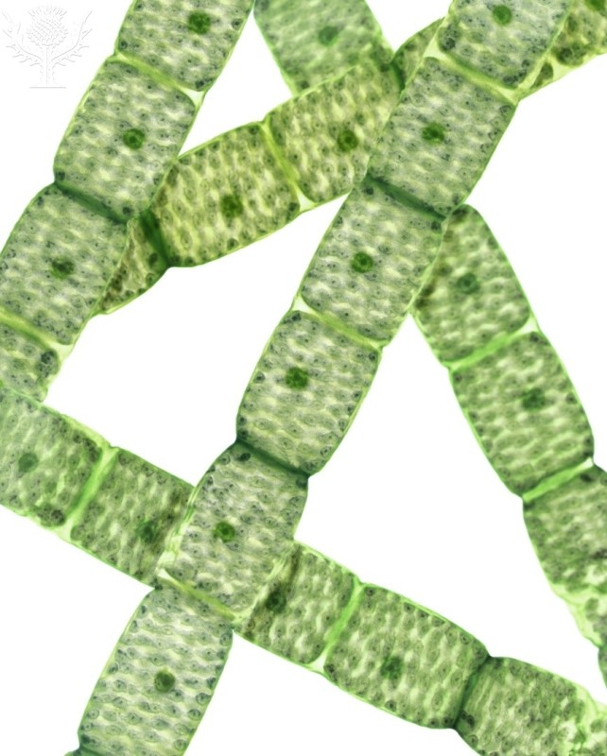

Image 2

Look at the photograph of the pondweed cells below.

- Label as many parts of the cell as you can.

- Swap your photograph with another group and see if you can add any labels to theirs.

- What other organelles would be present that you cannot see here?

- Work out the actual length and width of one cell.

Canadian pondweed leaf, light micrograph (x100)

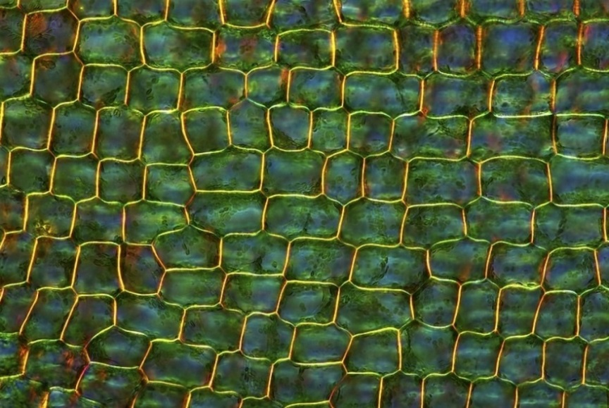

Image 3

Look at the photograph of the plant cells below.

- Label as many parts of the cell as you can.

- Swap your photograph with another group and see if you can add any labels to theirs.

- What other organelles would be present that you cannot see here?

Plant cell mitosis

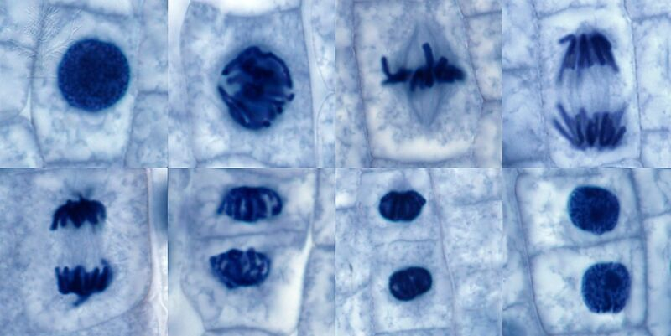

Image 4

Look at the photograph of human cheek cells below.

- Label as many parts of the cell as you can.

- Swap your photograph with another group and see if you can add any labels to theirs.
- What organelles would you not find in this cell that you could find in the earlier ones you have looked at?

- Work out the actual length and width of one cheek cell.

Human cheek cells (x500)

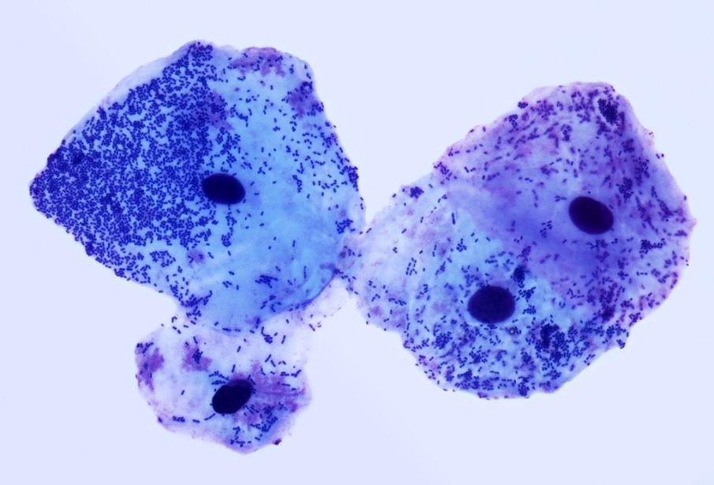

Image 5

Look at the photograph of human blood cells below.

- Label as many parts of the two types of cells as you can.

- What other organelles would be present that you cannot see here?

- Work out the actual diameter of a red blood cell and a white blood cell.

- Swap your photograph with another group and see if you can add any labels to theirs.

Human blood cells (x1000)

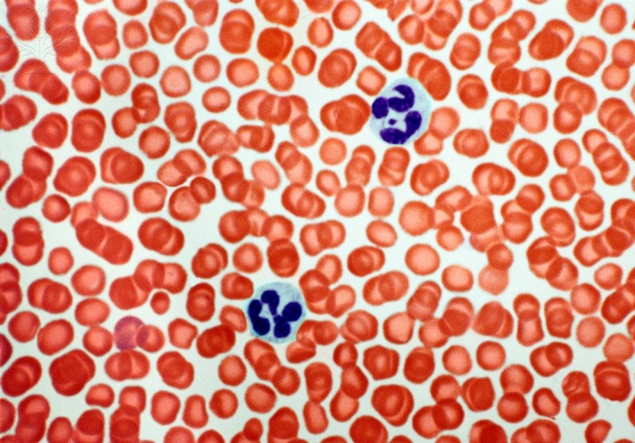

Image 6

Look at the photograph of muscle cells and motor neurones below.

- Label as many parts of the cells as you can.

- Swap your photograph with another group and see if you can add any labels to theirs.

- How has this cell specialised and why does this happen?

Muscle motor neurones

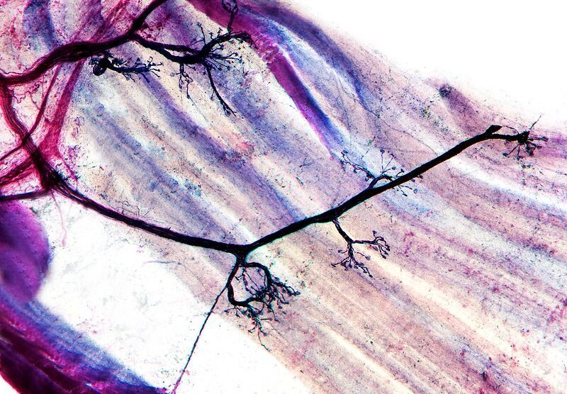

Main activity 4
Task 1

Below are statements about light microscopes and electron microscopes.
For each one decide which type of microscope it applies to and group them together.

Electrons are used  to form an image | Low resolution  (200 nm)
High resolution  (0.2 nm) | Used since 17th century to observe and understand cell structure
Visible light is used  to form an image | Low magnification  (up to x2000)
High magnification  (up to x2 000 000) | Used since the 1930s to observe subcellular structures in more detail

Task 2

Complete the table.
 | Light microscope | Electron microscope
What is its highest magnification?
What is its resolving power?
What is the type of radiation used to form an image?
How has it helped scientific understanding of living things?

Plenary

RP Microscopy – taboo

microscope | magnification | mitochondria
slide  magnification  lens  stage  light | microscope  image  objective lens  size  cells | cell  eukaryotic  respiration  glucose  organelle
ribosomes | eukaryotic | prokaryotic
cell  organelle  proteins  amino acids  cytoplasm | plant  animal cell  nucleus  bacteria  prokaryotic | bacterial cells  animal  nucleus  plasmid  eukaryotic
resolution | slide | objective lens
microscope  image  specimen  distance  unresolved | microscope  coverslip  specimen  cover  stage | magnification  microscope  eyepiece  power  stage


eyepiece | microscope stage | electron microscope
microscope  lens  magnification  slide  stage | slide  coverslip  clip  microscope  mirror | image  specimen  light  resolution  magnification
light microscope | cell specialisation | standard form
electron  magnification  lens  slide  specimen | function  structure  sperm  xylem  nerve | numbers  large  small  power of 10  multiplied
chloroplast | nerve cells | micrometre
plant  photosynthesis  cell  cell wall  green | axon  myelin sheath  specialised  impulse  motor | length  1 x 10⁻⁶  metre  millimetre  nanometre

Image credits

Spirogyra algae, light micrograph / Credit: STEVE GSCHMEISSNER / SCIENCE PHOTO LIBRARY / Universal Images Group / Copyright © Science Photo Library / For Education Use Only. This and millions of other educational images are available through Britannica Image Quest. For a free trial, please visit www.britannica.co.uk/trial

ELODEA LEAF PREPARATION FOR LIGHT MICROSCOPE Cell Structure, Nucleus & Chloroplasts / Credit: Warren Rosenberg / Fundamental Photographs / Universal Images Group / Copyright © Science Photo Library / For Education Use Only. This and millions of other educational images are available through Britannica Image Quest. For a free trial, please visit www.britannica.co.uk/trial

Plant cell mitosis, light micrograph Chloroplasts / Credit: STEVE GSCHMEISSNER/SCIENCE PHOTO LIBRARY / UIG / Copyright © Science Photo Library / For Education Use Only. This and millions of other educational images are available through Britannica Image Quest. For a free trial, please visit www.britannica.co.uk/trial

Human blood cells, light micrograph / Credit: STEVE GSCHMEISSNER / SCIENCE PHOTO LIBRARY / Universal Images Group / Copyright © Science Photo Library / For Education Use Only. This and millions of other educational images are available through Britannica Image Quest. For a free trial, please visit www.britannica.co.uk/trial

Muscle motor neurones, light micrograph / Credit: DR KEITH WHEELER/SCIENCE PHOTO LIBRARY / UIG / Copyright © Science Photo Library / For Education Use Only. This and millions of other educational images are available through Britannica Image Quest. For a free trial, please visit www.britannica.co.uk/trial

Canadian pondweed leaf, light micrograph / Credit: MAREK MIS/SCIENCE PHOTO LIBRARY / Copyright © Science Photo Library / For Education Use Only. This and millions of other educational images are available through Britannica Image Quest. For a free trial, please visit www.britannica.co.uk/trial

