The inner planets

Burt and Duncan investigated the inner planets of our solar system.

Burt compiled some information about the four inner planets.

Planet | Time to orbit the Sun (Earth years) | Distance from the Sun (million km)
Mercury | 0.25 | 60
Venus | 0.50 | 110
Earth | 1.0 | 150
Mars | 2.0 | 230

Duncan sketched a diagram that shows the orbits of the Earth, Mercury, Venus and Mars, and their position at one particular time.

Earth
Mars
Venus
Sun
Mercury
Diagram not to scale

- Duncan used the information in the table to calculate the largest and smallest possible distances between the four inner planets.

Copy and complete the table below.

Planet | Smallest separation (millions of km) | Largest separation (millions of km)
Mercury
Venus
Earth
Mars

- Burt wanted to calculate how long it would take a flash of light on the Sun to reach the different planets.

He researched the speed of light and found out that it has a speed of 300 000 km/second.

        - He also discovered that it takes 250 minutes for a flash of light from the Sun to reach the planet Neptune.

Use this information to calculate the distance to the planet, Neptune. Give the unit.

        - Duncan wanted to find the times for light to travel to the inner planets of our solar system.

Copy and complete Duncan’s table below.

Planet | Distance from the Sun (million km) | Time for light flash to reach planet (seconds)
Mercury | 60
Venus | 110
Earth | 150
Mars | 230

Solar system models

Donna and Evie decided to look at the force of gravity and how this force can affect objects in space.

To begin with, Donna drew a picture of herself standing at four different positions on the Earth.
In positions A, B and D she also drew a ball hanging from a string.

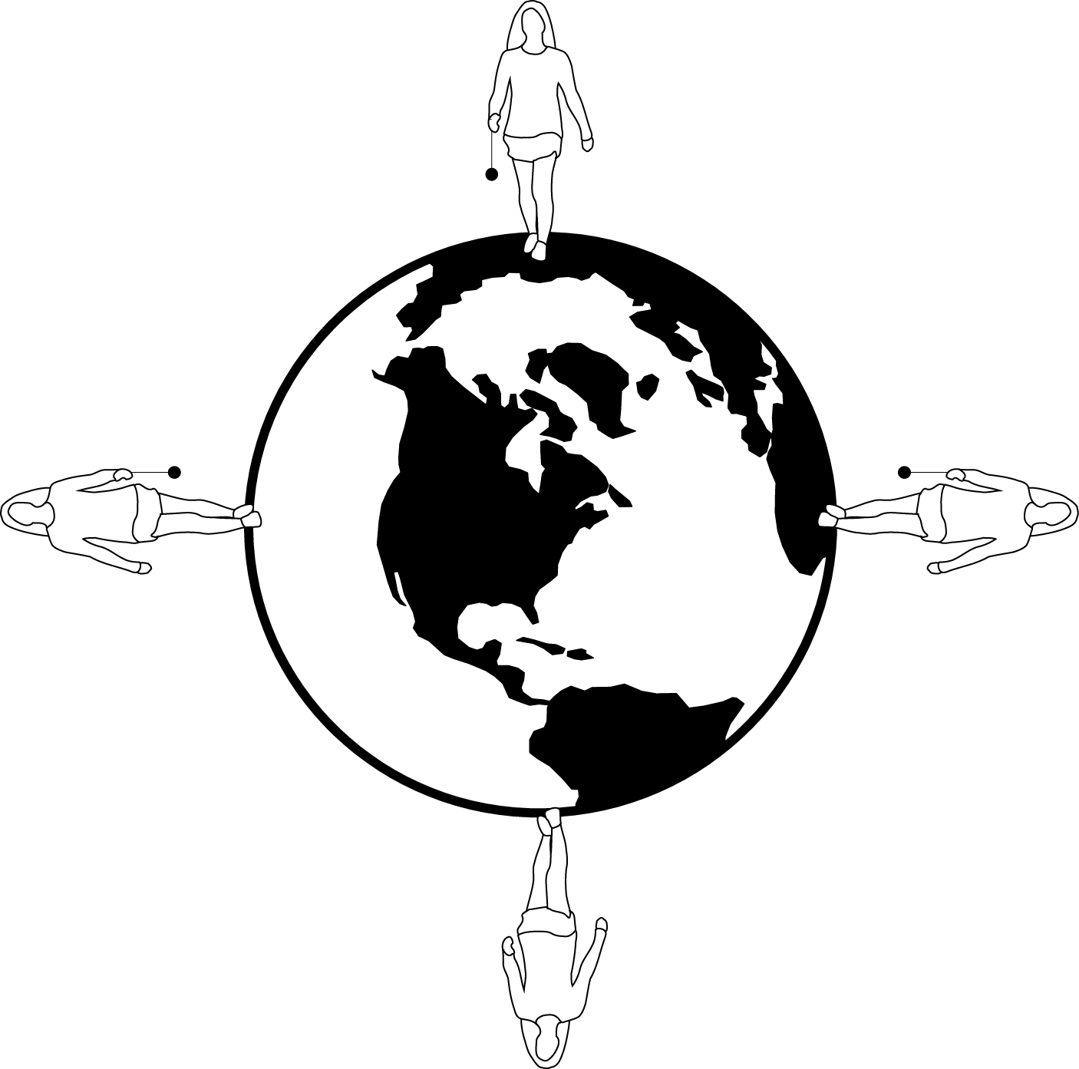
Diagram not to scale
A
B
C
D

  - Looking at diagrams A, B, and D, what conclusion could Donna reach about the direction of the force of gravity?

  - In which direction would the ball be drawn in diagram C?

- Next, Evie looked at the effect of gravity acting on the Earth.

To start, she drew a sketch of the Sun and the Earth in orbit around it, shown below.

Sun
Diagram not to scale
Earth

  - In what direction would the force of gravity acting on the Earth be now?

  - In what direction would the force of gravity acting on the Earth be 6 months later?

- Choose from the list below to answer parts a) to d) below.

day | year | 24 hours | night | 28 days | 365 days

  - How long does it take for the Earth to go around the Sun once?

  - What name is given to the time for the Earth to go around the Sun?

  - How long does it take for the Earth to rotate on its axis once?

  - What name is given to the time taken for the Earth to rotate once on its axis?

Satellites

Archie and Burt are trying to find out about satellites and what they are used for.
Archie has heard of the Hubble telescope and knows that this is also a satellite.

- Which of the following descriptions best describes a satellite?

A | A man-made object that orbits the Earth
B | Any object that orbits the Earth
C | Any object that orbits any planet
D | A man-made object that orbits any planet

- Burt sketches a diagram to show the Hubble telescope in orbit around the Earth.

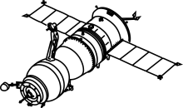
Earth
Hubble telescope
Diagram not to scale

  - State the force that keeps the telescope in orbit around the Earth.

  - Burt knows that the Hubble telescope is in a type of orbit called a Low Earth Orbit.
Find out one other type of orbit used by satellites.

- Archie has researched the Hubble telescope and knows that the cost of putting it into space was very large.

Normally, telescopes are placed on the Earth, often in mountainous areas.

  - Give one other reason why it might be a disadvantage to have a telescope in space.

  - Give one reason why it might be an advantage to have a telescope in space.

  - Give one advantage to placing a telescope on Earth.

  - Give one disadvantage to having a telescope in a mountainous area.

- Burt knows that two other uses of satellites are for communications and for monitoring the weather. However, he remains unsure of the type of orbit used by these different types of satellite.

From the perspective of a person standing on the Earth, a communication satellite never appears to move.

  - Name this type of orbit.

  - Explain why it is an advantage for a communication satellite to appear stationary in this way.

A weather satellite will be in an orbit that goes around the Earth quite quickly so that its orbital time is short.

  - Explain why it is an advantage for a weather satellite to have a short orbital time.

Eclipses 1

Anna and Bella are studying eclipses. Anna starts by sketching one arrangement for the Sun, Moon, and Earth during an eclipse, shown below.

1.a. What type of eclipse is represented on Anna’s diagram?

- Copy the diaram. Use the table below to help you to label the features during this type of eclipse.

1 | the Earth
2 | the Moon
3 | the Sun
4 | a region where the total eclipse of the Sun is taking place

Diagram not to scale

Eclipses 2

Bella found out through her research that eclipses come in a regular repeating pattern called the Saros cycle. The table below shows the dates of some eclipses in the Saros cycle.

Use this information to predict the date of the next eclipse in the Saros cycle.

Eclipse Number | 1 | 2 | 3 | 4
Date | 20th July 1963 | 31st July 1981 | 11th August 1999

- Bella then found out about another type of eclipse.
She drew the arrangement of the Sun, Earth, and Moon as shown below.

Diagram not to scale

  - What type of eclipse is being shown on Bella’s diagram?

  - Copy the diagram. Label the diagram to show the correct positions of the Sun, Earth, and Moon.

  - Draw two light rays from the Sun to show that the Moon is in the shadow of the Earth.

Solar system patterns

Duncan and Eddie are looking for patterns in data on the planets in our solar system.
Duncan has compiled the information below with the planets (including Pluto) listed in alphabetical order.

Planet | Distance from Sun (AU) | Diameter (Earth=1) | Length of year  (Earth=1) | Length of day  (Earth=1) | Average temperature °C
Earth | 1.0 | 1.0 | 1.0 | 1.0 | 22
Jupiter | 5.2 | 11 | 12 | 0.41 | –110
Mars | 1.5 | 0.53 | 1.9 | 1.0 | –30
Mercury | 0.39 | 0.38 | 0.24 | 175.9 | 430
Neptune | 30 | 3.9 | 164 | 0.67 | –205
Pluto (dwarf planet) | 39 | 0.19 | 248 | 6.4 | –230
Saturn | 9.6 | 9.5 | 29 | 0.44 | –140
Uranus | 19 | 4.0 | 84 | 0.72 | –195
Venus | 0.72 | 0.95 | 0.62 | 117 | 470

(1 AU = 150 million km, the Earth – Sun distance)

- Eddie notices that Neptune and Pluto are the coldest planets. Explain why.
- Duncan thinks that there could be life on some of the other planets. He knows that the presence of liquid water would be necessary for life.
Explain why there could be no liquid water on the surface of Mars and Venus.
- On which planet would the time between sunrise and sunset be shortest?
- Which planet has the shortest year?
- Draw a temperature scale from -300 to 500°C and mark the average temperature for each planet on it. What pattern do you see?
- Plot a scatter-graph of the Length of year vs Distance from Sun and draw a line of best fit through the data.
Write a conclusion for the trend shown in this data.
Seasons

Archie and Burt are trying to understand why we have different seasons.
Archie draws a diagram showing the Earth and its orbit around the Sun.

Sun
Diagram not to scale
UK
N
S

- What season is it in the UK, based on Archie’s diagram?
Explain your answer.

- Burt wants to know where the Earth would be 6 months later.
Copy the diagram and add the position of the Earth 6 months later.
Include the North – South axis and the position of the UK during the night-time.

- The North – South axis is shown tilted at an angle of 23 degrees.
Explain why this angle is important in giving the Earth its seasons.

Answers

The inner planets

Planet | Smallest Separation (millions of km) | Largest Separation (millions of km)
Mercury | 50 | 290
Venus | 40 | 340
Earth | 40 | 380
Mars | 80 | 380

2a. 4.5 x 10⁹ km
b.

Planet | Distance from the Sun (million km) | Time for light flash to reach planet (seconds)
Mercury | 60 | 200
Venus | 110 | 366.7
Earth | 150 | 500
Mars | 230 | 766.7

Solar system models

11 1. | a. | th the force of gravity is pulling towards the centre of the Earth
 | b. | to towards the centre of the Earth
2. | a.  b. | towards the centre of the Sun (arrow pointing left from Earth towards the Sun)  towards the centre of the sun
3. | a. | 365 days
 | b. | year
 | c. | 24 hours
 | d | day

Satellites

1. |  | C
2. | a. | Gravity
 | b. | e.g. geostationary orbit
3. | a. | Difficult to repair and upgrade
 | b. | No atmosphere so can detect UV and infrared light
 | c. | Easier to repair
 | d. | Earth’s atmosphere absorbs UV and infrared light

- a. Geostationary
b. E.g. Satellite dishes don’t have to be moved to get signal
c. It can monitor the Earth in a short period of time.

Eclipses 2

1. 22nd August 2017
2 a. Lunar eclipse

Solar system patterns

- They are the furthest away so get less energy from the Sun
2. Mars – average temperature is below freezing point of water, any water will be solid
Venus – average temperature is above boing point, any water will be a vapour
3. Jupiter
4. Mercury

Seasons

1. Winter – as the northern hemisphere is tilted away from the Sun
3. When the northern hemisphere is tilted toward the Sun the light rays hit the Earth at a more acute angle and the day lasts longer than when it is tilted away.

