Task

Xylem and phloem are used to transport substances within plants.
Cut and stick the statements to complete the table below.

 | Xylem tissue | Phloem tissue
Function of tissue
Cell structure
Are the cells continuous tubes?
Direction of flow of contents
Process by which substances are moved

Carries water and mineral ions through plant | Transpiration – loss of water vapour from leaves pulls water through the xylem | From roots to leaves
Carries dissolved sugars | Hollow, dead cells | No – they have end walls with pores, so that cell sap can move between cells
From leaves to growing areas (tips of roots and stems) and to storage organs | Living cells which have lost many organelles. They have companion cells to keep them alive and transfer the energy needed to transport sugars in the phloem. | Yes – they form long tubes strengthened by lignin. This gives support to the plant and helps withstand the water pressure in the tubes.
Translocation – movement of dissolved sugars | 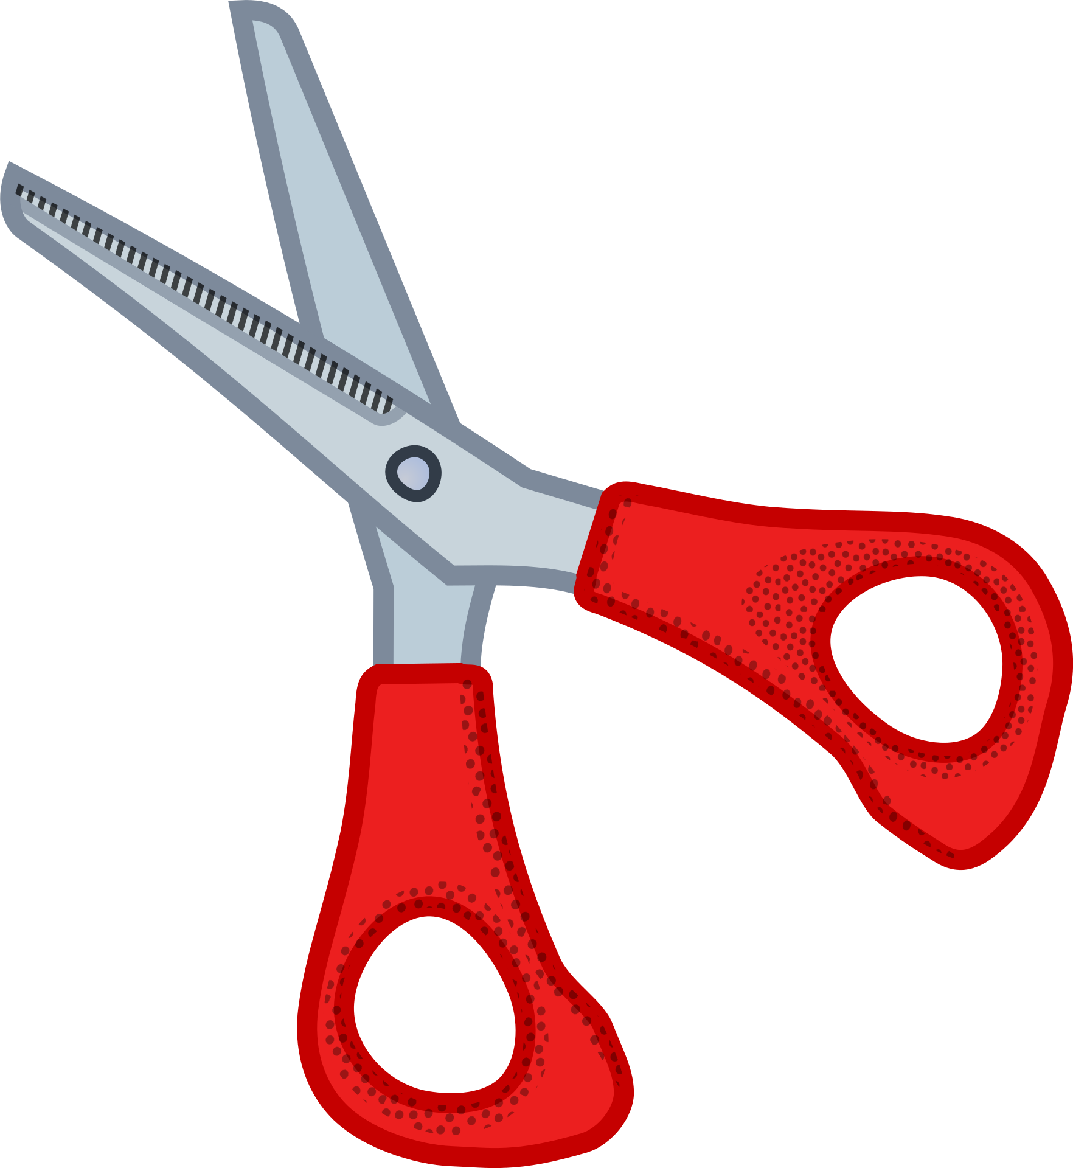

Task (HT)

Xylem and phloem are used to transport substances within plants.
Complete the table below to show the differences in their structure and how this relates to their function.

 | Xylem tissue | Phloem tissue
Function of tissue
Cell structure description.
Relate the structure of the cells to their function.
Are the cells continuous tubes?
Explain why this is important.
Direction of flow of contents. Explain why this is important to the plant.
Which substances are transported?
Name and describe the process by which substances are moved.

Keywords to include

Companion cells, lignin, transpiration, translocation, water, sugars.

Teaching notes and answers

The task has been differentiated. It could be differentiated further by filling in some of the answers or removing the keywords on the HT version.

The students could sketch and annotate the cells rather than writing a description.

 | Xylem tissue | Phloem tissue
Function of tissue – what substances does it transport? | Water and mineral ions | Dissolved sugars
Cell structure | Hollow, dead cells | Living cells which have lost many organelles. They have companion cells to keep them alive and transfer the energy needed to transport sugars in the phloem.
Do the cells form continuous tubes? | Yes – they form long tubes strengthened by lignin. This gives support to the plant and helps withstand the water pressure in the tubes. | No – they have end walls with pores, so that cell sap can move between cells
Direction of flow of contents | From roots to leaves | From leaves to growing areas (tips of roots and stems) and to storage organs
Process by which substances are moved | Transpiration – loss of water vapour from leaves pulls water through the xylem | Translocation – movement of dissolved sugars

