Task 1
Complete the table below using the diagram of the eye.
Label no. | Part of the eye | Description | Function
1
2
3
4
5
6
7
8
9
10
11
12

Task 1 - Complete the table below using diagram of the eye. Use the words in the box to help you, they can be used more than once.
Label no. | Part of  the eye |  | Description |  |  |  | Function
1 |  |  | Mucous that covers the front of the eye  and lines the inside of the eyelid. |  |  |  | Provides the eye with so that it can open and close easily.
2 |  |  | Front part of the sclera, tough, convex and . |  |  |  | Bends the as it enters the eye. It helps to protect the eye.
3 | pupil |  | The opening in the middle of the eye that appears to be  . |  |  |  | Allows to enter the eye and focus on the .
4 |  |  | Soft, flexible, transparent disc. |  |  |  | Focuses light on the .
5 | iris |  | It is the part of the eye. |  |  |  | Contains muscles that control the size of the pupil and therefore the  amount of light that enters the eye.
6 |  |  | A group of fibres that connects the lens to the  muscles. |  |  |  | Hold the in place.
7 |  |  | Circular ring of muscle surrounding the . . |  |  |  | It cause the to change shape as it contracts and relaxes.
8 |  |  | Tough, outer part of the eye that extends  from cornea to the back of the eye. |  |  |  | Protects the eye from serious and provides a good  surface for the that control eye movement to connect to.
9 |  |  | A thin lining on the back of the eye. |  |  |  | Contains cells called rods and cones which are  sensitive to .
10 |  |  | Clear like substance located between the  and the lens. |  |  |  | Keeps the eye firm and gives it shape.
11 |  |  | The area of the eye where the optic nerve and the  meet. |  |  |  | This part of the eye is not sensitive to as it contains no  rod or cone cells.
12 |  |  | Group of neurons at the back of the eye. |  |  |  | Sends visual information to the .
membrane |  | brain |  | moisture | sensory | black |  | damage | retina | bi-convex
transparent |  | gel |  | light | muscles | coloured |  | lens | ciliary | white

Task 1
Complete the table below using diagram of the eye. Use the words in the box to help you, they can be used more than once.
Part of  the eye |  |  | Description |  |  |  |  |  |  | Function
 |  |  | Front part of the sclera, tough, convex and |  |  |  |  |  |  | Bends the as it enters the eye. It helps to protect the eye.
pupil |  |  | The opening in the middle of the eye that appears to be  . |  |  |  |  |  |  | Allows to enter the eye and focus on the .
 |  |  | Soft, flexible, transparent disc with a shape |  |  |  |  |  |  | Focuses light on the
 |  |  | It is the part of the eye. |  |  |  |  |  |  | Contains muscles that control the size of the pupil and therefore the amount of light that enters the eye.
sclera |  |  | Tough, outer part of the eye that extends  from cornea to the back of the eye. |  |  |  |  |  |  | Protects the eye from serious and provides a good  surface for the that control eye movement to connect to.
 |  |  | A thin lining on the back of the eye. |  |  |  |  |  |  | Contains cells called rods and cones which are  sensitive to
blind spot |  |  | The area of the eye where the optic nerve and the  meet. |  |  |  |  |  |  | This part of the eye is not sensitive to as it contains no rod or cone cells.
 |  |  | Group of neurons at the back of the eye. |  |  |  |  |  |  | Sends visual information to the .
white |  | brain |  |  | muscles |  | sensory |  | black |  |  | damage |  | retina |  | bi-convex
transparent | coloured |  |  | light |  | cornea |  | lens |  |  | retina |  | optic nerve |  | pupil |  | iris

Answer sheet
Label no. | Part of  the eye | Description | Function
1 | conjunctiva | Mucous membrane that covers the front of the eye and lines the inside of the eyelid. | Provides the eye with moisture so that it can open and close easily.
2 | cornea | Front part of the sclera, tough, convex and transparent. | Bends the light as it enters the eye. It helps to protect the eye.
3 | pupil | The opening in the middle of the eye that appears to be black. | Allows light to enter the eye and focus on the retina.
4 | lens | Soft, flexible, transparent disc with a bi-convex shape. | Focuses light on the retina.
5 | iris | It is the coloured part of the eye. | Contains muscles that control the size of the pupil and therefore the amount of light that enters the eye.
6 | suspensory ligament | A group of fibres that connects the lens to the ciliary muscles. | Hold the lens in place.
7 | ciliary muscle | Circular ring of muscle surrounding the lens. | It cause the lens to change shape as it contracts and relaxes.
8 | sclera | Tough, white outer part of the eye that extends from cornea to the back of the eye. | Protects the eye from serious damage and provides a good surface for the muscles that control eye movement to connect to.
9 | retina | A thin lining on the back of the eye. | Contains cells called cones and rods which are sensitive to light.
10 | vitreous humor | Clear gel like substance located between the retina and the lens. | Keeps the eye firm and gives it shape.
11 | blind spot | The area of the eye where the optic nerve and the retina meet. | This part of the eye is not sensitive to light as it contains no rod or cone cells.
12 | optic nerve | Group of sensory neurons at the back of the eye. | Sends electrical impulses to the brain.

Diagram A: Cross section of the eye
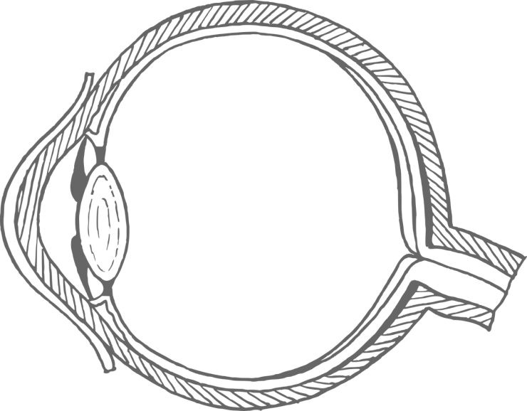
1
2
3
4
5
6
7
8
9
10
11
12
Diagram B: Cross section of the eye
1. conjunctiva
2. cornea
3. pupil
4. lens
5. iris
6. suspensory ligaments
7. ciliary muscle
8. sclera
9. retina
10. vitreous humor
11. blind spot
12. optic nerve
Diagram C: Cross section of the eye
cornea
pupil
lens
iris
sclera
retina
blind spot
optic nerve

