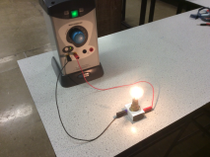 |  | Keywords
amps
ammeter

bulb

charge
conductor
copper
current

charge

insulator

power pack
potential difference (voltage)

voltmeter
volts

wire

This is a simple series circuit.
Draw the circuit diagram in the
box opposite.
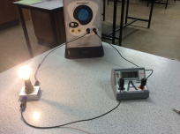
This circuit shows three pieces of equipment. Draw a circuit diagram and label each piece of equipment.
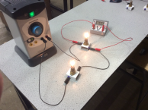
Draw this circuit diagram in the box opposite. Label each piece of equipment.

What is the rule for placing an ammeter in a circuit and what does it measure?
What is the rule for placing a voltmeter in a circuit and what does it measure?

Answers

A
V

What is the rule for placing an ammeter in a circuit and what does it measure?
The ammeter measures current. It is placed in series
What is the rule for placing a voltmeter in a circuit and what does it measure?
The voltmeter measures potential difference across a component. It is placed in parallel to the component that you want to measure.

