Work sheet A – task

The diagrams show a ray of light (incident ray) hitting a mirror. Draw the normal line (at 90∘ to the mirror) followed by the reflected ray. Make sure that you use a ruler and draw an arrow to show the way that the light is travelling. The first one has been done for you.

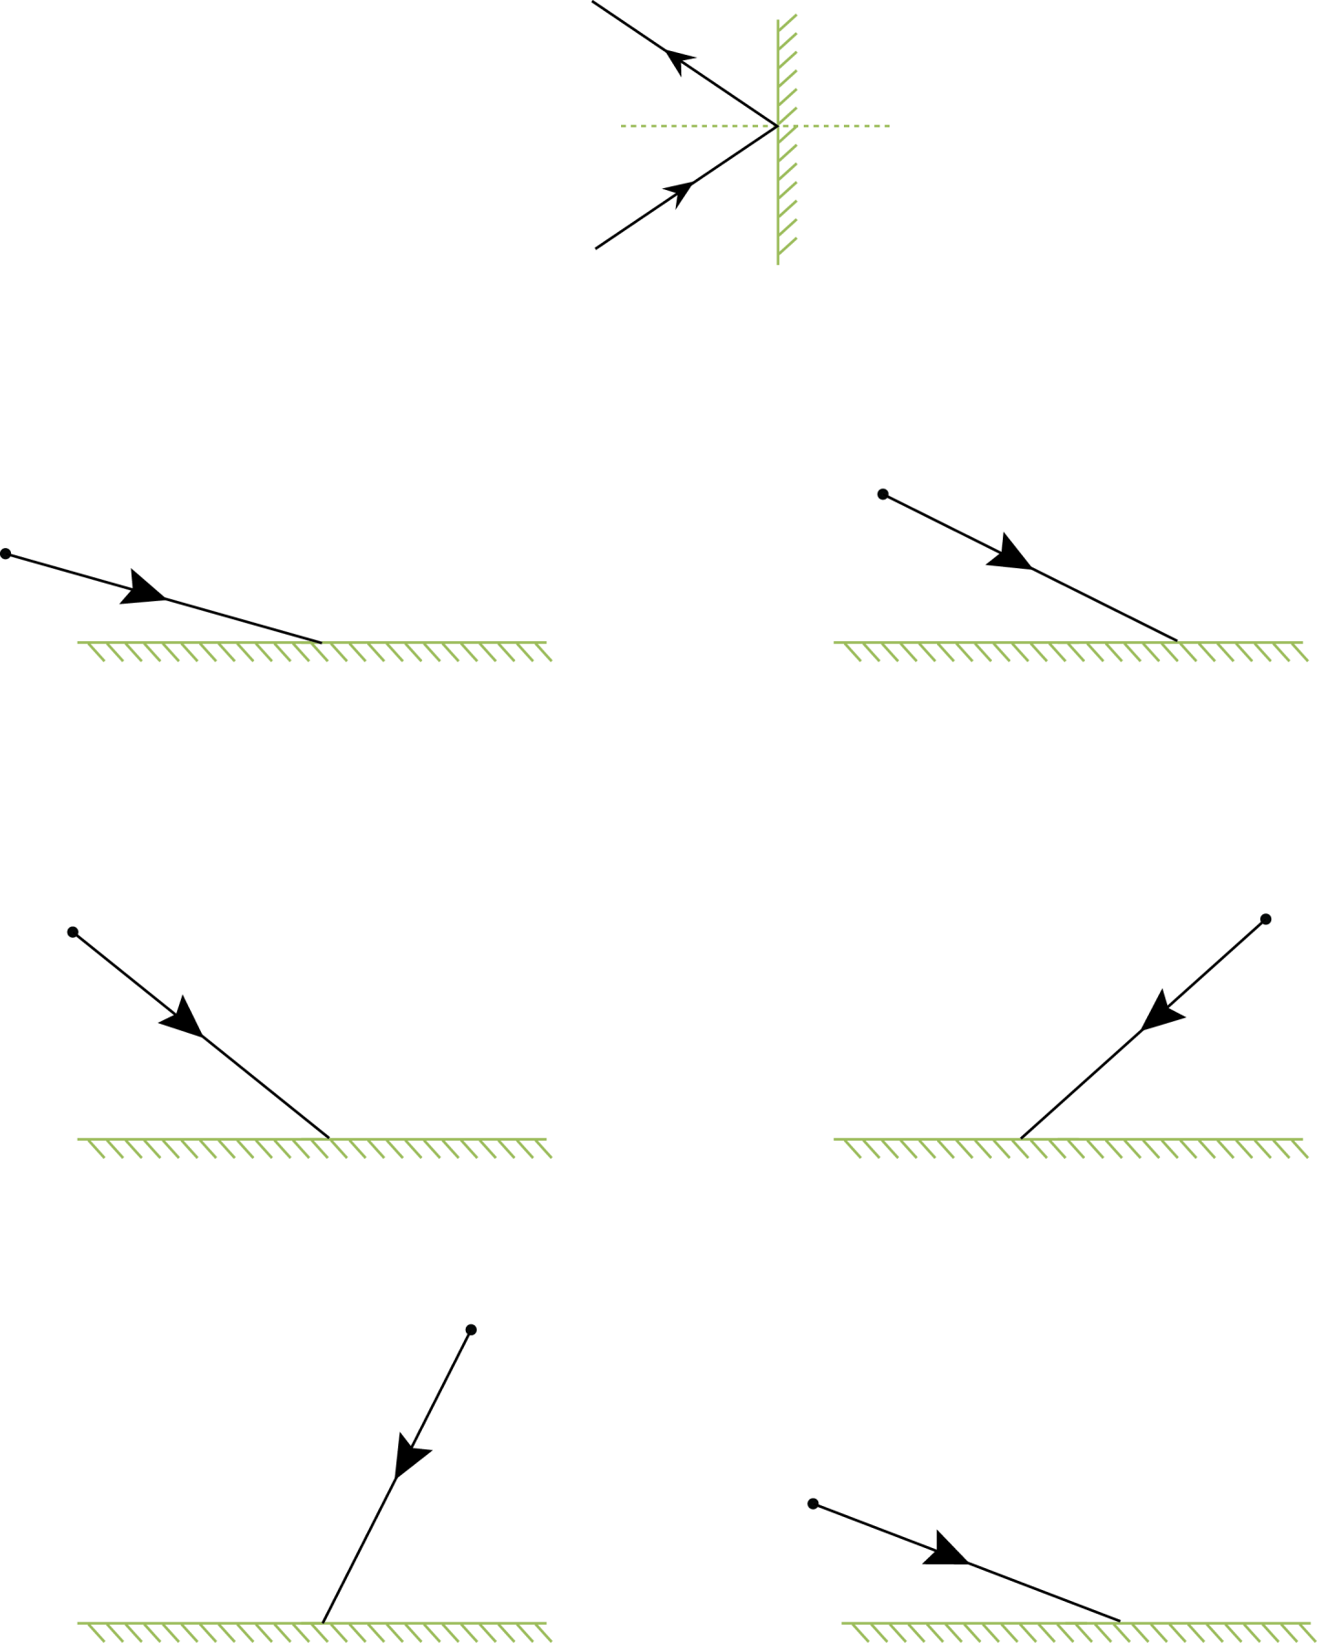
plane mirror
object
normal

Worksheet B - task

The diagrams show a ray of light (incident ray) hitting a mirror. Draw the normal line (at 90∘ to the mirror) followed by the reflected ray. Make sure that you use a ruler and draw an arrow to show the way that the light is travelling. The first one has been done for you.

plane mirror
object
normal

Teaching notes

There are two different versions of the activity. Students should know the rule for reflection before doing this activity. Provide students with protractors, rulers and sharp pencils.

Ask students to measure and write in the angles of incidence and reflection.

If half the class complete sheet A and the rest complete sheet B then students could peer assess each others diagrams. They should look out for the following marking points:

- rays drawn with a ruler
- the normal clearly drawn at a 90º angle
- rays should touch the surface of the mirror
- arrows should be drawn in the right directions
- the angle of incidence should equal the angle of reflection.

Answers

Angle of incidence and reflection (∘)
Example diagram = 30
Worksheet A |  | Worksheet B
50 | 14 | 74 | 63
63 | 23 | 50 | 48
15 | 68 | 27 | 70

