These answers have been submitted by a student. Your task is to tell them what they did correctly and where they need to improve. To do this you will need to redraw their circuits and correct their answers where necessary.
Current in series circuits

Question 1: Draw a series circuit with a light bulb, a 12 V cell and an ammeter.
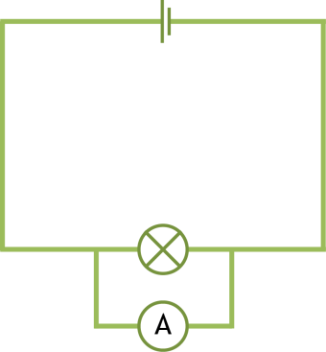 | What went well?  What went wrong? | Correct diagram
Question 2: Draw a series circuit with a bulb. It should show an ammeter and value of the current at three different points in the circuit.
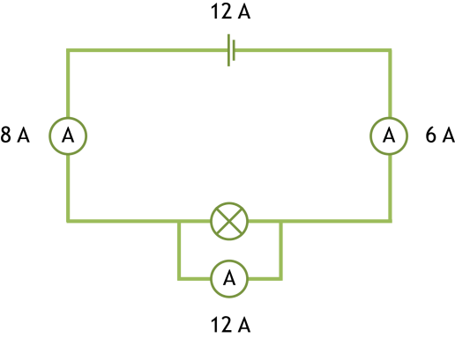 | What went well?  What went wrong? | Correct Diagram

Current in parallel circuits
Question 1: Draw a parallel circuit with a light bulb on each branch, a 12 V cell and an ammeter to measure the current in each branch.
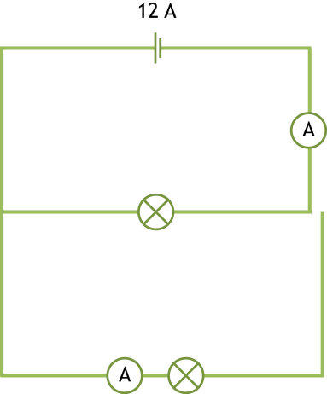 | What went well?  What went wrong? | Correct diagram
Question 2: Draw a parallel circuit with two branches and a light bulb on each branch. Add ammeters that show the value of the current as it leaves the cell and returns and the value of the current after each lightbulb. The value of the current leaving the cell is 9A.
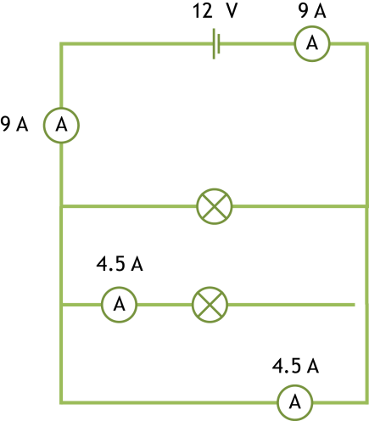 | What went well?  What went wrong? | Correct Diagram

Answers

Current in series circuits

Question 1: Draw a series circuit with a light bulb, a 12 V cell and an ammeter.
What went well?
- circuit is complete
- correct symbols used.

What went wrong?
- ammeter should not be outside of the circuit
- cell voltage should appear on the diagram.

Question 2: Draw a series circuit with a bulb that shows the value of the current at 3 different points on the circuit.
What went well?
- complete circuit
- drawn in series
- three ammeters at different points.

What went wrong?
- ammeter should not be placed in parallel
- current should be the same everywhere on a series circuit
- the value for the cell should be in volts not amps

Current in parallel circuits
Question 1: Draw a parallel circuit with a light bulb on each branch, a 12 V cell and an ammeter to measure the current in each branch.
What went well?
- correct symbols used
- parallel circuit
- two ammeters present
- bulbs on each branch.
What went wrong?
- circuit is broken
- first ammeter is not on the branch
- the cell should show voltage not amps.
Question 2: Draw a parallel circuit with two branches and a light bulb on each branch. Add ammeters that show the value of the current as it leaves the cell and returns and the value of the current after each lightbulb. The value of the current leaving the cell is 9A.
What went well?
- correct symbols used
- cell’s value is in volts (although this was not given in the question)
- diagram shows that current leaving and returning is the same
- values on the branches are correct for two branches (but not correct for the circuit drawn).

What went wrong?
- broken circuit
- three branches instead of two
- no ammeter in the first branch.

