Task
- Read carefully through the text.
- Put the images in the order that they appear in the text.
- Glue the images in the spaces provided on the worksheet and quote a small part of the text that you are linking the image to – this cannot be more than eight words! Next, say why you are matching the image to that piece of text.
When you think about the word ‘current’ what is the first thing that comes to mind? Perhaps the current in a river or something present-day?
The current of a river is the flow of water. As the current flows from high ground to low ground it can carry things with it, like leaves, twigs and even boats. Current can only flow from high ground to low ground.
Current in an electrical circuit is very similar, it also flows and carries electrical charge. The electrical current that flows in one direction is called direct current. Just like a river, it cannot flow backwards and forwards, it can only flow from one side of the battery to the other.
As long as the current flows through the wires and cell any components in the circuit, like lightbulbs or buzzers will work. However, it is very important that there are no breaks in the electrical circuit because if there were, the electrical charge would not be able to flow back to the cell.
We can think of the cell as being responsible for ‘pushing’ the current around the circuit. A bigger push from the cell will mean that more current can flow.
To measure the current we use a piece of equipment called an ammeter, and it is placed in the circuit so that it can measure the current that flows through it. An ammeter measures current in units called ‘amps’ or ‘amperes’. Amps are given the unit symbol, A, for example, 10 A is 10 amps. Remember that the ammeter must be part of the circuit and not on the outside of it.
The amount of current that leaves the cell must be the same as the amount of current that returns to the cell. No matter where we measure the current in a series circuit, it will always be the same.

Image | I think the image is linked to this piece of text (no more than 8 words). |  | Image | I think the image is linked to this piece of text (no more than 8 words).
 | This is because… |  |  | This is because…
 | This is because… |  |  | This is because…
 | This is because… |  |  | This is because…
 | This is because… |  |  | This is because…

Additional questions
- Why is current like a river?
- Why is current not like a river?
- What unit is current measured in?
- What piece of equipment is used to measure current?
- What can cause current to stop flowing around a circuit?
- Describe how current moves around a circuit.
- Describe how to correctly place an ammeter in a circuit.
- If current is flowing at the same rate around the circuit predict what might happen to it if another cell is added.
Images
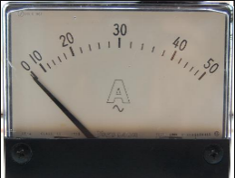 |  | 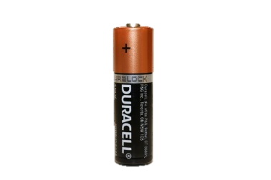
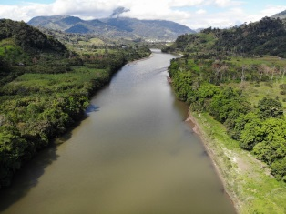 |  | 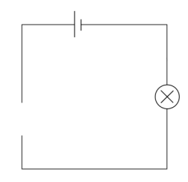
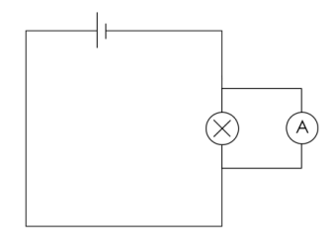 |  | 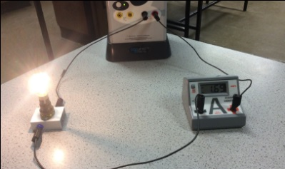
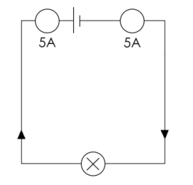 |  | 
 | 

Teaching notes
This activity is best used to consolidate learning after students have set up a series circuit and measured current.
The first activity will force students to actively engage with text while justifying their selections.
It is important to tell students that it is not the order in which they put the images that is important, but their justification for why.
Image credit
© By | - Own work, CC BY-SA 4.0, commons.wikimedia.org/w/index.php?curid=35197118

