Task
- Sort the cards below into the correct categories.
Check your answers with your teacher before doing the mind map.
Voltage | Current | Resistance

Measured in volts. | Calculated by the  formula I x R | Measured in ohms, Ω.
It is the movement  of electrons. | Measured in amps. | Measured using a voltmeter.
Measured using an ammeter. | Like the flow of a river. | Like a push.
Slows the current down. | Causes some energy to shift  to the surroundings. | Like water flowing from wide pipe into a narrower pipe.

- Complete the mind map using the information in your catagories. Each arm of the mind map shoul be labelled either, current, voltage or resistance.
- Use your completed mindmap to tell your partner about voltage, current and resistance (it is a good idea to trace your finger along the arms of the map as you speak to them).
- Now, without looking at your original mindmap try to recreate it.
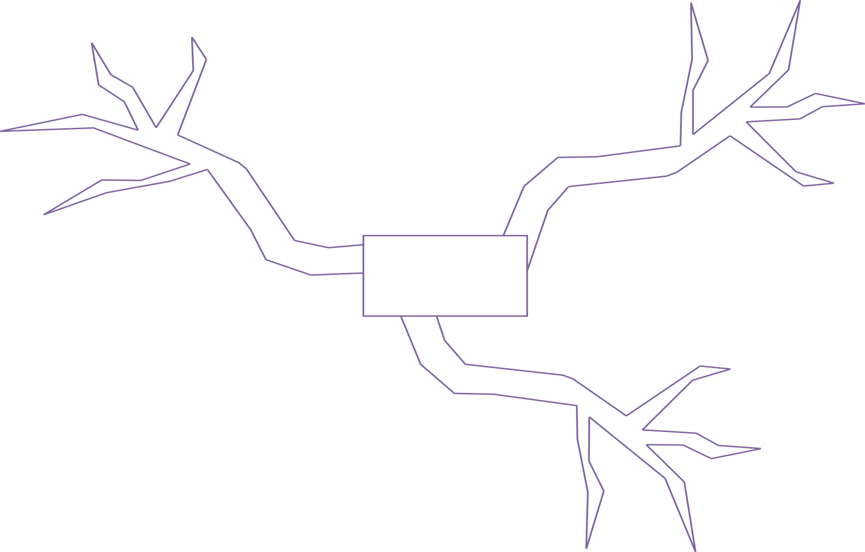

Teaching notes and answers
This activity is most suitable for lower to middle achievers after they have been introduced to current, voltage and resistance.
The task asks students to sort 12 statements into their relevant categories, current, voltage or resistance.
It is very important that at this stage their work is checked, otherwise, they may be using a powerful technique to rehearse, recall and link incorrect information.
After their work is corrected they are asked to complete a blank mind map.
Students then rehearse their knowledge by using their mind map to tell their partner about current, voltage and resistance and how they link together – and then they listen to their partner’s explanation. Usually at this point, some questions may arise or, if you’re luck some “what ifs”. Ask students to scribble down any of these points on their mind map for clarification later.
Then, in silence, students try to recreate their mind map without looking.
As a final task, you could then ask students to write a short paragraph on what they have learned.
Voltage | Current | Resistance
Measured in volts. | Measured using an ammeter. | Measured in ohms, Ω.
Measured using a voltmeter. | Measured in amps. | Causes some energy to shift  to the surroundings.
Like a push. | Like the flow of a river. | Slows the current down.
Calculated by the  formula I x R | It is the movement of electrons. | Like water flowing from a wide pipe  into a narrower pipe.

