Sometimes when chemicals are mixed they react to form a new substance and sometimes a chemical will just need heat to break apart.
The word thermal means heat and another way of saying breaking down is ‘decompose’ – so thermal decomposition means to break down with heat.
One example of this happening is chalk. The chemical name for chalk is calcium carbonate and when heated it breaks down into a chemical called calcium oxide and a gas called carbon dioxide.
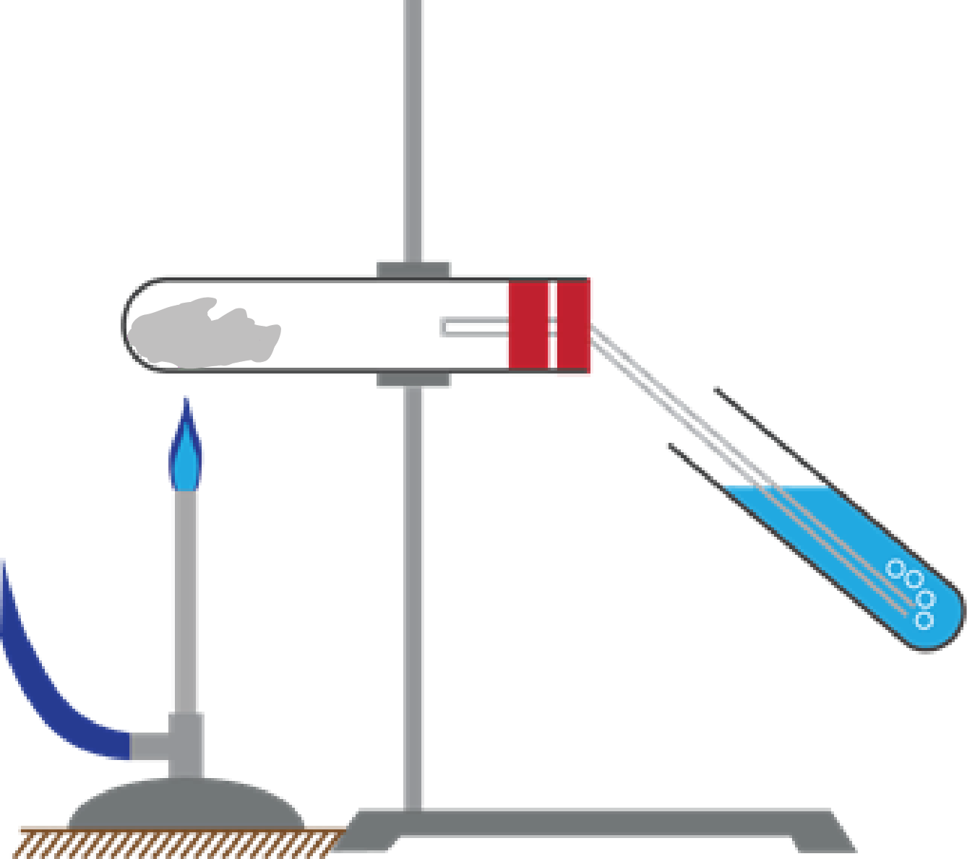

This is the equipment that your teacher will have used to show you thermal decomposition.
Label the diagram using these words:
Bunsen burner | heat-proof mat | limewater
bung | delivery tube | stand and clamp

List three things that could injure or hurt someone during the demonstration.

What observations did you make during the demonstration?

Calcium carbonate breaks down (decomposes) with heat, it thermally decomposes.

Carbon
Oxygen
Oxygen
Oxygen
Oxygen
Oxygen
Oxygen
Carbon
Calcium
Calcium

- Colour the calcium yellow, the carbon black, and the oxygen blue.

- Before the reaction there is/are compound(s).
After the reaction there is/are compound (s).

- What has caused the compound(s) to break up? .

- What is this process called? T d .

- How many carbon atoms are there before thermal decomposition?
How many carbon atoms are there after thermal decomposition?

How many oxygen atoms are there before thermal decomposition?
How many oxygen atoms are there after thermal decomposition?

How many metal atoms are there before thermal decomposition?
How many metal atoms are there after thermal decomposition?

Zinc carbonate breaks down (decomposes) with heat, it thermally decomposes.

heat
Carbon
Oxygen
Oxygen
Oxygen
Oxygen
Oxygen
Oxygen
Carbon
Zinc
Zinc

- Colour the calcium yellow, the carbon black, and the oxygen blue.

- Before the reaction there is/are compound(s).
After the reaction there is/are compound (s).

- What has caused the compound(s) to break up? .

- What is this process called? T d .

- How many carbon atoms are there before thermal decomposition?
How many carbon atoms are there after thermal decomposition?

How many oxygen atoms are there before thermal decomposition?
How many oxygen atoms are there after thermal decomposition?

How many metal atoms are there before thermal decomposition?
How many metal atoms are there after thermal decomposition?

Copper carbonate breaks down (decomposes) with heat, it thermally decomposes.

heat
Carbon
Oxygen
Oxygen
Oxygen
Oxygen
Oxygen
Oxygen
Carbon
Copper
Copper

- Colour the copper green, the carbon black, and the oxygen blue.

- Before the reaction there is/are compound(s).
After the reaction there is/are compound (s).

- What has caused the compound(s) to break up? .

- What is this process called? T d . .

- How many carbon atoms are there before thermal decomposition? .
How many carbon atoms are there after thermal decomposition? .

How many oxygen atoms are there before thermal decomposition? .
How many oxygen atoms are there after thermal decomposition? .

How many metal atoms are there before thermal decomposition? .
How many metal atoms are there after thermal decomposition? .

Teaching notes and answers
This resource gives a good basis to explore the idea of conservation of atoms during a chemical reaction. Ask the students what they notice about the answers that they give to questions 5, 10 and 15.

The answers repeat themselves for questions 6-15.
- Before the reaction there is one compound.
After the reaction there are two compounds.
- Heat energy
- Thermal decomposition
- How many carbon atoms are there before thermal decomposition? | One
How many carbon atoms are there after thermal decomposition? | One
How many oxygen atoms are there before thermal decomposition? | Three
How many oxygen atoms are there after thermal decomposition? | Three
How many metal atoms are there before thermal decomposition? | One
How many metal atoms are there after thermal decomposition? | One

