Task A
Cut out the ‘foldable’ below. Cut along the solid lines and make a fold along the dotted line.
Put glue just on the ‘Chemical reactions’ section and stick it in your book. You should be able to lift up each of the five flaps.
Sort the statements into the correct categories and write them under the correct flap.
Chemical reactions  foldable | What happens to atoms during a chemical reaction?
Chemical reactions  foldable | Why are catalysts useful?
Chemical reactions  foldable | How can you tell that a reaction is happening?
Chemical reactions  foldable | Examples of useful chemical reactions.
Chemical reactions  foldable | What is a reversible reaction?
Statements
Make new substances
Fizzing and bubbles
The substance is not used in the reaction
After atoms are rearranged they can return to their original substances
Atoms are rearranged
Burning fuel for heat
Medicines
Reactions speed up
Explosions
Temperature change
Smells
Making fabrics

Task B
Cut out the ‘foldable’ below. Cut along the solid lines and make a fold along the dotted line.
Put glue just on the ‘Chemical reactions’ section and stick it in your book. You should be able to lift up each of the five flaps.
Sort the statements into the correct categories and write them under the correct flap.
Chemical reactions  foldable | What happens to atoms during a chemical reaction?
Chemical reactions  foldable | Why are catalysts useful?
Chemical reactions  foldable | How can you tell that a reaction is happening?
Chemical reactions  foldable | Examples of useful chemical reactions.
Chemical reactions  foldable | What is a reversible reaction?
Statements
Make new substances
Energy is transferred
A + B ⇌ C + D
Temperature change
Reactions speed up
Medicines
Explosions
After atoms are rearranged they can return to their original substances
Fizzing and bubbles
Smells
Atoms are rearranged
The substance is not used in the reaction
Burning fuel for heat
Making fabrics

Teaching notes and answers
The worksheets are slightly different with worksheet B including two extra statements about energy transfer and reversible reactions. Choose the most appropriate for your students. To give greater challenge students could be given just the foldable and be asked to write their own statements.
The foldable should be glued into the book along the spine (as shown in the image and the statements sorted and copied into the correct categories.
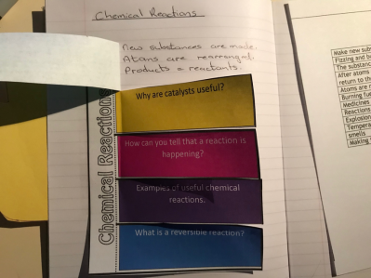
Worksheet A | Worksheet B
What happens to atoms during a chemical reaction? | What happens to atoms during a chemical reaction?
Make new substances | Make new substances
Atoms are rearranged | Atoms are rearranged
 | Energy is transferred
Why are catalysts useful? | Why are catalysts useful?
Reactions speed up | Reactions speed up
The substance is not used in the reaction | The substance is not used in the reaction
How can you tell that a chemical reaction is happening? | How can you tell that a chemical reaction is happening?
Explosions | Explosions
Temperature change | Temperature change
Fizzing and bubbles | Fizzing and bubbles
Smells | Smells
Examples of useful reactions | Examples of useful reactions
Burning fuel for heat | Burning fuel for heat
Medicines | Medicines
Making fabrics | Making fabrics
Reversible Reactions | Reversible Reactions
After atoms are rearranged they can return to their original substances | After atoms are rearranged they can return to their original substances
 | A + B ⇌ C + D

