Task 1
We are looking down on the head and shoulders of a human. The diagram shows the structures involved in breathing from this unusual perspective. Label the diagram using the keywords below.
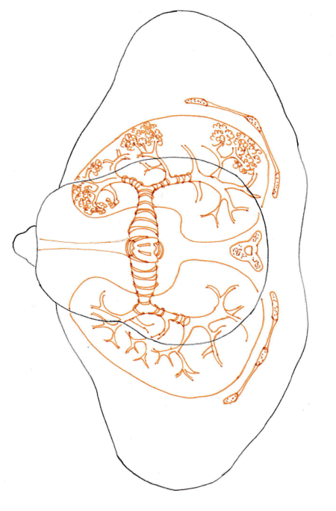
trachea | vertebra | alveoli | bronchus
bronchiole | rib | diaphragm | larynx

Task 2
The statements in the second and third column are muddled up. Cut them out and rearrange them in the correct places.
Check your completed table with your teacher and then stick them down.
Structure | Description | Adaptation for function
Rib | Thin sheet of muscle which is attached all around the inside of the ribs beneath the lungs. | Covered in rings of cartilage which support the trachea and hold it open.
Alveoli | Known as the windpipe it carries air from mouth and nose to the lungs. | Contains two vocal cords which vibrate and enable us to make sounds.
Bronchus | 'Cage' of narrow bones connected by muscles. | Contracts and relaxes with each breath. It alters the volume of the chest cavity.
Trachea | Small tubes inside the lungs. | Thin tissue allows gases to pass between lungs and blood stream quickly. The blood transports the oxygen and carbon dioxide.
Larynx | There are two of these tubes which carry air to the lungs. | Numerous and highly branched to allow large amounts of air to move in and out of the alveoli.
Diaphragm | Tiny 'balloons' of very thin tissue, surrounded by blood vessels. | Strong to protect heart and lungs. Mobile enough to alter the volume of chest cavity.
Bronchiole | Voice box. A tubular structure of muscle and cartilage. | Covered in rings of cartilage which hold tubes open.
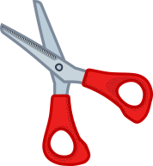

Answers
Task 1
rib
alveoli
bronchus
diaphragm
vertebra
bronchiole
trachea
larynx

Task 2
Structure | Description | Adaptation for function
Rib | 'Cage' of narrow bones connected by muscles. | Strong to protect heart and lungs. Mobile enough to alter the volume of chest cavity.
Alveoli | Tiny 'balloons' of very thin tissue, surrounded by blood vessels. | Thin tissue allows gases to pass between lungs and blood stream quickly. The blood transports the oxygen and carbon dioxide.
Bronchus | There are two of these tubes which carry air to the lungs. | Covered in rings of cartilage which hold tubes open.
Trachea | Known as the windpipe it carries air from mouth and nose to the lungs. | Covered in rings of cartilage which support the trachea and hold it open.
Larynx | Voice box. A tubular structure of muscle and cartilage. | Contains two vocal cords which vibrate and enable us to make sounds.
Diaphragm | Thin sheet of muscle which is attached all around the inside of the ribs beneath the lungs. | Contracts and relaxes with each breath. It alters the volume of the chest cavity.
Bronchiole | Small tubes inside the lungs. | Numerous and very branched to allow large amounts of air to move in and out of the alveoli.

