Task

The following statements are related to the compounds water, carbon dioxide and oxygen and their role in photosynthesis.

What are the similarities and differences between these compounds and their relationship with plants and the process of photosynthesis?

Use the diagram to help you sort the statements. Decide if a statement is relevant to one or all of the compounds and place it in the correct space on the diagram.

Used by plant in photosynthesis. | Reacts with glucose during respiration. | Plants absorb it from the atmosphere.
Helps support plants. | Used to make glucose. | Reacts with water during photosynthesis.
Carries dissolved substances into plant. | Absorbed through roots. | Plants produce the gas we breath.
Diffuse from plants through stomata. | Reactants or product in photosynthesis. | Reactant or products in plant respiration.
Molecules are made of elements which are present in glucose. | (Waste) product of respiration. | Will dissolve in water inside plant.
Enter and leaves plants as gases. | (Waste) product of photosynthesis.

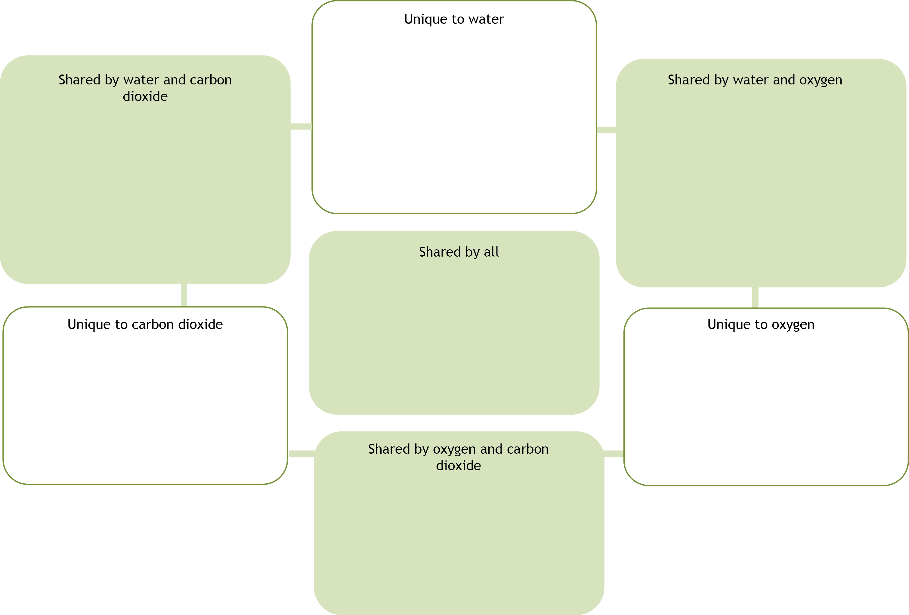
Answers

Unique to water | Unique to oxygen | Unique to carbon dioxide
Helps support plants.  Absorbed through roots.  Carries dissolved substances into plant. | (Waste) product of photosynthesis.  Reacts with glucose during respiration.  Plants produce the oxygen we breath. | (Waste) product of respiration.  Reacts with water during photosynthesis.  Plants absorb it from the atmosphere.
Shared by water and oxygen | Shared by carbon dioxide and oxygen | Shared by water and carbon dioxide
Diffuse from plants through stomata. | Enter and leaves plants as gases.  Both will dissolve in water inside plant. | Used by plant in photosynthesis.  Used to make glucose.
Shared by all
Involved in photosynthesis.

Involved in plant respiration.

Compound made of elements which are present in glucose.

