Task 1

Label the diagram of the skeleton below.

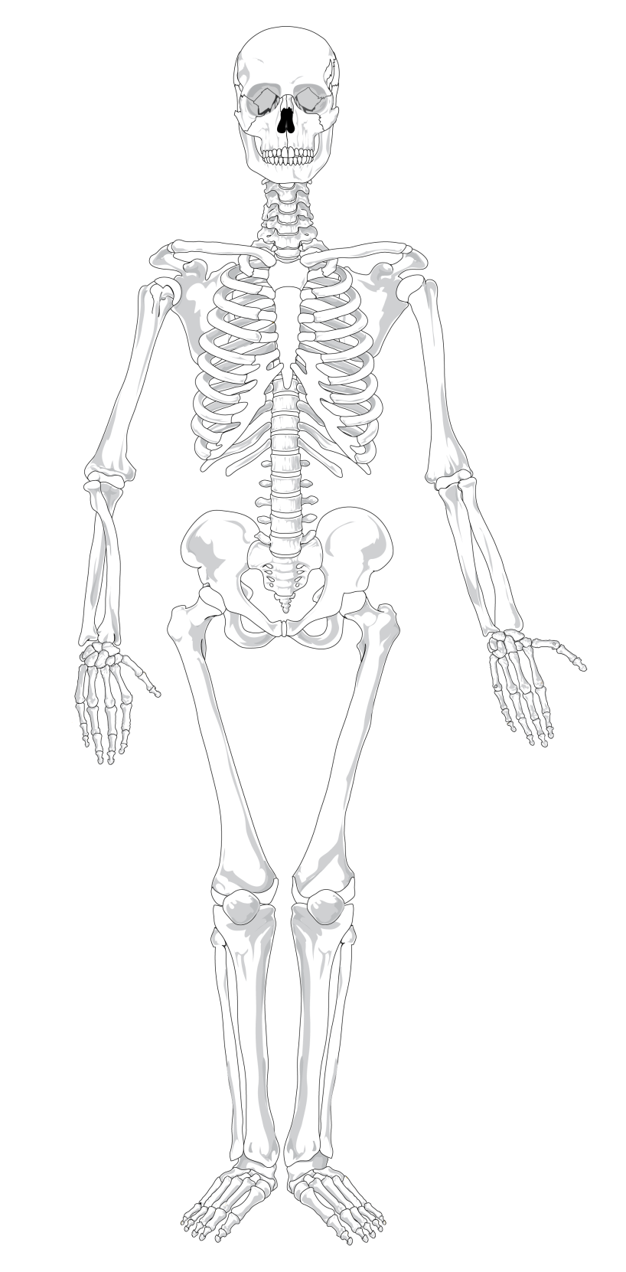

ankle | radius |  | spine |  | humerus
femur | collar bone |  | tibia |  | rib
wrist |  | pelvis |  | skull

Task 2

Answer the following questions.
1. The skeleton protects organs. State the names of the bones that protect the following organs:
a. heart and lungs
b. brain
c. spinal cord
d. bladder
2. Name two other functions of the skeleton.

3. Name a mineral we need from our diet to help make our bones strong.

4. Describe what a joint is and give an example of a joint.

5. Describe the properties of the skeleton that make it good at its job.

Extension

1. Predict how the skeleton of a large land animal would be different from a human skeleton. Explain what problems this would cause for the animal.

2. Suggest reasons why the largest animals, like whales, are only found in water.

Answers

Task 1

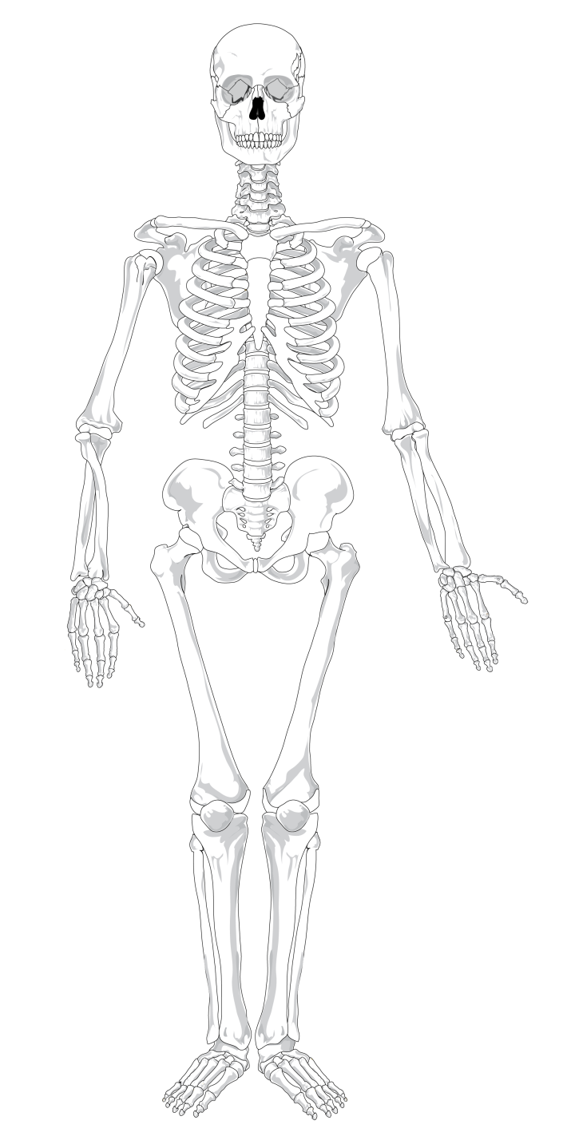
skull
collar bone
humerus
pelvis
femur
ankle
tibia
wrist
radius
rib
spine

Task 2

- a. ribcage b. skull c. spine d. pelvis

- Movement of the body, makes blood cells

- Calcium

- Joints are found where two bones meet e.g. hip – ball and socket joint

- Strong, rigid and light

