Marie Curie (1867 – 1934) biography A

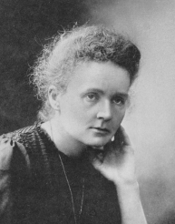 | Maria Salomea Sklodowska was born in Warsaw, Poland, on November 7th 1867. She was the youngest of five children – three older sisters and a brother. Her mother was a headmistress and her father taught maths and physics. He introduced the subjects to Maria when she was a child. When Maria was young, Poland was ruled by Russia. Maria’s family didn’t like the rules the Russian government made, however. For example, it was against the law to speak Polish and it was illegal for girls to go to school. Maria was clever and curious so her parents decided to send her to a secret school, where she did extremely well.
Unfortunately, however, not everything in Maria’s early life was easy. In 1877, when Maria was just 10 years old, her oldest sister died from typhus and in 1979 her mother died of tuberculosis. Maria and her family were heartbroken. Maria finished school when she was 15. She and her sister, Bronya were both interested in scientific research and after school, they both desperately wanted to go to University. The University in Warsaw, however, only allowed men to attend at the time. Women were allowed to go to University in other countries, but that was very expensive. So Maria and Bronya promised each other that they would take turns working to pay for the other to travel abroad to study. Maria thought that every child should be educated, so for almost 5 years, she secretly worked as a governess and a tutor, illegally teaching poor children to read. She sent the money she earned to Bronya, who attended University and became a doctor, which was almost unheard of for women at the time.

In 1891, Maria moved to Paris. She changed her name to Marie because it sounded more French. She studied at the Sorbonne, a famous University, where she earned a degree in physics, maths and chemistry. Later, she gained a master’s degree in physics and then yet another degree in maths. Marie was so poor while she was there
that she had to live on bread and tea and she sometimes fainted from hunger!  While she was in Paris, Marie met Pierre Curie, a physics professor. They soon fell in love and were married in 1895. Marie worked with her husband in scientific research to investigate x-rays, radioactivity, and how atoms work. In 1898 Marie and Pierre discovered two new substances, called polonium (named after Poland) and radium. In 1903, they won a joint Nobel Prize for their work in physics, making Marie the first woman ever to win the award. |  | 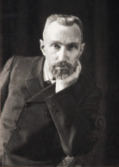

Marie and Pierre had two children – Irene born in 1897 and Eve, born in 1904. Sadly, in 1906, when Eve was just 2 years old, Pierre was killed when he was knocked down in the street by a horse drawn carriage. Marie was devastated but she decided to take over Pierre’s work. She became the first ever female professor at the Sorbonne University, and she won a Nobel Prize of her own for her work in chemistry in 1911. Soon after this, doctors found that radiology could help with curing cancer.

Then, in 1914, the First World War started. Marie realised if military doctors had access to x-ray machines, they could make better medical decisions and save more lives. She helped to develop mobile x-ray machines and put them into ambulances, which she herself drove to the wounded soldiers on the front line.
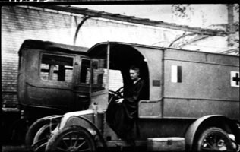
These vehicles became known as ‘Little Curies’ in Marie’s honour and they helped over one million soldiers during the war. She trained doctors and taught them how to use this new life-saving equipment and in 1921, she set up the Curie Institute in Paris. It is still an important cancer research centre today.

Marie didn’t realise it, but the radioactive substances she worked with were very dangerous. As a result of working with them for such a long time, Marie developed leukaemia, a blood disease, and died on 4th July 1934, aged 66.

Marie’s discoveries of radium and polonium have changed science and medicine forever. Her work meant that x-ray machines became more useful and were used more by doctors. They continue to be used today to detect broken bones and other problems, helping doctors to treat and cure their patients.

Comprehension questions A
Read the text and answer the questions below
- Where and when was Maria born?

- Why was Maria’s father influential in her career?

- How did Maria help her sister to go to university?

- Find 5 facts in the text about Maria’s education, including university.

- List 5 things that happened to Maria in Paris

- What was Marie’s husband called?

- What did Marie and Pierre Curie investigate?

- Which substances did Marie and Pierre discover?

- How do you think Marie and Pierre felt about receiving the Nobel Prize for their work in physics? Why?

- What were ‘Little Curies’?

- How and when did Marie Curie die?

Marie Curie (1867 – 1934) biography B

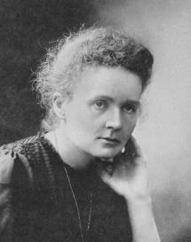 | - Marie Sklodowska was born in Warsaw, Poland, on November 7th 1867.  - Marie was a very clever child.  - It was against the law in Poland for girls to go to school at that time, so her parents sent her to a secret school, where she did extremely well.  - In 1877, when Marie was just 10 years old, her oldest sister died from typhus.  - Then 1879, Marie’s mother died of tuberculosis. After she had finished school, Marie secretly worked as a tutor, illegally teaching poor children to read.
- She saved up some money to help her sister, Bronya, go to University.  - In 1891, Marie moved to Paris, to study at the Sorbonne University  - She earned a degree in physics, maths and chemistry.  - She was so poor that she had to live on bread and tea and she sometimes fainted from hunger!  Then Marie met Pierre Curie, a physics professor, who she married in 1895.  - Together, they investigated x-rays, radioactivity, and how atoms work.  - In 1898, they discovered two new substances, called |  | 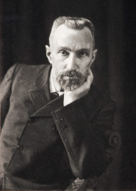
polonium (named after Poland) and radium.
- In 1903, they won the Nobel Prize for their work in physics, making Marie the first woman ever to win the award.
- Marie and Pierre had two children – Irene (born in 1897) and Eve (born in 1904).
- Sadly, in 1906, Pierre was knocked down by a horse drawn carriage and was killed
- Marie decided to take over Pierre’s work, becoming the first ever female professor at the Sorbonne University
- She won another Nobel Prize for her work in Chemistry in 1911.
- Soon afterwards, doctors found that radiology could help with curing cancer.
- In 1914, the First World War started.
- Marie helped to put mobile x-ray machines into ambulances, so that doctors could save more lives.
- These vehicles became known as ‘Little Curies’ and they helped over 1 million soldiers during the war.

- Marie trained doctors and taught them how to use this life-saving equipment.
- In 1921, she set up the Curie Institute in Paris, which is still an important cancer research centre today.
- Marie developed a blood disease called leukaemia because she worked with dangerous radioactive substances for such a long time.
- She died on 4th July 1934, aged 66.
- Marie’s discoveries have changed science and medicine forever.
- Her work meant that x-ray machines became more useful. They are still used today to detect broken bones and other problems, helping doctors to treat and cure their patients.

Comprehension questions B
Read the text and answer the questions below
- Where and when was Maria born?

- How did Maria help her sister to go to university?

- Which year and where did Marie Curie attend university?

- What did Marie Curie study at university?

- What was Marie’s husband called?

- What did Marie and Pierre Curie investigate?

- Which substances did Marie and Pierre discover?

- Which award did Marie Curie receive in 1903 and 1911?

- What were ‘Little Curies’?

- How and when did Marie Curie die?

Timeline

Read the information about Marie Curie’s life, then cut out the dates and events below, match them and sort them into chronological order.

Date | Event
7th November 1867 | Marie’s Mum died of tuberculosis
1877 | Marie and Pierre discovered polonium and radium
1879 | Pierre was hit by a carriage and killed
1891 | Marie was born
1895 | Marie and Pierre’s second daughter, Eve was born
1897 | Marie set up the Curie Institute in Paris
1898 | Marie died, aged 66
1903 | Marie moved to Paris and started studying at the Sorbonne University
1904 | Marie and Pierre’s first daughter, Irene was born
1906 | The First World War started and Marie helped to save soldiers’ lives by installing mobile x-ray machines into ambulances, called ‘Little Curies’
1911 | Marie’s oldest sister died of typhus
1914 | Marie and Pierre won the Nobel Prize for their work in physics
1921 | Marie won a Nobel Prize for her work in chemistry
4th July 1934 | Marie married Pierre Curie

After completing the comprehension, fill in the fact sheet below
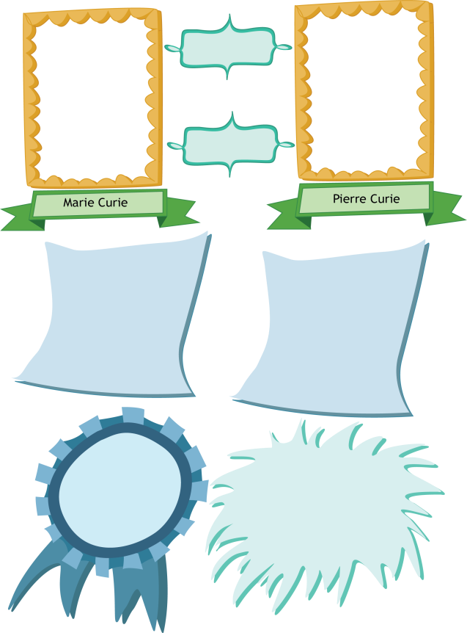
Born:
Died:
Early life:
Later life:
Achievements:
Interesting facts:

Comprehension answers
- Maria was born in Warsaw, Poland on 7th November 1867
- Maria’s father was influential in her career because he taught Maths and Physics and he introduced the subjects to Maria when she was a child.
- For almost five years, Maria secretly worked as a governess and a tutor, illegally teaching poor children to read. She sent the money she earned to her sister, who attended University and became a doctor
- Five facts:
- Maria’s parents decided to send her to a secret school
- Maria did extremely well at school
- Maria finished school when she was 15.
- In 1891, Maria moved to Paris and studied at the Sorbonne, a famous university
- Marie earned a degree in physics, maths and chemistry. Later, she gained a masters degree in physics and then yet another degree in maths.
- Pick 5 from:
- Maria moved to Paris in 1891.
- She changed her name to Marie because it sounded more French.
- She studied at the Sorbonne, a famous University
- She earned a degree in physics, maths and chemistry. Later, she gained a masters degree in physics and then yet another degree in maths.
- Marie often fainted from hunger because she was so poor and had to live on bread and tea
- Marie met Pierre Curie
- Marie and Pierre got married in 1895.
- Marie worked with her husband in scientific research
- In 1903, they won a joint Nobel Prize
- Marie and Pierre had two children
- Pierre was killed
- Marie’s husband was called Pierre
- Marie and Pierre investigated x-rays, ‘radioactivity’, and how atoms work.
- Marie and Pierre discovered polonium and radium
- Several answers could be used here – excited, proud, happy etc. and any related reason – e.g. They had worked hard to achieve this and were pleased to be recognised for their work
- Little Curies were the ambulances which had mobile x-ray machines on board to help the injured soldiers in the First World War
- Marie developed leukaemia, a blood disease, as a result of over exposure to radiation. She died on 4th July 1934, aged 66.

Comprehension B answers

- Marie was born in Warsaw, Poland on 7th November 1867

- For almost five years, Maria secretly worked as a governess and a tutor, illegally teaching poor children to read. She sent the money she earned to her sister, who attended University and became a doctor

- Marie moved to Paris in 1891, where she studied at the Sorbonne University

- Marie studied physics, maths and chemistry at University

- Marie’s husband was called Pierre

- Marie and Pierre investigated x-rays, ‘radioactivity’, and how atoms work.

- Marie and Pierre discovered polonium and radium

- Marie Curie received the Nobel Prize in 1903 and 1911

- Little Curies were the ambulances which had mobile x-ray machines on board to help the injured soldiers in the First World War

- Marie developed leukaemia, a blood disease, as a result of over exposure to radiation. She died on 4th July 1934, aged 66.

Timeline answers

Date | Event
7th November 1867 | Marie was born
1877 | Marie’s oldest sister died of typhus
1879 | Marie’s Mum died of tuberculosis
1891 | Marie moved to Paris and started studying at the Sorbonne University
1895 | Marie married Pierre Curie
1897 | Marie and Pierre’s first daughter, Irene was born
1898 | Marie and Pierre discovered polonium and radium
1903 | Marie and Pierre won the Nobel Prize for their work in Physics
1904 | Marie and Pierre’s second daughter, Eve was born
1906 | Pierre was hit by a carriage and killed
1911 | Marie won a Nobel Prize for her work in Chemistry
1914 | The First World War started and Marie helped to save soldiers’ lives by installing mobile x-ray machines into ambulances, called ‘Little Curies’
1921 | Marie set up the Curie Institute in Paris
4th July 1934 | Marie died, aged 66

