What are cells?
All living things are made up of tiny parcels of matter called cells. Cells are the smallest units of living things. This is why they are sometimes called the building blocks of life.
Living things may be made up of just one cell or many billions of cells. Anything that is made up of one or more cells is considered a form of life or lifeform.
The bodies of all types of animals, including humans, are made up of cells. Different types of cells have different functions or jobs. Human bodies are made up of hundreds of different types of cells, including types of blood cells, nerve cells and skin cells.
All types of plants are made up of cells, too. Plant cells and animal cells have some similar parts and some different parts.
1 Which of these things are living things? Circle your choices.
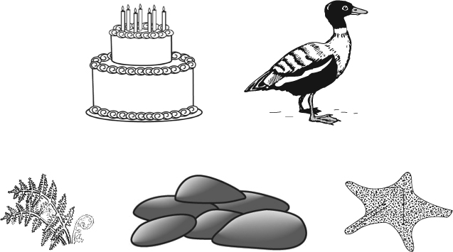
c) fernd) pile of stonese) sea star
a) cake
b) duck
2 Which of the things in Question 1 are made up of cells?

3 Circle the correct phrase within the brackets to complete each sentence.
a) Cells are (tiny parcels of matter / the enemies of all living things / found only in human bodies). They are sometimes called the (playdough / building blocks / organisms) of life.
b) Different types of cells have (different coloured parts / the same purpose / different functions or jobs).
What are cells? cont’d
4 Name three or more types of cells found in the human body.

When scientists talk about a living thing, they use the word organism. When they talk about things related to cells, they use the word cellular.
5 Write the words in the box into the answer spaces to break them into syllables. Remember, each syllable makes one beat when you say the word aloud. For example, the word matter has two syllables: m a t / t e r.
living organism cellular units
a) __ __ __ /__ __ __
b) __ __ /__ __ __ /__ __ /__
c) __ __ __ /__ /__ __ __
d) __ /__ __ __ __
6 If ‘multi-’ means many and ‘uni-’ means one, complete these
sentences using the words from the word bank.
Word bank
organism
cells
one
living
cell
many
a) A _____________ thing made up of _____________
_____________ is called a multicellular organism.
b) A living thing made up of _____________ _____________ is
called a unicellular _____________.

