The structure of cells
BACKGROUND
nucleus (say ‘nu-kle-us’) – the round structure at the centre of the cell containing the genetic information that controls what the cell does
cytoplasm (say ‘site-o-plaz-em’) – the main fluid substance inside a cell, which helps protect the cell’s contents
cell membrane (say ‘sell mem-brain’) – the thin skin around an animal or plant cell that holds the cell together
A cell is like a tiny parcel that contains many different parts or structures. All types of animal and plant cells contain the following three structures:
● the nucleus
● the cytoplasm
● the cell membrane.
1 Add the missing consonants to these letters to make the names of cell structures. Use the meanings to help you.
Letters | Name | 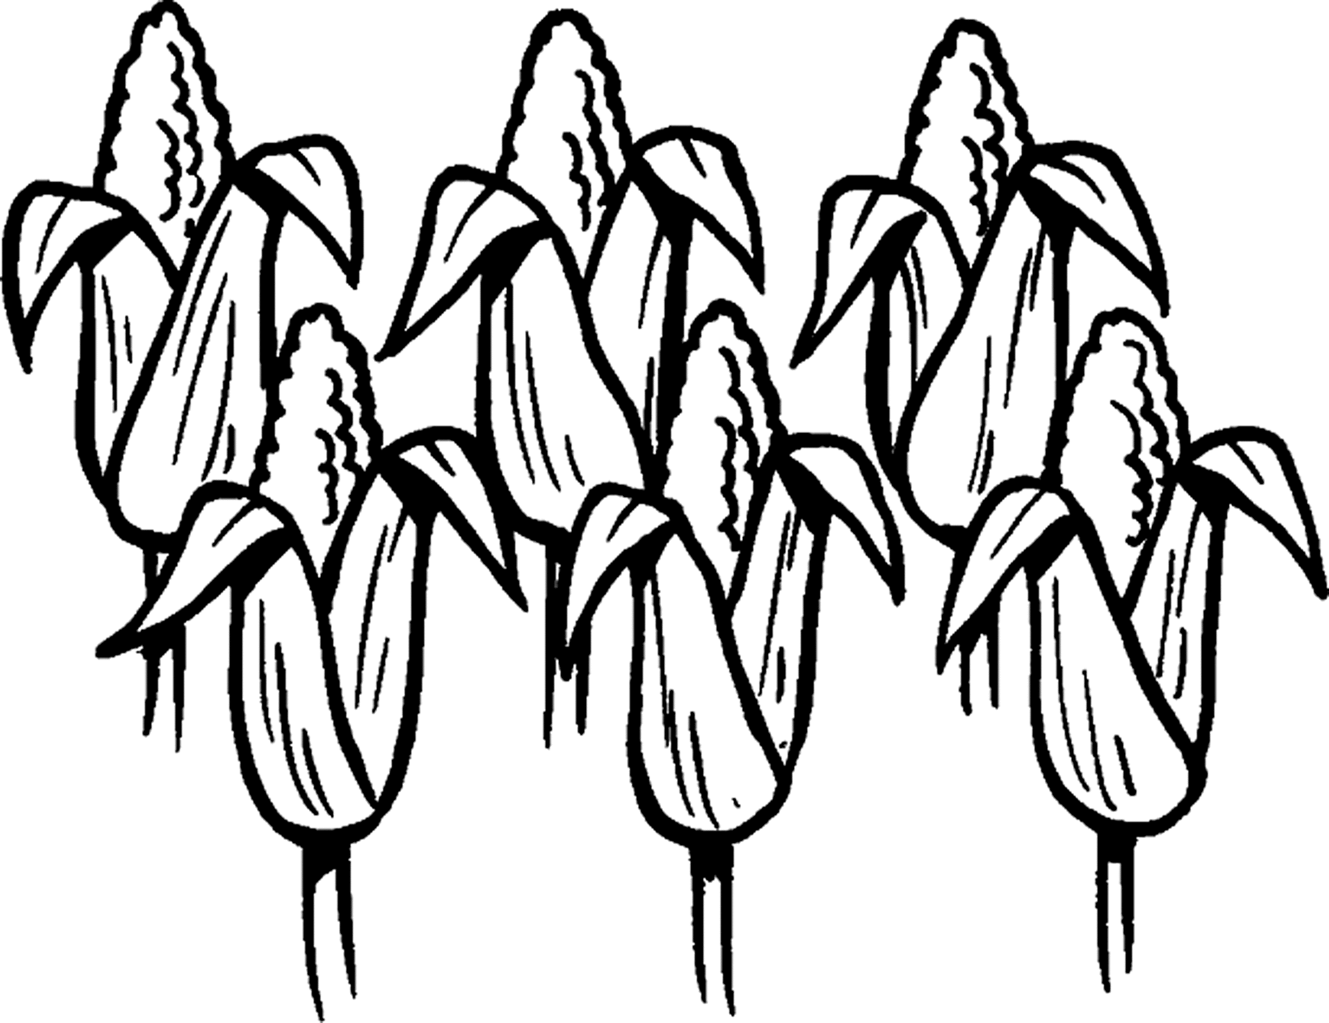  Meaning
u e u |  | found in the centre of the cell
e e a e |  | a thin skin
y o a |  | the jelly-like stuff inside a cell
2 Complete this passage by filling in the missing double letters. Hint: It is the same set of double letters that is missing throughout.
Both animal and plant ce __ __ s are held together by a soft ce __ __ membrane. However, plant ce __ __ s have another outer layer, called the ce __ __ wa __ __,
which is made of a substance called ce __ __ ulose. These hard ce __ __ wa __ __ s give plants their shape and make them able to stand up ta __ __. Animal
ce __ __ s do not have ce __ __ wa __ __ s.
The structure of cells cont’d
3 Choose the correct word within the brackets to complete each sentence.
a) A leaf is made up of tiny units of matter called _____________. (cells / cellulose)
b) Many cells make up the _______________ of human beings. (nucleus / bodies)
c) The cells of humans and animals have ______________ cell walls. (hard / soft)
4 Circle the correct answer.
What are the walls of plant cells made of?
cytoplasm cellulose cells
5 Using the information in this work sheet, draw a basic diagram of a plant cell. Label the four parts described in this Activity sheet.

