Animal cells
Most types of animal cells have a centre called a nucleus near their middle, which is surrounded by a jelly-like substance called cytoplasm. Around this is the cell membrane.
Cells also contain things called proteins and organelles. Proteins are a special kind of nutrient that are an essential part of all living things. Organelles are tiny, living machines that are found inside cells. The organelles perform various jobs to keep the cell alive. Types of organelles include:
● mitochondria, which provide energy for the cell to use
● ribosomes, which are like protein factories
● vacuoles, which are water-filled organelles that can have many functions
● Golgi bodies, which process proteins.
1 Look at the diagram of the animal cell.
a) Fill in the missing vowels (a, e, i, o, u) to complete the labels.
b) Add a label and pointer for cytoplasm.
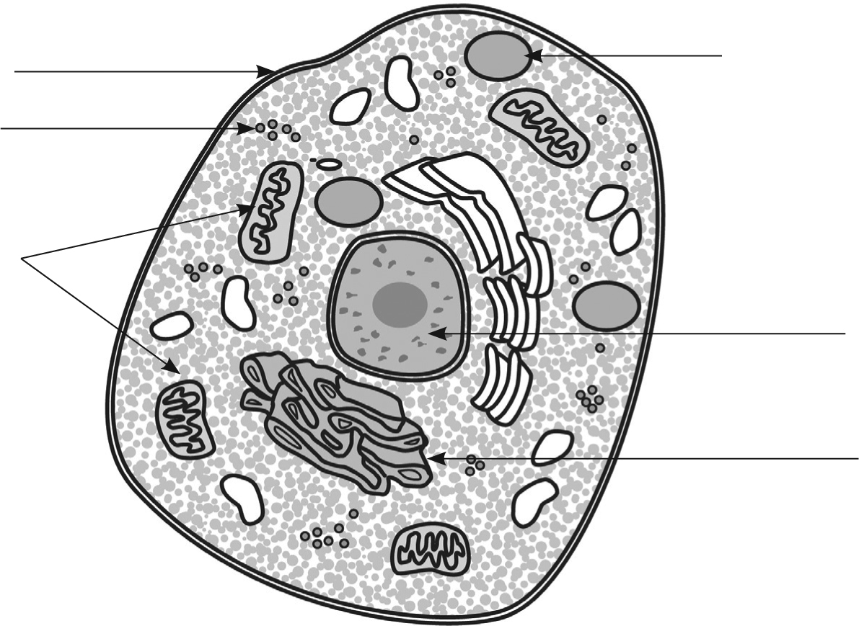
c__ll__m__mbr__n__
n__cl__ __s
m__t__ch__ndr__ __
v__c__ __l__
G__lg__b__dy
r__b__s__m__s
2 Complete the names of three types of animal cells.
b __ __ __ __ cells flow through veins and arteries
n __ __ v __ cells pass electrical messages around the body to help the body feel things
__ k __ __ cells make up the outer covering of a body

