Plant cells
Like animal cells, most plant cells have a nucleus, cytoplasm and cell membrane. Plant cells also have a hard cell wall made of cellulose. Also like animal cells, plant cells contain tiny, living machines called organelles. Golgi bodies and ribosomes are two organelles found in plant cells. They have special jobs to do in the cell to help the plant grow and to keep it healthy. Plant cells also contain large water-filled containers called vacuoles.
Green plants contain important organelles called chloroplasts. These parts have a chemical called chlorophyll in them. It is green. Green plants get their green colour from the chloroplasts. Chloroplasts are involved in the way that green plants use sunlight to produce food, through photosynthesis.
1 Look at the diagram of the plant cell below.
a) Fill in the missing vowels to complete the labels.
b) Add a label and pointer for the cell wall.
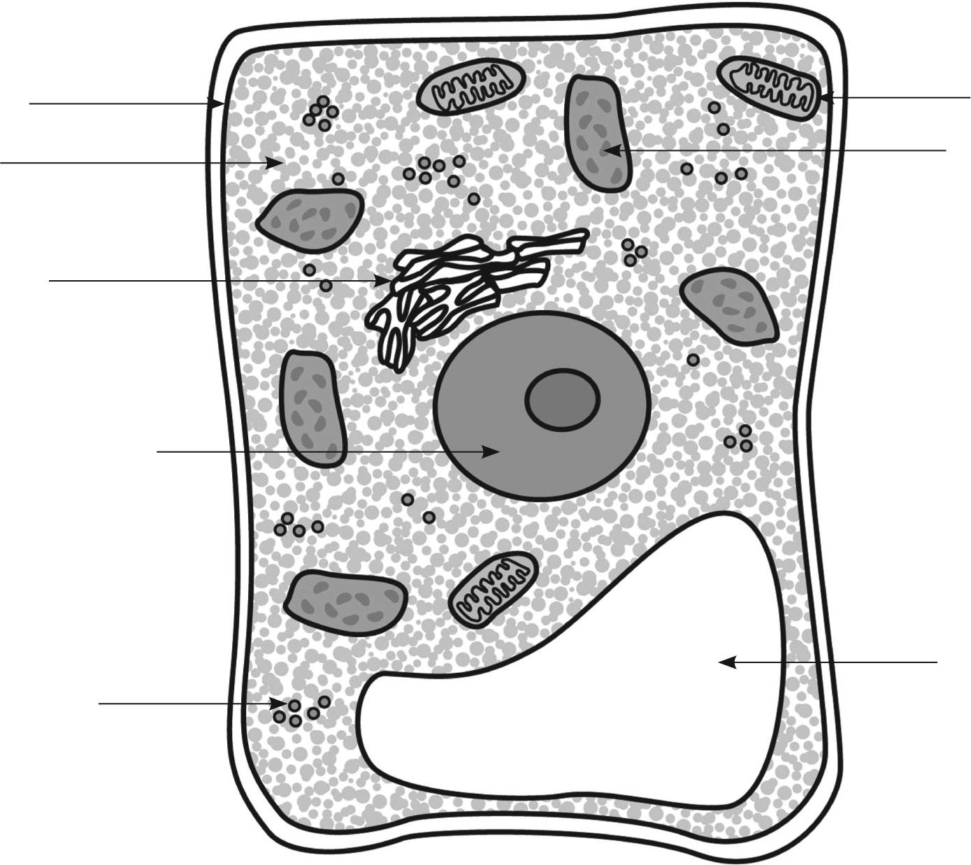
mitochondrion
c__ll m__mbr__n__
chl__r__pl__st
cyt__pl__sm
G__lg__ b__dy
n__cl__ __s
v__c__ __le
r__b__s__m__s
2 Complete the following words.
chloro __ __ __ __ __ A green chemical pigment found in green plant cells
chloro __ __ __ __ __ An organelle found in green plant cells

