CHAPTER 4: Ecosystems
Worksheet 4.1

Biotic and abiotic factors
Science Quest 7: pages 118–121
Answers
The parts of an ecosystem that are non-living are called the abiotic environment. The parts that are
living are called the biotic environment.
1. Complete the table below by classifying the named component as biotic or abiotic.
Component | Biotic or abiotic? | Component | Biotic or abiotic?
Water salinity | Abiotic | Competitors for mating | Biotic
Wind speed and direction | Abiotic | Producers | Biotic
Competitors for food |  | Humidity | Abiotic
Predators | Biotic | Decomposers | Biotic
Light penetration | Abiotic | Air temperature | Abiotic
2. The following photo shows a clownfish sheltering amongst the poisonous tentacles of a sea anemone. The sea anemone does not harm the clownfish as it searches for food.
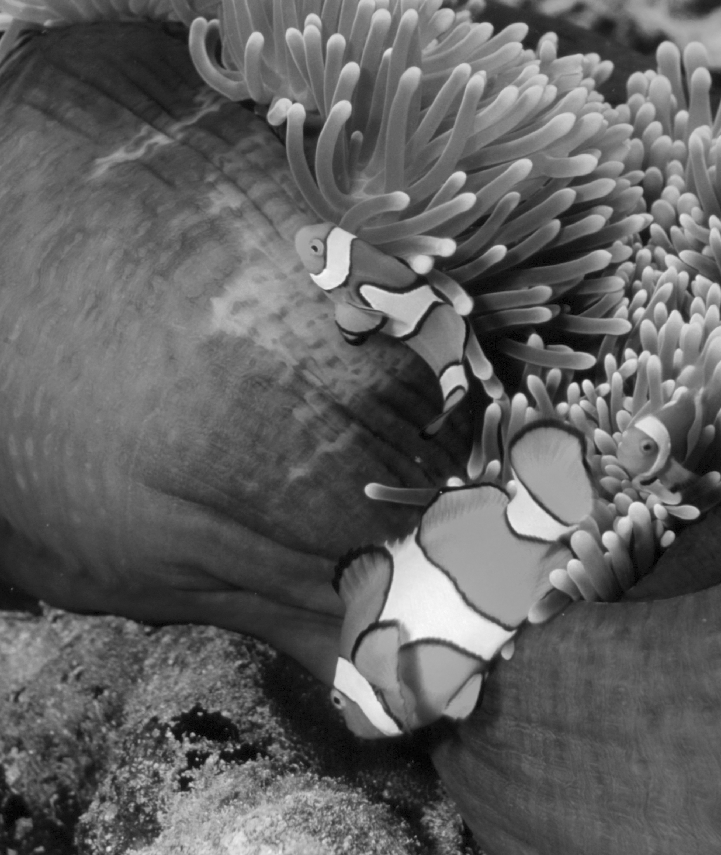
(a) Identify two abiotic components of this ecosystem.
© Photolibrary/SPL/Peter Scoones
Water salinity; light penetration

(b) Identify two biotic components of this ecosystem.
Predators; competitors for mating

(c) How does the association of the clownfish with the anemone benefit
the fish?
The anemone provides protection from predators.

3. The illustration below shows a boy on a field trip in the Australian bush.
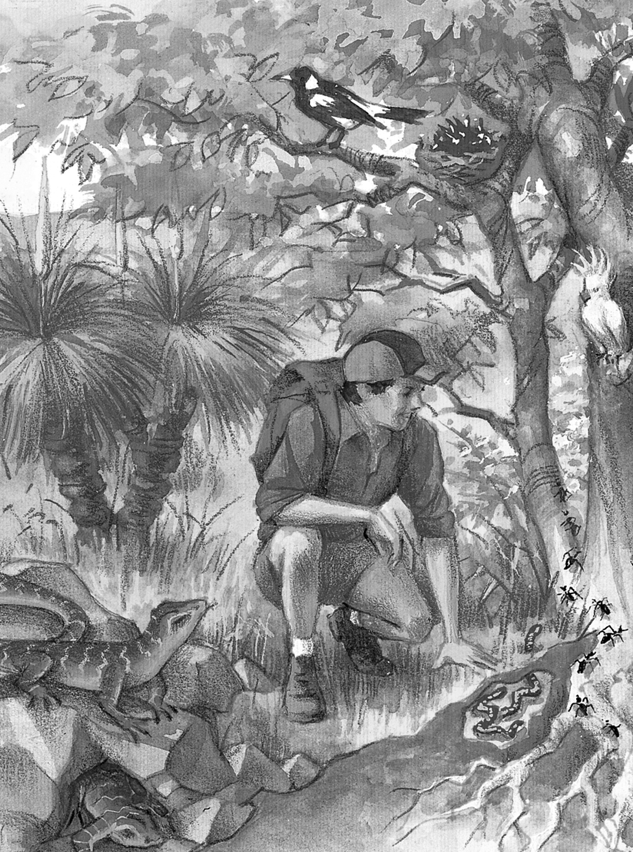
(a) Explain the importance of the trees and grass to this ecosystem.
Trees and grass provide food, habitat and
protection.

(b) Earthworms are shown in the soil under the tree. Explain the
importance of these worms to the ecosystem.
Earthworms improve the soil quality and help to release nutrients for plants.

(c) The student decides to measure an abiotic factor in this area.
Identify an abiotic factor he could measure and explain how he
will perform this task.
(A possible response) Humidity could be measured using an hygrometer (wet and dry bulb thermometer). This could be measured in various locations to compare the microclimate of each part of this ecosystem.

