Lesson 9 E&C SECRET CODES | 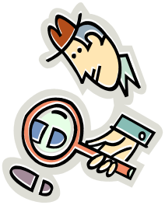

AIM OF THE LESSON

During this lesson students will:
- Design a circuit that enables communication without words.


EQUIPMENT

Per Class
      - one set of group equipment for demonstration model

Per Group
- 2 D cell batteries (1.5 V)
- 1 toothpick
- 1 rubber band
- 2 x 15 cm wires
- 2 x 90cm wires
- 1 light globe
- 2 Pop sticks

Preparation
      - Prepare a demonstration model.

Safety
      - Care with rubber bands.


Background Information for teachers

- A code is a system of symbols, letters, words, or signals that are used instead of ordinary words and numbers to send messages or store information. A code is used to keep the message short or to keep it secret.

- Secret writing has been employed about as long as writing has existed. Cryptology has long been employed by governments, military, businesses and organisations to protect their messages. Today, encryption is used to protect storage of data and transactions.

- Morse code is made up of dots and dashes that are translated into long and short taps, lights or noises of some sort. For example, during the day, tap on something or use a whistle; at night use a flashlight to send your signals.

- Morse Code
  - When you leave your globe on for a long time, this is a dash
  - When you quick flash your globe, this is a dot
  - An extra long dash of light signals the end of your response


Lesson Outline

1. Introduction (Engaging Students)
- Students to role play how they could communicate with a partner without using words.
What are some ways you used to communicate without using words?  What is Morse Code?  How could we use our expertise with circuits to show Morse Code? | Sign language, miming, codes, facial expression.  A system of long and shorts taps or flashes of light to communicate with others.  Set up a circuit that has a switch that you can easily turn on and off to create flashes.

2. Activities and Strategies
- Discuss aim and equipment.
- Demonstration by teacher : How to build a pop stick pressure switch.
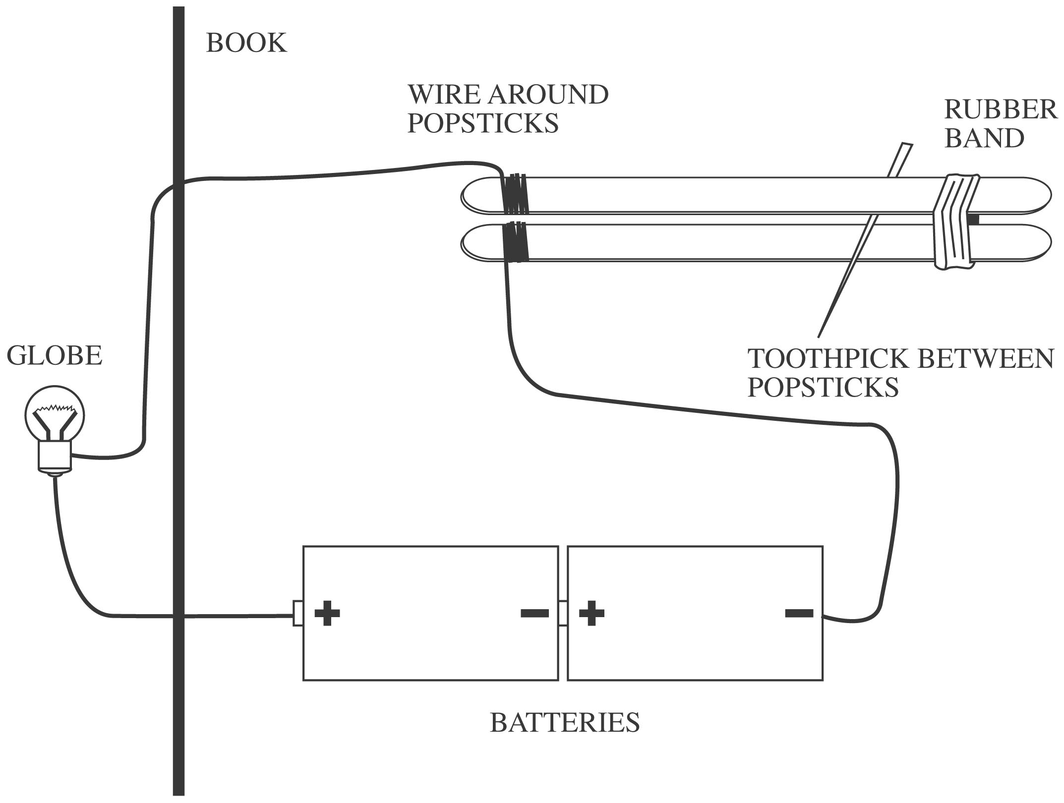

  - Take a wire and tightly wrap the bare wire around the end of a pop stick.
  - Repeat with a second wire on a second pop stick.
  - Place the two pop sticks and wire on top of each other with the wires touching.
  - Wrap the rubber band around as tight as possible at the opposite end (to the wires) on the pop sticks.
  - Place the toothpick in between the two pop sticks a couple of millimetres in front of the rubber band.

    - Students to:
- Set up a circuit with two batteries and a globe and test the switch to make sure it works.
- NB: The wires should touch when you push down on the switch and make the globe light up. When you do not push, the wires separate and the globe does not light up.
- Using your international Morse Code chart send a message to another group. Write down the words and underneath the code sequence before you attempt to send the message.

Hints for the Circuit
- Each group of four makes a simple circuit with a globe that includes the pressure switch (this could be done in pairs if enough equipment is available).
- The globe will be placed behind a wall (a book, box, cardboard) for one pair to see without being able to see the switch.
- In pairs students will face each other across their desks separated by the wall.
- The pairs will communicate using Morse Code by switching their globe on and off using the code sheet to make words.
- Therefore, each paired group will build a circuit that extends under the wall so that partners can only see the globe and not the switch.

3. Focus Questions (Explain and Elaborate)
What problems did you have?
What would you do differently next time? | Various  Various

4. Reflection
- Write a conclusion to explain how the circuit is used for Morse Code.


Extension Activities

- Adjust your switch to improve the way it works.
- Design an alternative switch to use for Morse code.


Links to other learning Areas

- Read a novel that is based on secret codes.
- Write a story about two people trying to communicate using secret codes.
- Role play a scene about two space creatures trying to communicate with earth using morse code.
- Develop a game that involves codes.
- Find out about codes used in Science (e.g. circuits diagrams or chemical symbols) Maths (e.g. algebra) or Music.
- Ancient codes include the Egyptian, Roman and Chinese alphabets. Write out the letters of these alphabets.

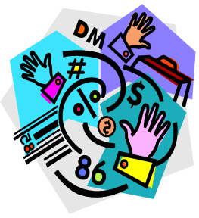
ACTIVITY 9 : SECRET CODES

Aim (What are we going to find out?)

Equipment (What do I need to complete the task?)

Method (How is the task to be done?) Draw a labelled diagram.

Results (What did I observe?) Write down your question and the code.

Conclusion (What did I learn about circuits and Morse code?)

MORSE CODE

LETTER | CODE
A | ●▬
B | ▬●●●
C | ▬●▬●
D | ▬●●  ● Use a quick flash for a dot  ▬ Turn your light on for a long  time for a dash
E | ●
F | ●●▬●
G | ▬ ▬●
H | ●●●●
I | ●●
J | ●▬ ▬ ▬
K | ▬ ●▬
L | ●▬●●
M | ▬ ▬
N | ▬●
O | ▬ ▬ ▬
P | ●▬ ▬●
Q | ▬ ▬● ▬
R | ●▬●
S | ●●●
T | ▬
U | ●●▬
V | ●●●▬
W | ●▬ ▬
X | ▬●● ▬
Y | ▬ ●▬ ▬
Z | ●●▬ ▬

