Lesson 5 e&c conductors | 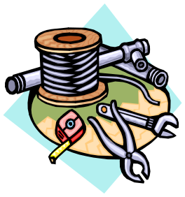

AIM OF THE LESSON

During this lesson students will:
- Classify materials as conductors or insulators.
- Describe the role insulators and conductor in everyday appliances.


EQUIPMENT

Per Class
- a selection of insulators and conductors:
- insulators (wooden pop sticks, plastic spoons, glass jars, paper, rubber, ceramic tiles, cotton, foam cups, kitchen sponge)
- conductors (alfoil, iron nails, steel wool, coins, copper, aluminium cans, drawing pins, paper clips)

Per Group
- 2 D Batteries (1.5 volt)
- 3 lengths (15cms) of insulated copper wire with about 1cm of insulation removed at each end
- 2 globes
- cardboard (1 piece about 10x10cm)
- paper clips
- a few insulators and conductors as listed above
- masking tape

Preparation
  - Collect a range of materials to test; students could bring one each from home.

Safety
- Mains electricity must not be used.

Background Information for teachers

Circuits
- A circuit is a path in which electricity flows.
- Electrons are tiny particles that are found in atoms.
- Electric current is the movement of electrons, which creates the flow of electricity.
- The power supply pushes electrons through a circuit. This power supply can come in many different forms (for example, a battery is a power supply).
- You can think of the power supply as a pump that creates pressure to force water to flow in a hose.
- In a series circuit the batteries and light bulbs are connected in a line. There is only one path for the electrons to flow along. Therefore, the current through each of the circuit elements is the same.
- This is why when one Christmas tree light blows, the rest do not light up.
- Electricity can be transferred to heat, light, sound and motion energy.

Conductors and Insulators
- A conductor allows electricity to flow through it. Examples include metals such as wire made of aluminium, steel or copper.
- An insulator does not allow electricity to flow through it. Examples include non metals such as plastic, wood and foam.

Additional Information
- A parallel circuit is one in which electric current travels along more than one path (as in the home), because there is more than one path for the electricity to follow. Some parts of the circuit can be on while others are off.
- Voltage can be thought of as electrical pressure, which pushes the electrons through the circuit. Electric pressure is measured in volts.
- The most basic electrical devices in the home e.g. a kettle, are made from simple pieces of wire which resists the flow of electricity. The wire will become warm, perhaps red hot when electricity flows through it.
- The household voltage in Australia is 240 Volts.
- Wiring in houses is designed to have very low resistance so they don’t become warm with electricity flowing through them.


Lesson Outline

1. Introduction (Engaging Students)
- Direct students into groups.
- The students to design a simple circuit using two batteries, a globe and copper wire.
- The circuits should be built and taped onto a sheet of cardboard or their desk to hold the components in place.
- The group with their globe shining first is the winner.
- The teacher introduces the concept of materials that conduct electricity (conductor) and those that do not (insulators).
What do we call materials that let electricity pass through them?
Name some examples of conductors.  What do we call materials that do not let electricity pass through them?  Name some examples of insulators. | Conductors.  All metals.  Insulators.  Foam, plastic, wood.

How could we test materials to see if they are conductors or insulators? | Break the circuit and then place the materials one at a time and see if the globe still glows.

2. Activities and Strategies
- Write down the aim, equipment and method for the activity.
- Revise what is meant by a prediction and ask students to predict whether the globe will shine with each material (therefore a conductor) or not (therefore an insulator).
- Groups to break the circuit using two drawing pins a few centimetres apart.

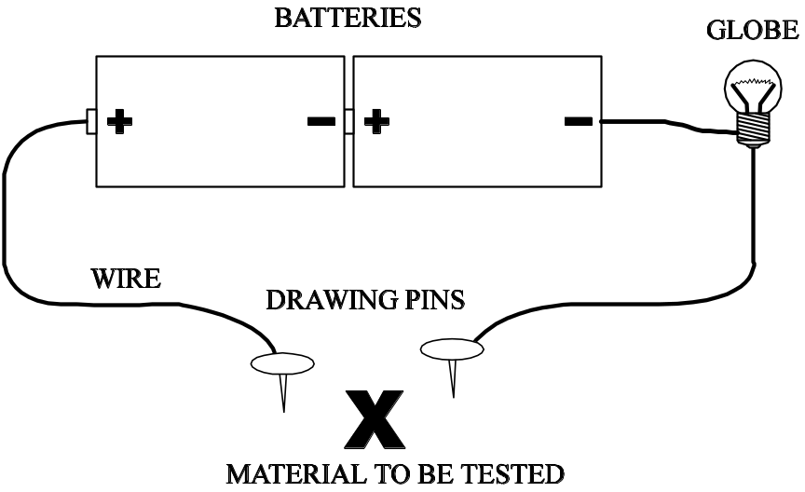

- Groups test the different materials to see if they are conductors or insulators and record their observations.

3. Focus Questions (Explain and Elaborate)
Why is copper used for electrical wiring?
Why is plastic used to cover electrical wiring?  Does the electricity have one or more paths that it can travel along?  Cars run on petrol, diesel or LPG, but there are many electrical parts to cars. Where does the electricity come from to run things like the lights, CD and the radio?  Some ovens use electricity that is converted into heat energy to cook food. What kinds of energy do non-electric ovens and stoves use?  Does your computer use electricity to produce heat, light or motion? | It is a very good conductor.  It is a very good insulator and therefore it is used to protect us and stop wires touching.  One. The light bulbs are connected together in sequence or line. Therefore, all of the electrons forming the electric current are flowing along the same path.  The battery.  Gas or wood.  All three. There is a fan in the box, which moves. The monitor emits light and both the monitor and the hard drive give off heat.

4. Reflection
- Write a conclusion that describes the types of materials that are conductors (metals) and those that are insulators (plastics and wood).
- In groups of three students write down the answers to the following quiz questions on one sheet of paper.

No | Question | Answer
1 | What 3 things do you need to make a circuit? | Battery, wire and globe
2 | What do you call substances that let electricity flow through it? | Conductor
3 | Give an example of a conductor. | Any metal e.g.: aluminium, steel, copper
4 | Give an example of an insulator. | Non metals such as plastic or wood
5 | Do all metals conduct electricity? | Yes
6 | Is a foam cup an insulator or a conductor? | Insulator
7 | If 2 batteries are arranged together, will a bulb glow brighter or dimmer than it did when only one battery was used? | Brighter
8 | Is plastic an insulator or a conductor? | Insulator
9 | What enables the flow of electricity to be stopped? | Switch
10 | Would a silver fork be a conductor or an insulator? | Conductor


Extension Activities

- Students to rejoin the circuit once materials have been tested and add in a second globe to see what happens to the brightness of the globe. Add further globes to determine the effect it has.


Links to other learning Areas

- Write a newspaper article outlining how an electrician can carry out his/her work more safely.
- Make a quiz game based on what you have learnt about electricity so far. Add to this each week to complete your game.
- Develop an advertising slogan to promote copper as a good conductor, useful for so many things!
- All metals are good conductors. Make a fact sheet about one metal that describes what it is used for.
- Survey family and friends to find out what types of saucepans they use. Graph this data.

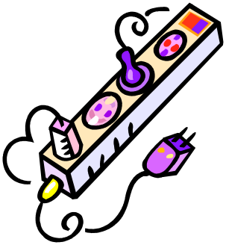
ACTIVITY 5 CONDUCTORS

Aim (What are we going to find out?)

Equipment (What do I need to complete the task?)

Method (How is the task to be done?)

Results (What did I observe?)

Material | Prediction  Conductor or Insulator | Observation  Conductor or Insulator

Conclusion (What did I learn about the conductors and insulators?)

