Lesson 8 E&C FLASH LIGHTS | 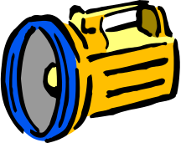

AIM OF THE LESSON

During this lesson students will:
- Apply their understanding of simple circuits, batteries, copper wire and globes to construct a torch.
- Use conductors and switches to construct a torch.


EQUIPMENT

Per Class
- blu-tac
- masking tape

Per Group
- 2 D batteries (1.5 volts)
- two lengths (15cms) of insulated copper wire with about 1cm of insulation removed at each end
- one small globe (have some spares)
- cardboard cylinders (recycled such as from paper towel or rolled up card)
- aluminium pie dishes (small)
- alfoil
- paper clips or split pins

Preparation
  - Collect a variety of light sources e.g. pen light, torch, candle, sparkler, bedside lamp, kerosene lantern, mosquito lantern, spotlight, flare or emergency beacon (preferably one powered by battery, one by mains power and one chemical).

Safety
- Care must be taken if using sparklers and other light sources.

Background Information for teachers

Light Sources
- Chemicals: candles, flares, sparklers, kerosene lamps, mosquito lanterns.
- Battery: torches, pen light, toys that light up, caving head lamps, spotlights.
- Mains Power: bedside lamps, house lights.

History of Flash lights
- Searching in a dark closet before 1896, one had to use a candle or kerosene lantern. Accidents occurred and fires followed. A safer alternative was needed.
- In 1896, the first flashlight was invented.
- Portable electric lights were called "flash lights" since they would not give a long steady stream of light. The bulbs were inefficient and the batteries were weak, allowing the user to flash the light on for only a few seconds.
- Very early lights did not have an on/off switch, just a ring that would push against a band of metal. When batteries and bulbs became more efficient, the switch was improved.

Example of a Torch

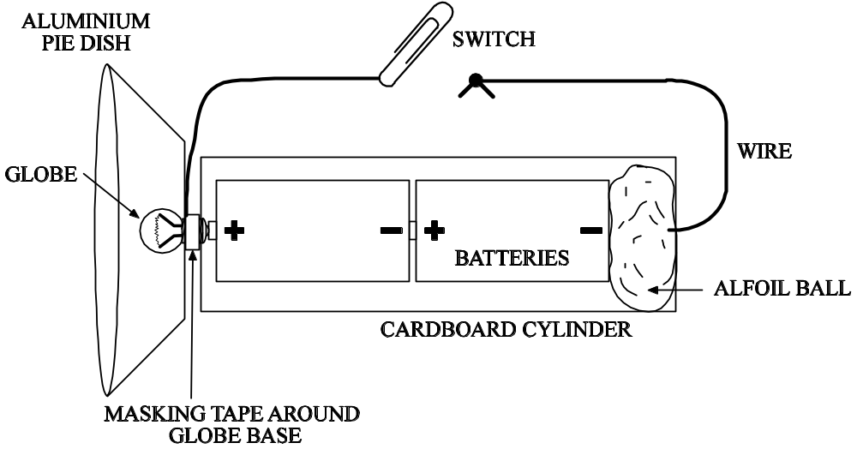


Lesson Outline

- Introduction (Engaging Students)
  - Show students a variety of light sources e.g. pen light, torch, candle, sparkler, bedside lamp, lantern or spotlight.

How are all of these items similar?  How are they different?  How could you make a light source? | They all produce light.  Various answers.  They use different sources to produce light. Eg mains electricity, batteries or chemicals.  Batteries, some wires and a globe.

2. Activities and Strategies
- Discuss the aim, equipment and method. Students can make the torch in a variety of ways. Encourage creativity.
- Students design and construct a simple torch using
- 2 batteries
- 1 globe (test these first)
- A cardboard cylinder (as the battery case and torch shaft)
- An aluminium pie dish (as the reflector)
- A combination of two split pins and a paper clip as a switch
- Copper wire

- 10 minutes: discussion in groups of what they will do and drawing their design.
- 40 minutes: build the torch.
- Suggestions for the torch once students have attempted their own.
  - All wiring and the switch should be on the outside of the cardboard cylinder
  - Break the circuit using two split pins bridged by a swivelling paper clip.
  - Ensure the circuit is complete, no breaks other than the switch.
  - Pack the back of the torch with a ball of aluminium foil.
  - Cut a small hole in the pie dish to enable it to touch the battery.
  - The wire where it joins the globe and the base of the globe must not touch the pie dish so these need to wrapped in masking taps or blue tack to keep them separated.
  - The wire joins the globe between the pie dish and the cylinder.

- Groups to demonstrate their working torches.

3. Focus Questions (Explain and Elaborate)
What problems did you have and how did you overcome them?  What would you do differently next time? | Various.  Wiring, number of batteries, connections.

4. Reflection

- Write a conclusion to describe how your torch works and what changes you would make to improve your design.


Extension Activities

- Build a torch with internal wiring, with a pressure switch (using sponges), or one that allows you to change the batteries.


Links to other learning Areas

- Students collect old torches and lamps for a school display.
- Design a lantern using coloured cellophane paper.
- Research how people lit their homes in the 1700s.
- Develop a timeline that shows the development of lighting which may include torches, flashlights and home lighting.
- Prepare a fact sheet about Thomas Edison or other inventors of light.
- Write a list of materials needed to make light globes.
- Make a table to find out the average number and types of light globes in the homes of your friends.
- Find out the cost of different types of light globes.

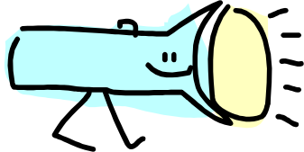
ACTIVITY 8 FLASH LIGHTS

Aim (What are we going to find out?)

Equipment (What do I need to complete the task?)

- 2 batteries
- 1 globe
- A cardboard cylinder
- A aluminium pie dish
- A combination of two split pins and a paper clip as a switch
- Copper wire as leads

Method (How is the task to be done?) Draw a plan of your torch.

Results (What did I observe?)

Conclusion (What did I learn?)

