Lesson 7 E&C Magic Magnets | 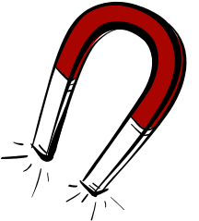

AIM OF THE LESSON

During this lesson students will:
- Investigate how you can make a nail into a magnet using electricity.


EQUIPMENT

Per Class
- 1 jar with some sugar , one leaf and 5 paper clips (iron filings are very useful if available)
- 1 magnet
- alfoil
- masking tape
- a compass (optional)

Per Group
- 2 D batteries
- 2 x 15 cm lengths of plastic coated copper wire
- 10 paper clips
- 1 large nail
- masking tape
- 15cm of alfoil
- pop sticks

Preparation
- In a jar mix one teaspoon of sugar, five very small paper clips or pins and a leaf cut into tiny pieces

Safety
- Mains electricity must not be used to make magnets.


Background Information for teachers

An electromagnet is a temporary magnet formed when electric current flows through a wire or other conductor.
- Most electromagnets consist of a wire wound around an iron core.
- When an electric current moves in one direction through a wire, a magnetic field is created around the wire.
- When the wire is wrapped around an object to form a coil, the magnetic field around each wire is aligned right next to the field of the adjacent wires.
- All the coils work together to form a much stronger, single magnetic field.
- Electromagnets are a part of our everyday lives.
- They are useful because they act like magnets when the current is on and lose their magnetism when the current is off.
- Some electromagnets we use everyday are in school bells, telephones, automatic doors, video and tape recorders.


Lesson Outline

1. Introduction (Engaging Students)
- Show students the jar of sugar, plant material and metal.
How could you separate these items?

Remove the paper clips with a magnet.
Add water to dissolve the sugar (this could be left on the window to evaporate the water).
The leaves will float on the top and can be scooped off.

- Ask a student to attempt to separate the materials. One student could do each step.
- Magnets are very useful to separate materials and in this lesson they will make a magnet from a nail.

2. Activities and Strategies

- Demonstrate how to make an electromagnet.

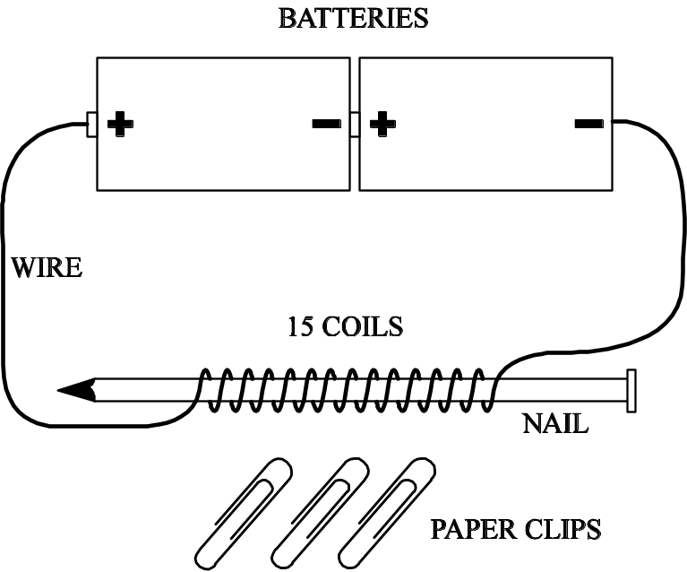

- Using the copper wire, begin at the top of the nail head and wrap the wire
around it (about 15 -20 turns).
- You will need a 5cm wire tail at the top of the nail.
- Wrap the wire tightly trying hard not to leave any spaces.
- When you get near the end of the nail, loop the wire under the previous loop.
- You will need to have another 5cm wire tail at the bottom of the nail.
- Connect each end of the wire to one of the terminals on the battery.

  - Discuss the aim, equipment and method.

  - Students to complete the following:
- Touch the electromagnet to a heap of paper clips.
- Unhook the battery. What happens to the clips?
- Slide the nail out from the copper wire turns.
- What does the nail do when it touches the clips?

3. Focus Questions (Explain and Elaborate)

Why does the nail pick up the paper clips?  What is an electromagnet?  How could the magnet be made to pick up more paper clips?  Where in everyday life do we use magnets?  Why do you think an electromagnet might be better than a normal magnet? | It has become a magnet.  A magnet created when electricity flows through a material e.g. nail.  Add more coils of wire, add more batteries.  Latches on doors, car junk yards, fridges, washers.  They can be turned on and off.

4. Reflection
- Write a conclusion to the activity.
- Draw a labelled diagram of your electromagnet.

Extension Activities

- Investigate the effect of changing the number of coils or the number of batteries on the how many paper clips the magnet can pick up.
- Investigate how changing the size or type of nail effects how many paper clips the magnet can pick up.
- Investigate the effect of the electromagnet on a small compass.


Links to other learning Areas

- Create a line graph to show the strength of the electromagnet.
- Find out where magnets and electromagnets are used in everyday life.


ACTIVITY 7 MAGIC MAGNETS

Aim (What are we going to find out?)

Equipment (What do I need to complete the task?)

Method (How is the task to be done?)

Results (What did I observe?) Draw a labelled diagram of your electromagnet.

Conclusion (What did I learn about electromagnets and how they work?)

