Colours

White light can be produced by shining all colours of light together. Surprisingly, white light can also be made by just using three colours of the spectrum – red, green and blue. For this reason these are called the primary colours of the spectrum.

If you combine light of the primary colours in pairs, the three secondary colours, magenta, cyan and yellow, are produced.

The colours of transparent objects, such as cellophane, depend on the colour of the light which is transmitted through it. If you place red cellophane over the end of a torch, all other colours of light are absorbed by the cellophane and only red light is transmitted. These types of substances are called filters.

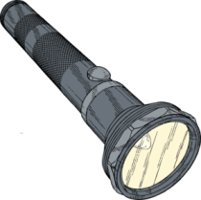

Red light Red White
only filter light

The colour of opaque objects depends on the light it reflects. Blue objects only reflect blue light. When white light falls on a green leaf, only the green light is reflected, all other colours are absorbed. Black objects absorb all colours of light, and reflect no light.

White Green Red No light
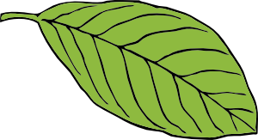
light light light reflected

