Teacher Resource

Light, Reflection, Refraction and Absorption.

Year 5 Unit

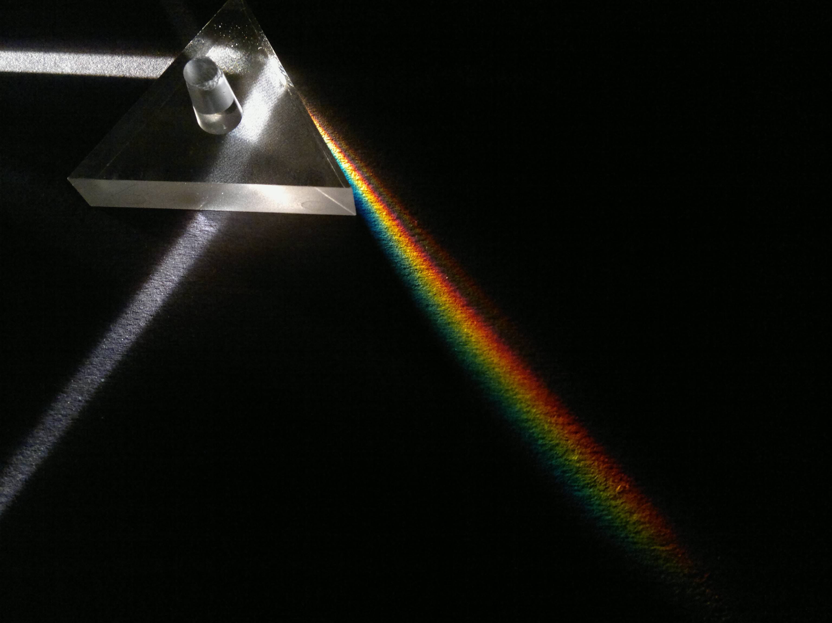

CONTENTS

Unit Overview 4

Unit Outline 5

Lesson Plans 7

Lesson 1 7
Lesson 2 8
Lesson 3 9
Lesson 4 10
Lesson 5 11
Lesson 6 12
Lesson 7 13
Lesson 8 14
Lesson 9 15

Resources 18

Lesson 1 - Instruction for cone reflector 19
- Template for cone reflector 20
Lesson 2 - Equipment for light exploration rotations 21
- Instruction sheets for light exploration 22
Lesson 3 - Student worksheet
- Light introduction 27
Lesson 4 - Student worksheet
- Diffused and Specular Reflection 28
Lesson 5 - Student worksheet
- Colour 29
Lesson 6 - Student worksheet
- Reflection 30
Lesson 7 - Student worksheet
- Shadows 31
Lesson 8 - Student worksheet
- Refraction 32
Lesson 9 - Student Investigation planner 33

The text and images in this booklet are under Creative Commons licences.
All text and images are under a BY-NC-SA licence.

CREATIVE COMMONS LICENCE ELEMENTS

Attribution (BY) | You must credit the creator, the title and the licence the work is under. For more information on how to attribute a work, see the “How to Attribute Creative Commons Material” guide, http://creativecommons.org.au/materials/attribution.pdf
Non-commercial (NC) | Any use of the work must be for non-commercial purposes only. This means file sharing, educational use and film festivals are all permissible, but advertising and for-profit uses are not.
No Derivative Works (ND) | Only verbatim copies of the work may be used. In other words, you can’t change the work in any way. You need to get extra permission if you want to crop a photo, edit text, or use a song in a film. Basically, any remixing is not permissible.
Share Alike (SA) | Any new work produced using this material must be made available under the same terms. So if you do remix a work, you have to release your new work under the same licence. e.g. Attribution-Share Alike has to stay Attribution-Share Alike.

This unit was developed by: Paul Brandon
Senior Project Officer (Primary Science)
Strategic Learning, Queensland Museum
2011
Unit title: Light – Reflection, Refraction and Absorption | Science Understanding (Physical Sciences)  Science Inquiry Skills  Science as a Human Endeavour  Strands: |  | Year 5
UNIT FOCUS | STRAND CONCEPTS | ELABORATIONS |  | UNIT LITERACY FOCI
What is the context?  How do we see things?  How does light help us to see?  What is the inquiry?  What happens to light when it passes through a prism?  What happens to light when it reflects off a mirror?  Why does the length of shadows change?  How will students demonstrate  their learning?  Student light diagrams.  Student participation in class investigation and data collection. | Year 5  Science Understanding  Physical Sciences  - Light from a source forms shadows and can be absorbed, reflected and refracted (ACSSU080)  .  Science as a Human Endeavour  Nature and development of science  - Science involves exploring and observing the world using the senses (ACSHE013)  Science Inquiry Skills  Questioning and predicting  - Respond to questions about familiar objects and events (ACSIS014)  Planning and conducting  - Explore and make observations by using the senses (ACSIS011)  Processing and analysing data and  Information  - Engage in discussions about observations and use methods such as drawing to represent ideas (ACSIS233)  Communicating  - Share observations and ideas (ACSIS012) | - Drawing a simple labelled ray diagram to show the paths of light from a source to our eyes  - Comparing shadows from point and extended light sources such as torches and fluorescent tubes  - Classifying materials as transparent, opaque or translucent based on whether light passes through them or is absorbed.  - Recognising that the colour of an object depends on the properties of the object and the colour of the light source  - Exploring the use of mirrors to demonstrate the reflection of light  - Recognising the refraction of light at the surfaces of different transparent materials, such as when light travels from air to water or air to glass |  | Everyday literacies: Cooperative small group work, whole class discussion, word walls and posters, PowerPoint presentations and Digital pictures, verbal reports.  Literacies of science: factual text, data tables, drawings, graph (picture).  Scientific literacy: knowledge and understanding of scientific concepts and processes and the application of such to everyday situations.  Examples: Drawing, factual text, graph, procedural text, report, science journal, table, word wall.

4

Unit title: Light, Reflection, Refraction and Absorption. Strands: Science Understanding (Physical Sciences);
Science Inquiry Skills; and Science as a Human Endeavour. Stage: Year 5

Time: 10 weeks (60 mins per week)

PHASE | ACTIVITIES
ENGAGE  (Lesson 1) | Activity: Creating a focused mirror.  Thinking about how the light travels and interacts with the reflective surface.
EXPLORE  (Lessons 2 ) | Exploring, experimenting and discovering light.  Students work through 5 rotational activities:  - Shadows – experimenting with a single light source and the shadows it creates  - Refraction – exploring and experimenting with refraction using a laser and prism  - Real Images – Exploring real images through a lens and focal length.  - Categorising – Using slides and a point light source, students explore and classify the material as transparent, translucent or opaque.  - Reflection/refraction and separation – Students explore light using a hodson light box, mirrors and lenses.
EXPLAIN  (Lessons 3– 8) | Explicit teaching of Light:  - Introduction to light and waves, how light is represented in scientific drawings.  - Diffused and Specular Reflection  - Colour  - Reflection  - Shadows  - Refraction
ELABORATE  (Lesson 9-10) | Student Investigation, data collection and analysis.  Planning and conducting an Investigation. Using sunlight and reflection build a solar oven to heat par-bake bread rolls for your group?  Planning Investigation: Students plan and conduct an investigation about the best shape for reflecting a light source for a specific purpose (heating par bake buns).  Question and Hypothesis: Students will hypothesis their thoughts and ideas during class discussions.  Data Collection:  Data Analysis and Communication:.
EVALUATE  (lesson 10) | Provide students opportunities to review and reflect on their learning and represent what they now know.  Questioning and Reflection: .  Communicating Understanding:

Lesson number: 1 | Lesson title: Introduction of story and animals
ENGAGE | • To capture students’ interest and find out what they think they know about the key concepts.  • To elicit students’ questions about the key concepts.
LESSON SUMMARY |  | RESOURCES | LITERACY FOCI | ASSESSMENT -  DIAGNOSTIC
Teacher:  - Introduce the topic of light.  - Ask student how we use light in the world today and in their own lives.  - Discuss the concept of reflection and it’s uses in the world.  - Introduce the history of using fire to light the dark and ask the students to think of some of the safety issues and practical issues in using light this way.  - Introduce the idea of projecting the light in one direction to increase it’s intensity and projection, such as it a light house, torch, car headlights.  - Set students introduction group task.  - Students work in a small group to make a cone shaped reflector to reflect and focus light from a tea light.  Students:  - In small groups using the materials provided, students create a cone shaped reflector to focus the light from a tea light in one direction allowing the light generated by the tea light to be projected in a concentrated manner (Similar to the concept of a light house or torch beam)  - Students then represent their ideas of what is happening to the light rays in a diagram. |  | Paper or card  Tea lights  (Battery operated – no flame)  Aluminium foil  Instruction on making cone  Glue  Stapler or sticky tape. | Students will be able to:  - Discuss the concept of reflection and it’s uses in the world.  - Discuss the safety issues of using fire.  - Discuss the idea of projecting the light in one direction to increase it’s intensity and projection, such as it a light house, torch, car headlights.  - Represent their ideas using a scientific labelled diagram. | Find out what students already think they know and understand. This allows you to take account of students’ existing ideas when planning future learning experiences.
 |  |  |  | ASSESSMENT OPPORTUNITIES
Diagnostic:

Students identify the concept of reflection and how light interacts with a reflective surface.

.

Lesson number: 2 | Lesson title: Light, Reflection, Refraction and Absorption
EXPLORE | • To provide hands-on, shared experiences.  • To explore the students ideas of what light is, How we can change or manipulate it and how we use it to see..
LESSON SUMMARY |  | RESOURCES | LITERACY FOCI | ASSESSMENT -  FORMATIVE
Teachers:  Set out instruction sheets for each station.  Outline to students that they do not have a lot of time at each station and thus to stay on task.  If available, students record their exploration and discoveries using a digital camera  Students will:  Exploring, experimenting and discovering light.  Students work through 5 rotational activities:  - Shadows – experimenting with a single light source and the shadows it creates  - Refraction – exploring and experimenting with refraction using a laser and prism  - Real Images – Exploring real images through a lens and focal length.  - Categorising – Using slides and a point light source, students explore and classify the material as transparent, translucent or opaque.  - Reflection/refraction and separation – Students explore light using a hodson light box, mirrors and lenses |  | Queensland Museum Light kit.  - Low powered laser  - Hodson Light Box  - Torch  - Hand lens (Magnifying glass)  - Plastic prisms  - Slit slides  - Coloured Filters  - Rulers and paper | Students will be able to:  - Explore light and it’s interaction with objects, filters, lenses and prisms.  - Test their own pre-conceptions of light and discover new ideas and phenomenon.  - Discuss their ideas with their peers and the teacher. | Monitor students’ developing  understanding and give feedback that extends their learning.
 |  |  |  | ASSESSMENT OPPORTUNITIES
 |  |  |  | Verbal reports

Lesson number: 3 | Lesson title: Light, Reflection, Refraction and Absorption
EXPLAIN | • To support students to develop explanations and understanding through explicit teaching and visual examples.
LESSON SUMMARY |  | RESOURCES | LITERACY FOCI | ASSESSMENT -  FORMATIVE
Teacher:  - Presents the provided PowerPoint file to introduce the concept of light waves and how wavelength, frequency and amplitude influence waves. Students then are introduced to the details of scientific drawing of light.  Students will:  - View PowerPoint presentation  - Complete task sheet to consolidate their understanding of scientific diagrams of light. |  | - Introduction PowerPoint  - Student introduction worksheet. | Students will be able to:  - Develop an idea of how light interacts with the world around us.  - Demonstrate their developing knowledge of scientific drawing. | Monitor students’ developing  understanding and give feedback that extends their learning.
 |  | - Introduction PowerPoint  - Student introduction worksheet. |  | ASSESSMENT OPPORTUNITIES
 |  | - Introduction PowerPoint  - Student introduction worksheet. |  | Students work sheet.

Lesson number: 4 | Lesson title: Light, Reflection, Refraction and Absorption
EXPLAIN | • To support students to develop explanations and understanding through explicit teaching and visual examples.
LESSON SUMMARY |  | RESOURCES | LITERACY FOCI | ASSESSMENT -  FORMATIVE
Teacher:  - Presents the provided PowerPoint file to introduce the concept diffused and specular reflection and how this assists us in seeing the world around us.  Students will:  - View PowerPoint presentation  - Complete task sheet to consolidate their understanding of scientific diagrams of light. |  | - PowerPoint  - Student Worksheet | Students will be able to:  - Understand how the light from the sun lights up the world around them.  - Demonstrate their understanding of the concepts of diffused and specular reflection using the student worksheet. | Monitor students’ developing  understanding and give feedback that extends their learning.
 |  | - PowerPoint  - Student Worksheet |  | ASSESSMENT OPPORTUNITIES
 |  | - PowerPoint  - Student Worksheet |  | Student work booklet

Lesson number: 5 | Lesson title: Light, Reflection, Refraction and Absorption
EXPLAIN | • To support students to develop explanations and understanding.
LESSON SUMMARY |  | RESOURCES | LITERACY FOCI | ASSESSMENT -  FORMATIVE
Teacher:  - Presents the provided PowerPoint file to introduce the concept of colour and how we see the different wavelengths on the light spectrum  Students will:  - View PowerPoint presentation  - Complete task sheet to consolidate their understanding of light and colour. |  | - PowerPoint  - Student worksheet | Students will be able to:  - Understand how the light from the sun is made up of lots of colours and that each colour has a particular wavelength.  - Demonstrate their understanding of the concepts of light and colour using the student worksheet | Monitor students’ developing  understanding and give feedback that extends their learning.
 |  | - PowerPoint  - Student worksheet |  | ASSESSMENT OPPORTUNITIES
 |  | - PowerPoint  - Student worksheet |  | Student work sheet

Lesson number: 6 | Lesson title: Light, Reflection, Refraction and Absorption
EXPLAIN | • To support students to develop explanations and understanding.
LESSON SUMMARY |  | RESOURCES | LITERACY FOCI | ASSESSMENT -  FORMATIVE
Teacher:  - Presents the provided PowerPoint file to introduce the concept reflection and how this is represented in scientific drawing.  - Introduce the specific terms of:  - Incidence ray  - Perpendicular  - Normal  - Reflection ray  - Angle of Incidence  - Angle of reflection  Students will:  - View PowerPoint presentation  - Complete task sheet to consolidate their understanding of reflection. |  | - PowerPoint  - Student worksheet  - Protractor  - Ruler | Students will be able to:  - Understand how light interacts with a mirrored surface.  - Demonstrate their understanding of the concepts reflection using the student worksheet | Monitor students’ developing  understanding and give feedback that extends their learning.
 |  | - PowerPoint  - Student worksheet  - Protractor  - Ruler |  | ASSESSMENT OPPORTUNITIES
 |  | - PowerPoint  - Student worksheet  - Protractor  - Ruler |  | Student work sheet

Lesson number: 7 | Lesson title: Light, Reflection, Refraction and Absorption
EXPLAIN | • To support students to develop explanations and understanding.
LESSON SUMMARY |  | RESOURCES | LITERACY FOCI | ASSESSMENT -  FORMATIVE
Teacher:  - Presents the provided PowerPoint file to introduce the concept of shadows and how shadows change due to the relationship between the source of light and object creating the shadow.  Students will:  - View PowerPoint presentation  - Complete task sheet to consolidate their understanding of light and shadows. |  | - PowerPoint  - Student worksheet | Students will be able to:  - Understand how the light interacts with objects to create shadows.  - Demonstrate their understanding of the relationship between the light source and the object when creating a shadow using the student worksheet | Monitor students’ developing  understanding and give feedback that extends their learning.
 |  | - PowerPoint  - Student worksheet |  | ASSESSMENT OPPORTUNITIES
 |  | - PowerPoint  - Student worksheet |  | Student work sheet

Lesson number: 8 | Lesson title: Light, Reflection, Refraction and Absorption
EXPLAIN | • To support students to develop explanations and understanding.
LESSON SUMMARY |  | RESOURCES | LITERACY FOCI | ASSESSMENT -  FORMATIVE
Teacher:  - Presents the provided PowerPoint file to introduce the concept of refraction.  - Reinforce the technical terms from the previous lesson when referring to the refraction slides.  Students will:  - View PowerPoint presentation  - Complete task sheet to consolidate their understanding of refraction. |  | - PowerPoint  - Student worksheet | Students will be able to:  - Understand how the light from the sun is made up of lots of colours and that each colour has a particular wavelength.  - Demonstrate their understanding of the concepts of light and colour using the student worksheet | Monitor students’ developing  understanding and give feedback that extends their learning.
 |  | - PowerPoint  - Student worksheet |  | ASSESSMENT OPPORTUNITIES
 |  | - PowerPoint  - Student worksheet |  | Student work sheet

Lesson number: 9-10 (Weather dependant) | Lesson title: Light, Reflection, Refraction and Absorption
ELABORATE | • To challenge and extend students’ understanding in a new context or make connections to additional concepts through a student-planned investigation.  • To support students to plan and conduct an investigation.
LESSON SUMMARY |  | RESOURCES | LITERACY FOCI | ASSESSMENT –  SUMMATIVE
Teacher:  - Re-introduce scientific investigation. The class will investigate whether or not enough energy from the sun can be reflected and focused on a point to cook some bread rolls.  - Students will also need to collect information or data during the experiment.  - Outline experiment to the students:  - Students complete their own hypothesis before being placed into two groups.  - Students are to make an A4 reflective surface from alfoil and card or paper.  - Students discuss how they are going to conduct the experiment and the roles each person will have.  ****Special consideration needs to be made regarding safety and rules, such as ensuring all reflective sheets are pointing away from people reading thermometer, Sun protection such as a hat and sunglasses are worn****  - Once students have agreed on a method and completed their investigation planners up to this point, students are then supplied with thermometer for their experiment to see if they can create enough heat (50-60 O^{c}) to cook the par bake rolls and how many reflective sheets it will take.  - Once students have completed their trail and the investigation planner, they are issued with the bread rolls to heat (this will take approx. 20 min with the lower heating temperatures.  *****This lesson may need to be delayed or postponed until the correct solar conditions are in place******  Students will:  - Complete a hypothesis on their investigation sheet.  - Create a reflective card  - Participate in a group discussion regarding how the experiment will be carried out and write this on their investigation planner.  - Work as a team to conduct their investigation and record the results.  - Summarise their results and create a graph.  - Review their results against their original hypothesis.  - Celebrate their results by heating bread rolls and eating them. |  | - Par bake bread rolls  - A4 card or paper  - Aluminium Foil  - Thermometer  - Investigation planner student worksheet | Students will be able to:  - Use oral language to discuss their ideas on how they are going to heat up the bread rolls and how many reflective sheets are needed.  - Students will complete the investigation planner including writing a conclusion to their investigation. | Look for evidence of the extent to which students have achieved the investigating outcomes.
 |  |  |  | ASSESSMENT OPPORTUNITIES
 |  |  |  | Students investigation planner.

RESOURCES

Lesson 1 - Instructions for cone reflector 19
- Template for cone reflector 20

Lesson 2 - Equipment for light exploration rotations 21
- Instruction sheets for light exploration 22

Lesson 3 - Student worksheet
- Light introduction 27

Lesson 4 - Student worksheet
- Diffused and Specular Reflection 28

Lesson 5 - Student worksheet
- Colour 29

Lesson 6 - Student worksheet
- Reflection 30

Lesson 7 - Student worksheet
- Shadows 31

Lesson 8 - Student worksheet
- Refraction 32

Lesson 9 - Student investigation planner 33

Instructions for Cone Reflector (Lesson 1):

- Students cut out the circle on the template provided.
- Paste aluminium foil on the blank side of the circle ensuring the mat side of the foil is against the paper.
- Cut the paper and foil along the dotted line.
- Bring one of the cut edges over the other and continue to slide the edges past each other until a 90 degree internal angle is made.
- Check the angle using the corner of a work pad or book.
- Hold the tea light in the opening and observe the reflected light.

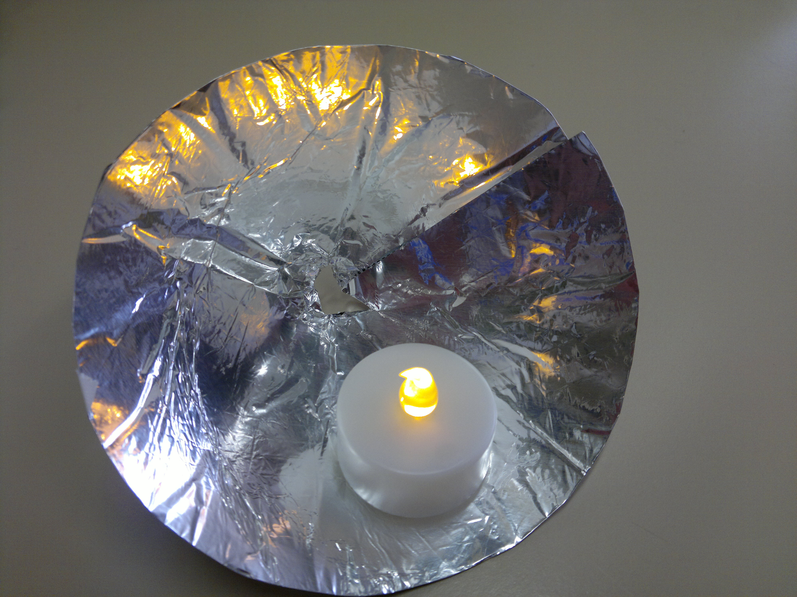

Cone Reflector

Equipment required for Light Exploration (lesson 2):

- Shadows
  - Equipment:
- Low Powered Laser (Provided in Kit)
- Various prisms (Provided in Kit)
- A4 paper
- Pencil
- Ruler
- Blue tack or similar
- Sticky tape
- Refraction
  - Equipment:
    - Instruction Sheet (Provided in Kit)
    - Low Powered Laser (Provided in Kit)
    - Blue tack
    - Paper
    - Three prisms (Provided in Kit)
- Real images
  - Equipment
    - Instruction Sheet (Provided in Kit)
    - Hand lenses (Provided in Kit)
    - Paper
    - Ruler
- Categorising Transparency
  - Equipment
    - Instruction Sheet (Provided in Kit)
    - Small torches (Provided in Kit)
    - Coloured slides(Provided in Kit)
- Reflection/Refraction
  - Equipment
    - Instruction Sheet (Provided in Kit)
    - Hodson Light Box (Provided in Kit)
    - Slit cards (Provided in Kit)
    - Mirrors (Provided in Kit)
    - Prisms and lenses (Provided in Kit)

Shadows Instruction Sheet

Equipment:
- Instruction Sheet (Provided in Kit)
- One torch (Provided in Kit)
- Two rulers
- Object from classroom such as tube of glue

Method:

- Place one ruler vertical using a wall or book and secure it in place
- Measure 10 cm out from vertical ruler and place object here.
- Place second ruler in front of object.
- Draw the following table in your workbooks:
Distance to Object | Height of Shadow | Conclusion to discussion
10cm
20cm
30cm
Height of torch | Height of shadow | Conclusion to discussion
10cm
20cm
30cm

- Turn the torch on and using the ruler place it 10 cm from the base of the object.
- Note the height of the shadow created using the vertical ruler.
- Repeat steps 4 and 5 at 20 cm and 30 cm.
- Discuss what you think would happen to the shadow if you had a very powerful torch placed 100m away?
- Repeat the experiment with the torch approximately 20 cm away from the object and 10 cm in the air, then 20cm and 30cm in the air
- Ensure the torch is pointing at the object to create a solid shadow.
- Discuss what you think would be the effect on the shadow is the torch was 100m high?

Laser Refraction Instruction Sheet

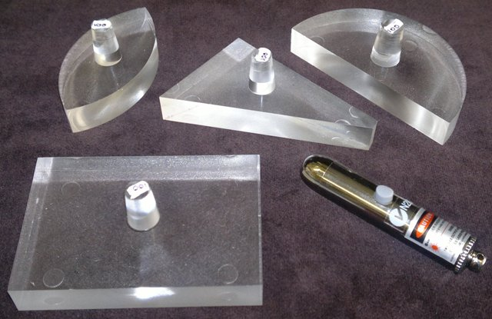
Equipment:
- Low powered laser
- Various prisms
- A4 paper
- Pencil
- Ruler
- Blue tack or similar
- Sticky tape
Method:
- Draw the following table in your work books:
Prisms Tested | Distance of refraction

- Using the Blue Tack secure the laser to a desk top, ensuring the power button is facing up.
- Fold up long edge of A4 paper (3cm) and place this 10cm from the laser, perpendicular to the beam. Secure to the table with tape.
- Turn on laser and mark location of the beam on the paper.
- Select a prism and place it in the laser beam.
- Turn the prism until the maximum refraction is reached (Beam must maintain it’s integrity, defusing no more than 2mm). Mark this point on the paper and measure the distance. Note the distance in your table and draw a line on the prism in your table where the laser went through.
- Choose another prism and repeat the process.
- Discuss your results and why you think some prisms refracted the light more than others?
- Discuss why the refraction changes when the prism in moved?

Real Images Instruction Sheet

Equipment
- Instruction sheet (Provided in Kit)
- Hand lenses (Provided in Kit)
- Paper
- Ruler

Method

- Draw the following table in your pad.
Lens | Distance
Large Lens
Small Lens
Reason for difference:

- Hold a hand lens up facing a window.
- With your other hand or another group member, hold a piece of paper up at the same height as the lens.
- Slowly change the distance between the paper and lens until an in focus image appears on the page.
- Measure the distance between the page.
- Repeat with the second hand lens.
- Discuss your thoughts on the reason for the results you recorded.

Categorising Transparency Instruction Sheet

Equipment
- Instruction sheet (Provided in Kit)
- Three torches (Provided in Kit)
- Coloured slides(Provided in Kit)

Method

- Draw the following table in your workbook.
Slide Name | Transparent | Translucent | Opaque

- Turn the torch on and place a coloured slide over the front of the torch.
- Ensure the torch is placed in the centre of the slide.
- Observe the light coming through the slide.
- Discuss your observations with your group and classify each slide as Transparent, Translucent or Opaque.
- Note your classification in the table in your workbook using a tick.

Reflection/Refraction Instruction sheet

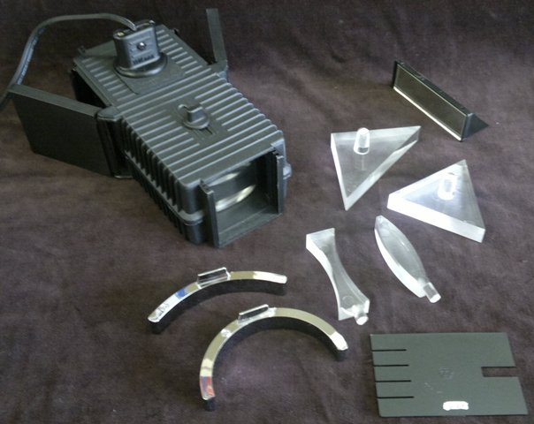
Equipment
- Instruction Sheet (Provided in Kit)
- Hodson Light Box (Provided in Kit)
- Slit cards (Provided in Kit)
- Mirrors (Provided in Kit)
- Prisms and lenses (Provided in Kit)

Method

- Set up the Hodson light box with the flaps open and the four slit slide placed in the long end. Ensure this end remains open to prevent the bulb overheating.
- Turn the power on.
- Use the adjustor on the top to focus the light rays into parallel lines.
- Place a curved mirror into the light rays and observe what happens.
- Try moving the mirror around and observe.
- Flip the mirror so the curvature is in the opposite direction.
- Change to the other curved mirror and repeat.
- Repeat using the concave and convex lenses.
- Use the flat mirror and reflect the light at 90 degrees.
- Observe the order of the light rays in the original beam and the reflected beam.
- Change to the single fat slide.
- Using a triangular prism see if you can refract (bend) the light beam.
- Experiment with the position of the prism to create separation(rainbow) in the refracted white light beam.
- Turn the power off.

Introduction to light – Student Work Sheet

Using a ruler draw a line between the torch and the eye facing it.



Diffused and Specular Reflection – Student Work Sheet

Draw the reflected light rays.
House Brick
Bathroom mirror
Cue ball from pool table
Colour – Student Worksheet

Colour in the visible light spectrum (rainbow)

Red | Orange | Yellow | Green | Blue | Indigo | Violet
Reflection – Student Worksheet

Complete the reflected rays at the correct angle of reflection.

Mirror
Mirror
Mirror
Mirror
Shadows – Student Worksheet

Refraction – Student worksheet

F₂
F₂
F₂
F₂
F₂
F₂
F₂
F₂
F₁
F₁
F₁
F₁
F₁
F₁
F₁
F₁
Light, Reflection, Refraction and Absorption

Investigation planner
Name: ______________________________________ Date:_______________
Other members of your team: ____________________________________ ___
Planning the investigation
Question for investigation  (Testable Question)  How many A4 reflectors will it take to reflect enough solar radiation to heat a par bake (60 O^{c}) |  | What do you predict will happen? Explain why.  (Hypothesis)  ………………………………………………………...  ………………………………………………………...  ………………………………………………………...  ………………………………………………………...  ………………………………………………………...
Things (variables) you are going to:
What will you Change  (make sure it fits the testable question)  The number of A4 reflectors. | What will you Measure  (make sure it fits the testable question)  The temperature in the cooking area. |  | What will you Keep the same  (make sure it fits the testable question)  Keep the same  - Size of cooking area  - Size of reflectors
What equipment will you need?  - Par bake bread rolls  - A4 card or paper  - Aluminium Foil  - Thermometer  - Investigation planner student worksheet |  | Diagram of how you will set up the equipment.
Method: What will you do?, step by step:

Recording results
Record your results in a table.
Number of Cards | Temperature Reading
Graph the results:

Title: ____________________________________________________________________________

Explaining results
Write a statement to summarise your findings.
Why did this happen? | Did the results match your prediction? Why or why not?

Evaluating the investigation

Features of the Investigation. | WHAT DID I? (tick a box for each feature)
Features of the Investigation. | Change | Measure | Keep the Same
.

Was this a scientific fair test? YES

NO (Circle one)

Explain your answer: __________________________________________________________________________

____________________________________________________________________________________________

____________________________________________________________________________________________

____________________________________________________________________________________________

____________________________________________________________________________________________

What challenges did you have doing this investigation? | How could you improve this investigation?

Can you apply the knowledge gained through this experiment in the world outside of the school?

____________________________________________________________________________________________

____________________________________________________________________________________________

____________________________________________________________________________________________

____________________________________________________________________________________________

____________________________________________________________________________________________

____________________________________________________________________________________________

____________________________________________________________________________________________

____________________________________________________________________________________________

