
Year 9 Heat IT
- How does a Hot Air balloon work?
- How do sea breezes and land breezes work? Include a diagram to explain below


- What is conduction?
- List 5 materials that are best at conducting heat?
- List 5 materials that are not good at conducting heat?
- What is Convection? Draw a diagram below to help explain
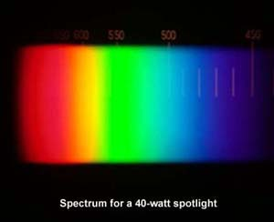
- What is radiation of heat?
- Colour is a factor in radiation. What colours are best and worse at absorbing heat radiation? What colours are best and worse at losing heat?
-  List 5 ways to improve the energy efficiency of a house:

- How does a Thermos flask keep drinks cool or hot?

